**TRƯỜNG ĐẠI HỌC TÀI NGUYÊN VÀ MÔI TRƯỜNG TP.HCM**

**KHOA CÔNG NGHỆ THÔNG TIN**



**BÁO CÁO MÔN HỌC**

**LẬP TRÌNH ỨNG DỤNG DI ĐỘNG**

**TỔNG HỢP 5 BÀI LAB THỰC HÀNH**

Giảng viên hướng dẫn: **ThS. Phạm Trọng Huynh**

Sinh viên thực hiện: **Ngô Quang Chương**

Mã số sinh viên: **1150080087**

Lớp**: 11_ĐH_THMT**

Khoá**: 2022 - 2026**

**TP. Hồ Chí Minh, 2 tháng 12 năm 2025**

**TRƯỜNG ĐẠI HỌC TÀI NGUYÊN VÀ MÔI TRƯỜNG TP.HCM**

**KHOA CÔNG NGHỆ THÔNG TIN**



**BÁO CÁO MÔN HỌC**

**LẬP TRÌNH ỨNG DỤNG DI ĐỘNG**

**TỔNG HỢP 5 BÀI LAB THỰC HÀNH**

Giảng viên hướng dẫn: **ThS. Phạm Trọng Huynh**

Sinh viên thực hiện: **Ngô Quang Chương**

Mã số sinh viên: **1150080087**

Lớp**: 11_ĐH_THMT**

Khoá**: 2022 - 2026**

**TP. Hồ Chí Minh, 2 tháng 12 năm 2025**

MỤC LỤC

LAB 1 1

1.1 Máy tính 1

1.2 Lắc xúc xắc 7

1.3 Gọi điện và nhắn tin 10

1.4 Tạo 1 ứng dụng Animal sound 15

1.5 Tạo giao diện loading 18

1.6 Tạo giao diện profile 21

LAB 2 29

2.1 Xây dựng ứng dụng Truyện Cười 29

2.1.1 Chuẩn bị tài nguyên cần thiết 29

2.1.2 Thực hiện xử lý Logic 33

2.1.3 Kết quả sau khi thực hiện 43

2.2 Xử lý đa ngôn ngữ 44

2.3 Thiết kế giao diện Login/ Register 48

2.3.1 Chuẩn bị tài nguyên 48

2.3.2 Thực hiện xử lý Logic 51

2.3.3 Kết quả sau khi thực hiện 52

2.4 Tạo giao diện menu 53

2.4.1 Chuẩn bị tài nguyên cần thiết 53

2.4.2 Thực hiện xử lý logic 55

2.5 Face Emoji 59

2.5.1 Chuẩn bị tài nguyên cần thiết 59

2.5.2 Thực hiện xử lý logic 62

2.5.3 Kết quả sau khi thực hiện 66

2.6 Hiệu ứng 66

2.6.1 Chuẩn bị tài nguyên cần thiết 66

2.6.2 Thực hiện xử lý logic 68

2.6.3 Kết quả sau khi thực hiện 70

2.7 Hiệu ứng điện thoại 70

2.7.1 Chuẩn bị tài nguyên cần thiết 70

2.7.2 Thực hiện xử lý Logic 74

2.7.3 Kết quả sau khi thực hiện 76

LAB 3 77

3.1 Xây dựng chương trình đổi tiền tệ 77

3.1.1 Chuẩn bị tài nguyên cần thiết 77

3.1.2 Thực hiện xử lý logic 83

3.1.3 Kết quả sau khi thực hiện 85

3.2 Chuyển đổi đơn vị 85

3.2.1 Chuẩn bị tài nguyên cần thiết 85

3.2.2 Thực hiện xử lý Logic 90

3.2.3 Kết quả sau khi thực hiện 92

3.3 Custom Button phần 1 92

3.3.1 Chuẩn bị tài nguyên cần thiết 92

3.3.2 Kết quả sau khi thực hiện 98

3.4 Custom Button phần 2 98

3.4.1 Chuẩn bị tài nguyên cần thiết 98

3.4.2 Thực hiện xử lý Logic 103

3.4.3 Kết quả sau khi thực hiện 105

3.5 SeekBar 105

3.5.1 Chuẩn bị tài nguyên 105

3.5.2 Thực hiện xử lý logic 107

3.5.3 Kết quả sau khi thực hiện 108

3.6 List trong Android 108

3.6.1 ListView 108

3.7 Xây dựng chương trình hiển thị và quản lý các món ǎn 113

3.7.1 Chuẩn bị tài nguyên cần thiết 113

3.7.2 Thực hiện xử lý logic 115

3.7.3 Kết quả sau khi thực hiện 118

3.8 GridView 118

3.9 Thực hiện chức năng thêm xóa sửa quản lý món ăn 123

LAB 4 126

4.1 Ứng dụng truyện cười phần 126

4.1.1 Chuẩn bị tài nguyên 126

4.1.2 Thực hiện xử lý logic 127

4.2 Ứng dụng truyện cười phần 2 129

4.2.1 Chuẩn bị tài nguyên 129

4.2.2 Thực hiện xử lý logic 130

4.3 Ứng dụng truyện cười phần 3 132

4.3.1 Chuẩn bị tài nguyên 132

4.3.2 Thực hiện xử lý logic 133

4.3.3 Kết quả sau khi thực hiện 139

4.4 Ứng dụng 12 cung hoàng đạo 140

4.4.1 Chuẩn bị tài nguyên cần thiết 140

4.4.2 Thực hiện xử lý logic 144

4.4.3 Kết quả thực hiện 150

LAB 5 152

5.1 Ứng dụng đăng nhập và đăng ký 152

5.1.1 Chuẩn bị tài nguyên cần thiết 152

5.1.2 Thực hiện xử lý logic 156

5.1.3 Kết quả sau khi thực hiện 159

# 

## Máy tính

Bước 1: Tạo ứng dụng Android đơn giản

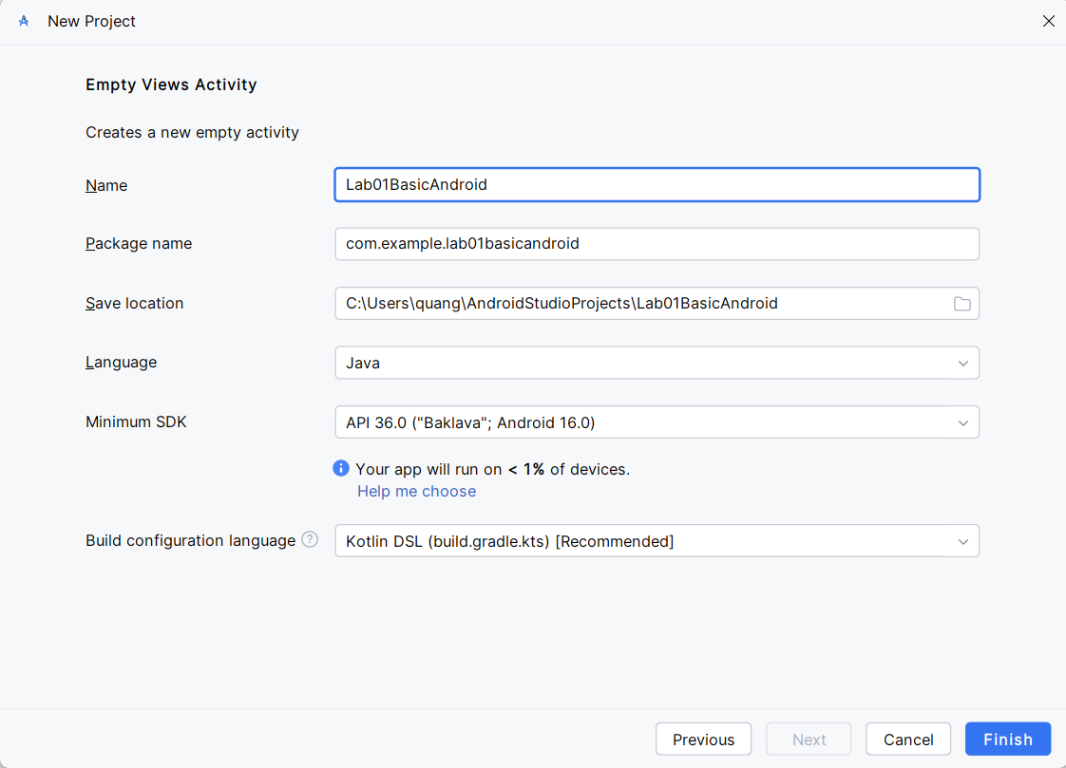

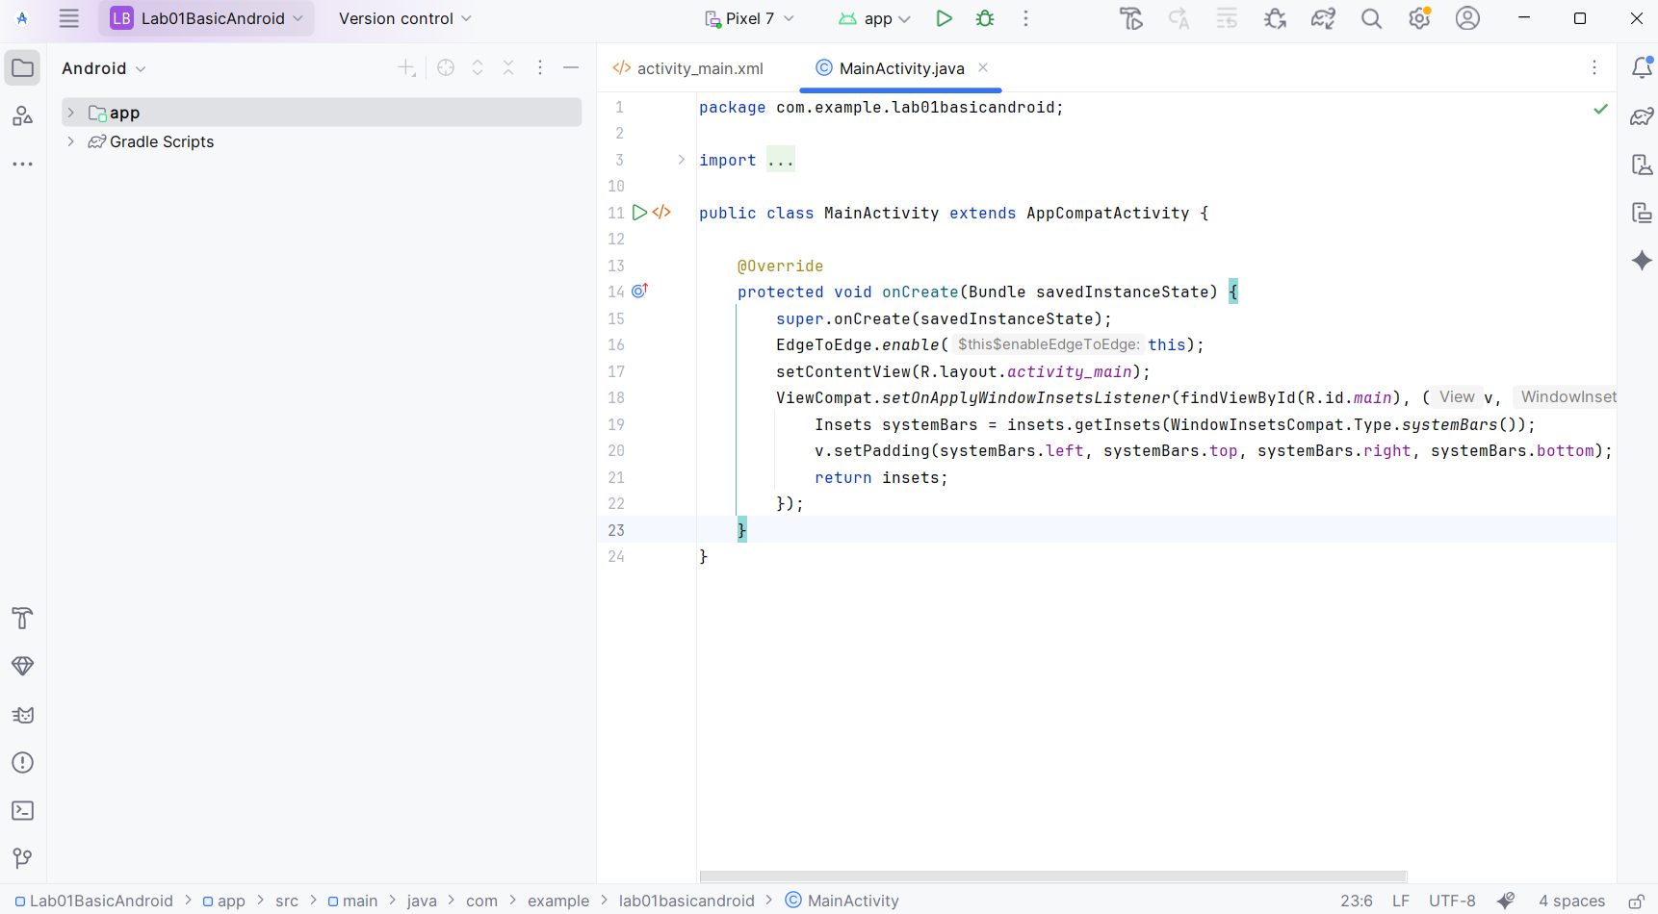

Bước 2: Trong activity_main.xml, sửa lại giao diện như sau.

<LinearLayout  
 xmlns:android="http://schemas.android.com/apk/res/android"  
 xmlns:tools="http://schemas.android.com/tools"  
 android:layout_width="match_parent"  
 android:layout_height="match_parent"  
 android:orientation="vertical"  
 android:weightSum="10"  
 tools:context=".MainActivity"  
 android:id="@+id/main">  
  
 <EditText  
 android:id="@+id/txtx"  
 android:gravity="center"  
 android:layout_weight="1"  
 android:layout_width="match_parent"  
 android:layout_height="0dp"  
 android:hint="Nhập X" />  
  
 <EditText  
 android:id="@+id/txty"  
 android:gravity="center"  
 android:layout_weight="1"  
 android:layout_width="match_parent"  
 android:layout_height="0dp"  
 android:hint="Nhập Y" />  
  
 <TextView  
 android:id="@+id/txtResult"  
 android:layout_width="match_parent"  
 android:layout_height="0dp"  
 android:layout_weight="1"  
 android:gravity="center"  
 android:text="@string/result" />  
  
 <LinearLayout  
 android:layout_width="match_parent" android:layout_height="0dp"  
 android:orientation="horizontal"  
 android:weightSum="5"  
 android:layout_weight="1">  
 <Button  
 android:id="@+id/btnCong"  
 android:layout_width="0dp"  
 android:layout_weight="1"  
 android:text="@string/cong"  
 android:layout_height="match_parent"/>  
 <Button  
 android:id="@+id/btnTru"  
 android:layout_width="0dp"  
 android:layout_weight="1"  
 android:text="@string/tru"  
 android:layout_height="match_parent"/>  
 <Button  
 android:id="@+id/btnNhan"  
 android:layout_width="0dp"  
 android:layout_weight="1"  
 android:text="@string/nhan"  
 android:layout_height="match_parent"/>  
 <Button  
 android:id="@+id/btnChia"  
 android:layout_width="0dp"  
 android:layout_weight="1"  
 android:text="@string/chia"  
 android:layout_height="match_parent"/>  
 <Button  
 android:id="@+id/btnChiaLayDu"  
 android:layout_width="0dp"  
 android:layout_weight="1"  
 android:text="%"  
 android:layout_height="match_parent"/>  
 </LinearLayout>  
</LinearLayout>

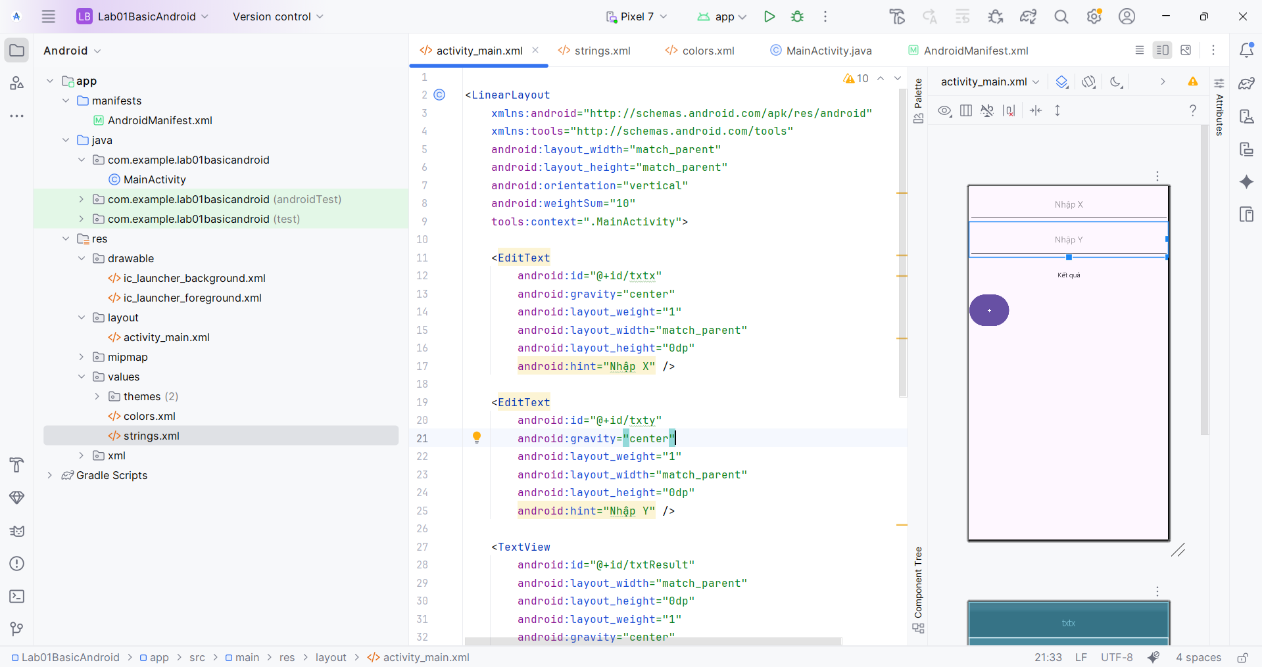

Bước 3: Sau đó ta thêm các phép tính còn lại

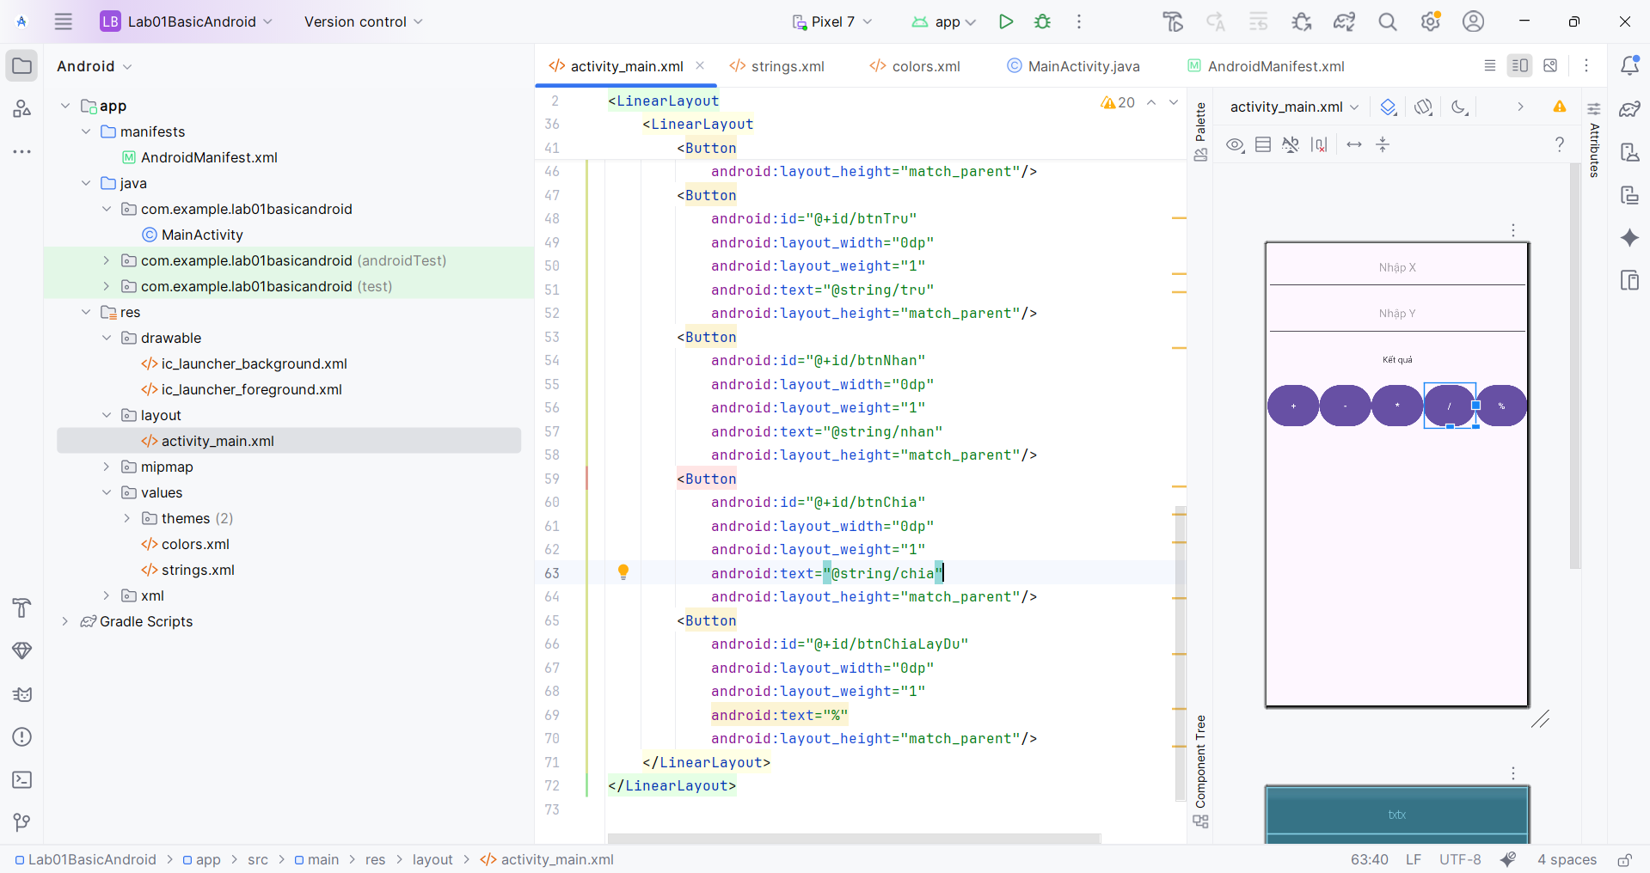

Bước 4: Tạo các tham số

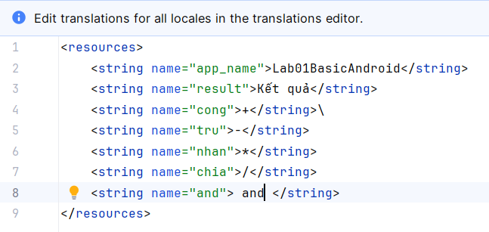

<resources>  
 <string name="app_name">Lab01BasicAndroid</string>  
 <string name="result">Kết quả</string>  
 <string name="cong">+</string>\  
 <string name="tru">-</string>  
 <string name="nhan">*</string>  
 <string name="chia">/</string>  
 <string name="and"> and </string>  
</resources>

Bước 6: Tiến hành viết phương thức kết nối và xử lý các đối tượng xml. Tùy vào đối tượng có thuộc tính khác nhau ta gán kiểu dữ liệu khác nhau đối với thuộc tính button ta cần xử lý sự kiện ta thêm

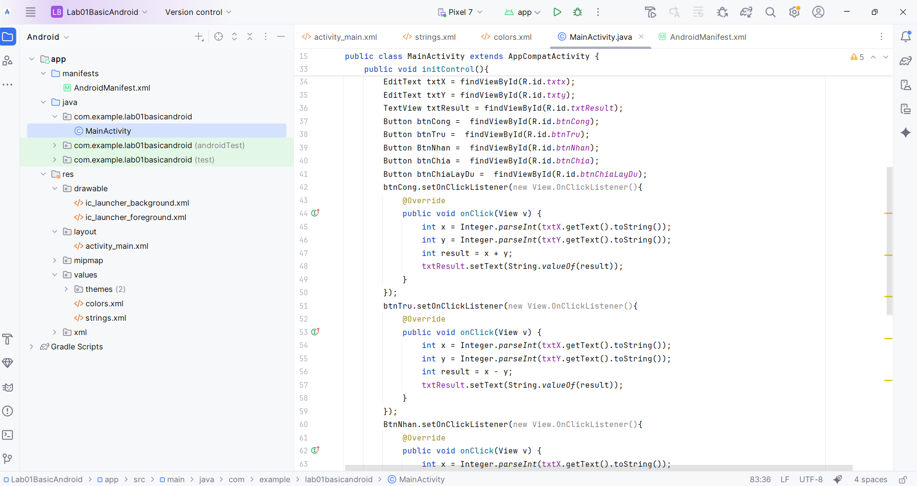

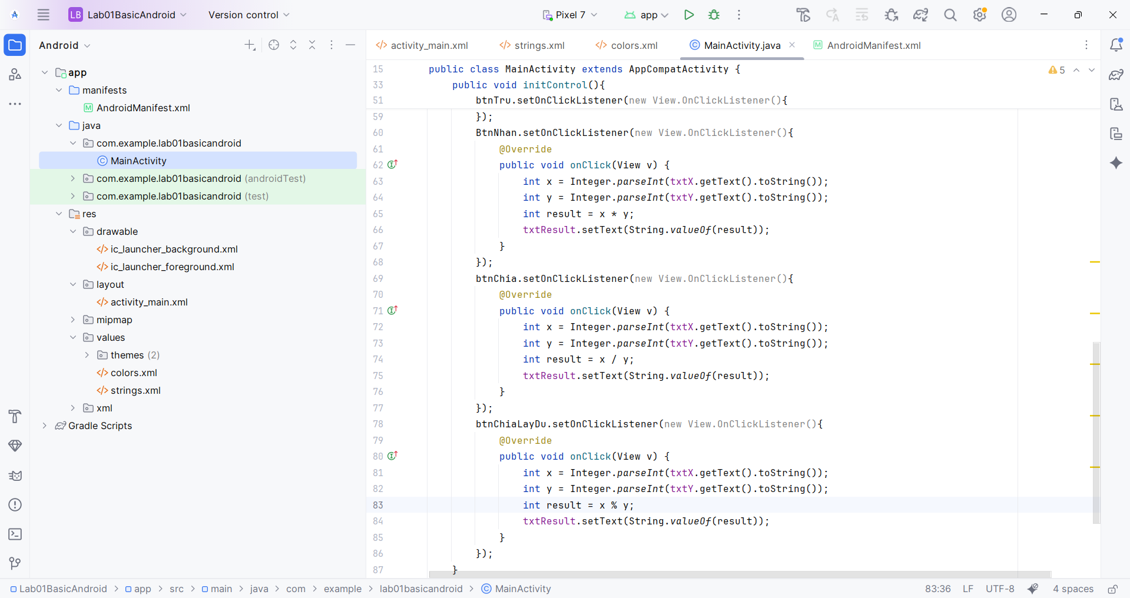

Bước 7: Ta tiến hành chạy kiểm nghiệm kết quả sau khi code.

Kết quả: Phép tính cộng

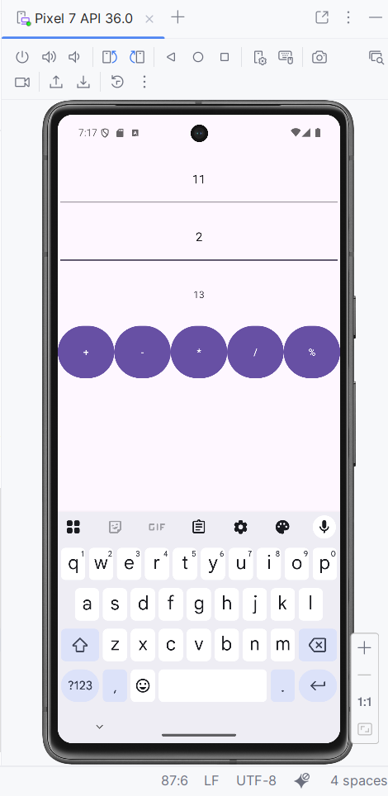

Kết quả phép tính trừ

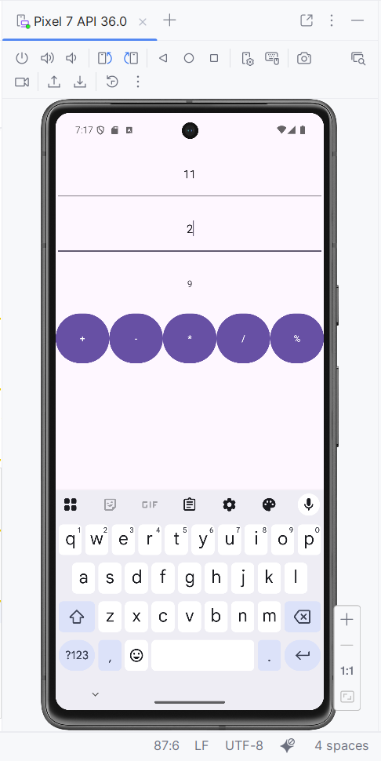

Kết quả: Phép tính nhân

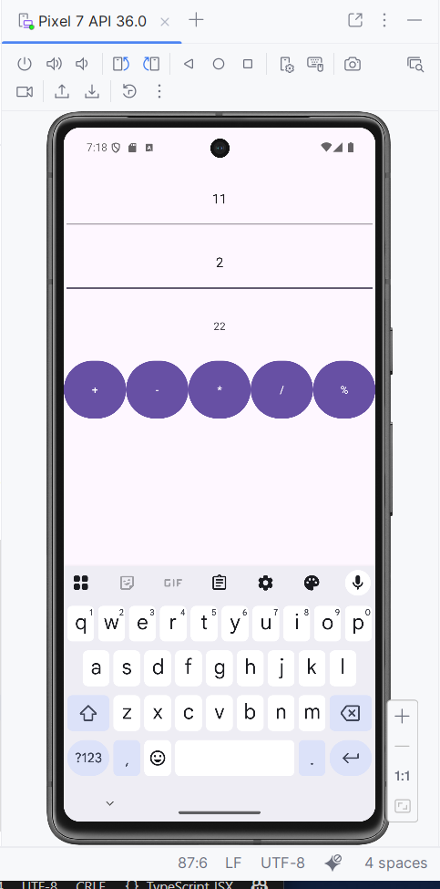

Kết quả: Phép tính chia lấy nguyên

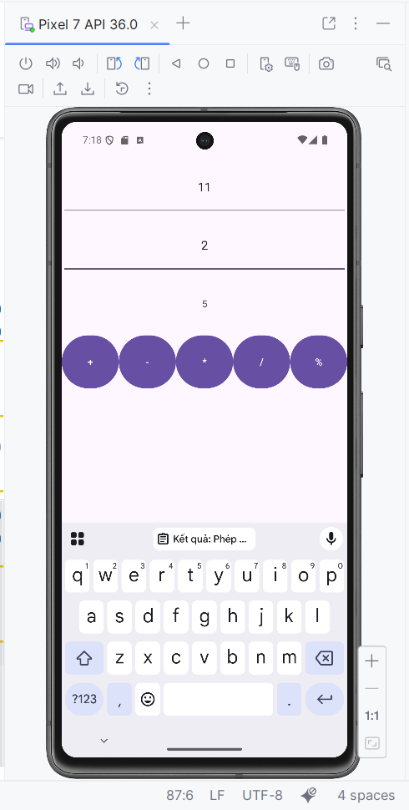

Kết quả phép tính chia lấy dư

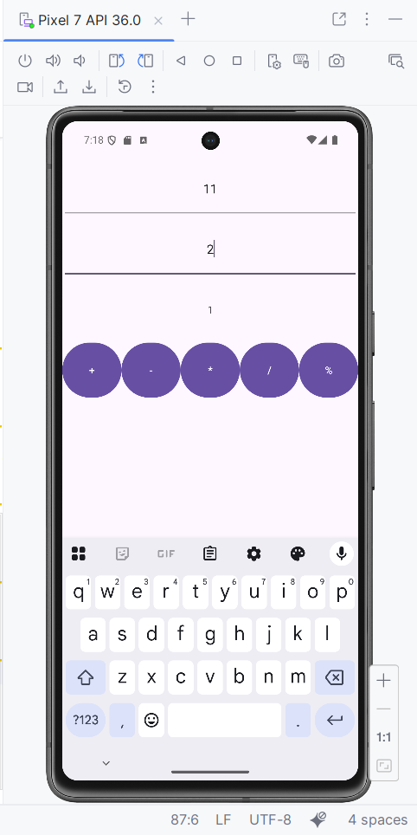

## Lắc xúc xắc

Bước 1: Ta tiến hành tải hình ảnh 6 bộ xúc xắc đặt vào drawable

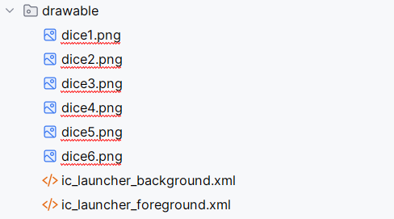

Bước 2: Ta tiến hành tạo dựng layout hiển thị. Ta sử dụng Linear Layout căn giữa và chiều từ trên xuống. Đặt id hình ảnh là imgDice để khi bấm ta bắt đầu chuyển hình ảnh.

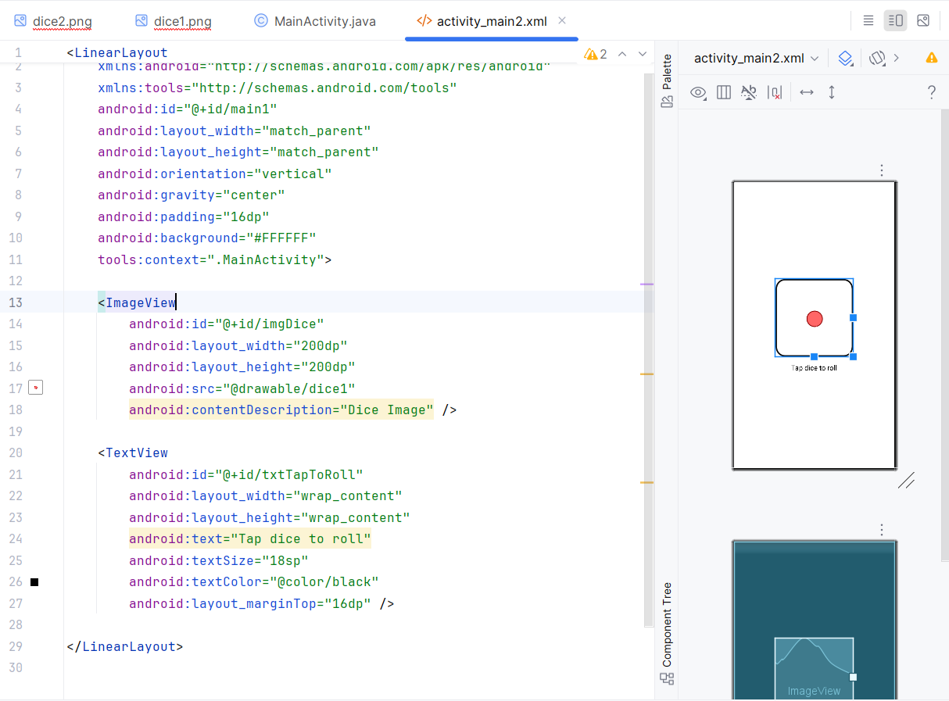

Bước 3: Ta tiến hành viết Control để xử lý sự kiện khi người dùng click vào thì thay đổi hình ảnh con xúc xắc. Ta lấy id của imgDice sau đó thêm sự kiện khởi tạo đối tượng random sau đó Random và tiến hành lấy hình ảnh và gán ngược lại.

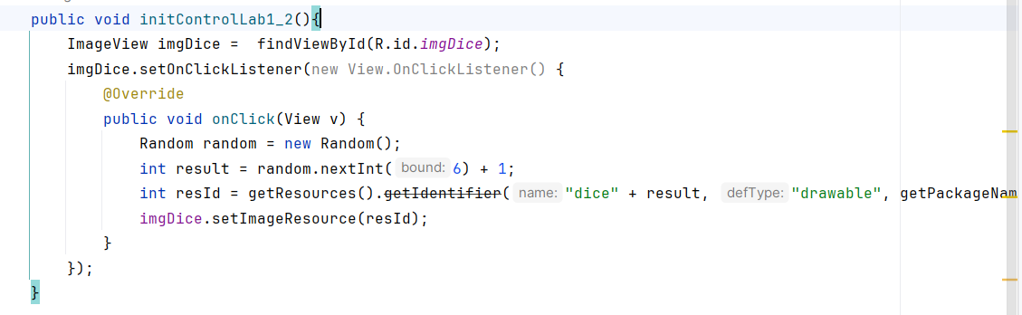

Bước 4: Ta tiến hành kiểm tra kết quả

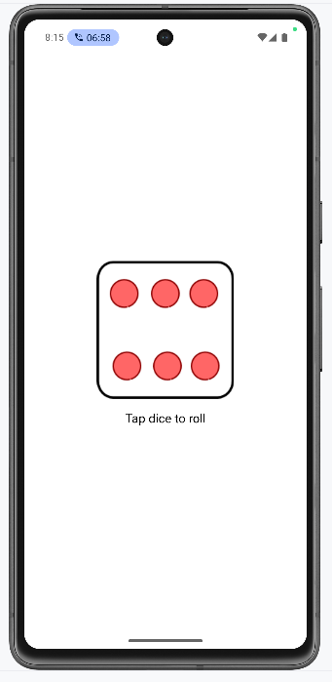

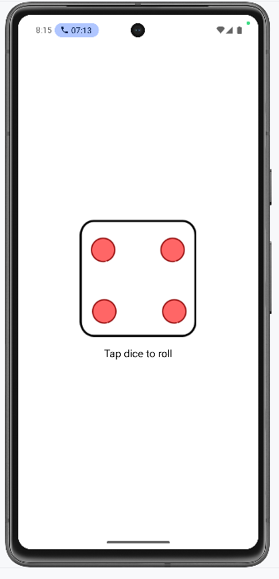

## Gọi điện và nhắn tin

Bước 1: Ta bắt đầu thiết kế giao diện cho ứng dụng gọi và gửi tin nhắn

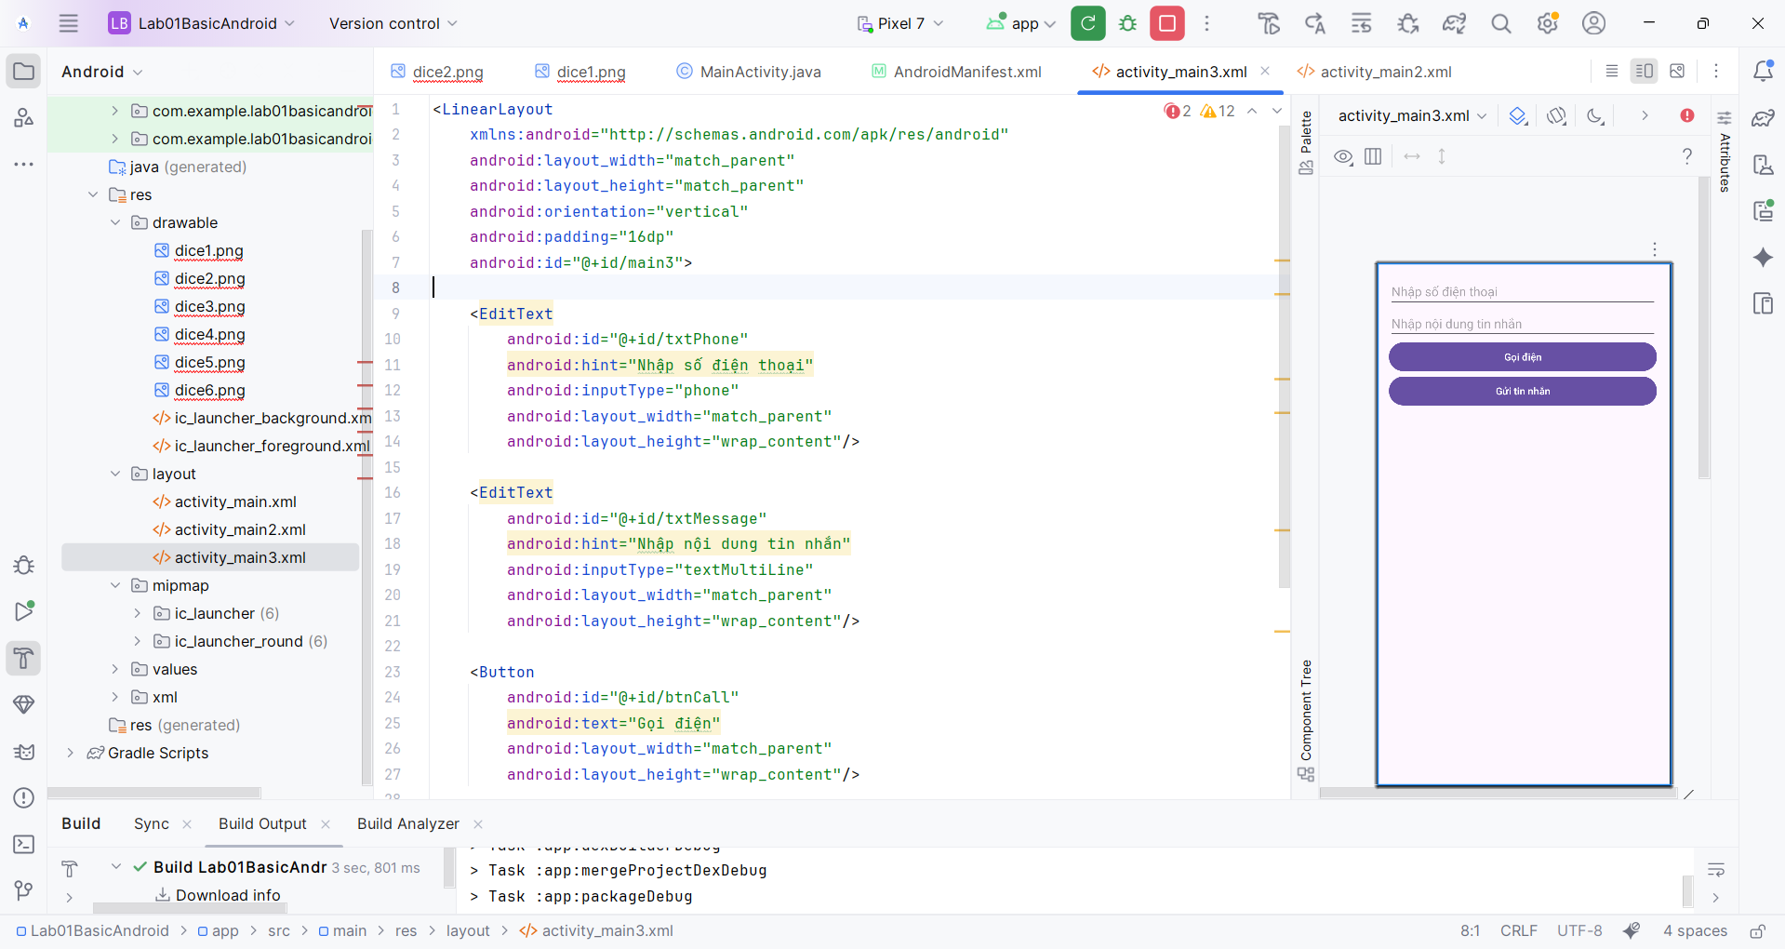

Bước 2: Ta tiến hành viết hàm Control.

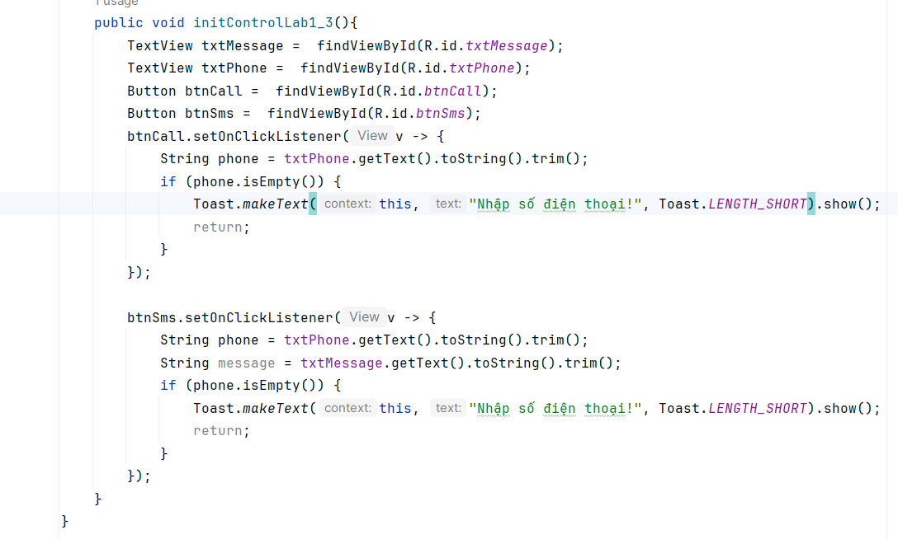

Bước 3:Sau đó ta tiến hành cấp quyền truy cập cho vào quyền gọi và nhắn tin trong Android Manifest

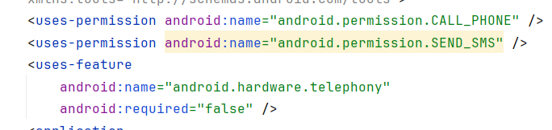

Bước 4: Sau đó ta tiến hành code logic gọi và nhắn tin. Để gọi và nhắn tin ta phải sử dụng các Intent được cung cấp. INTENT.ACTION_CALL để gọi điện, INTENT.SENDTO để gửi tin nhắn.

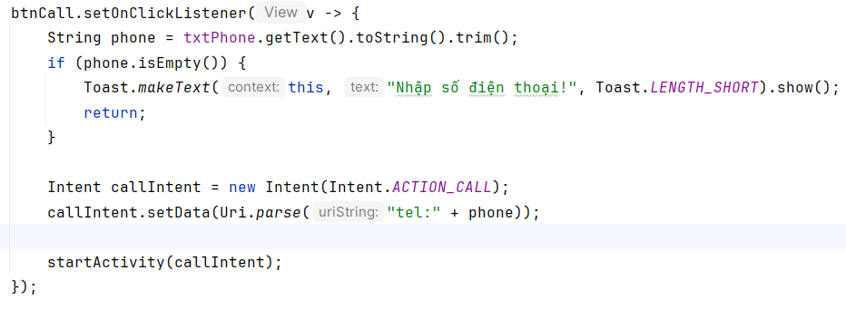

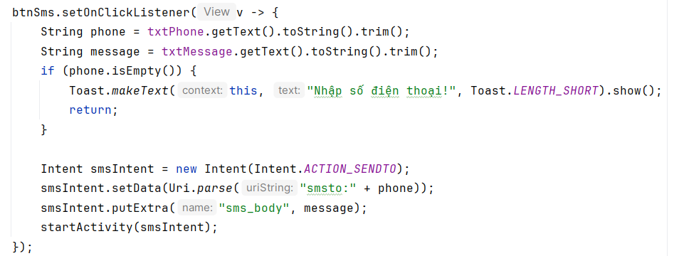

Bước 5: Ta tiến hành kiểm tra kết quả

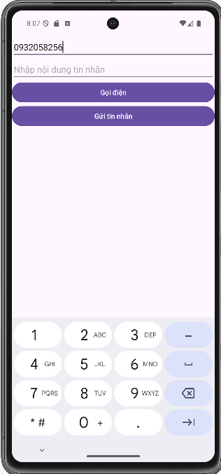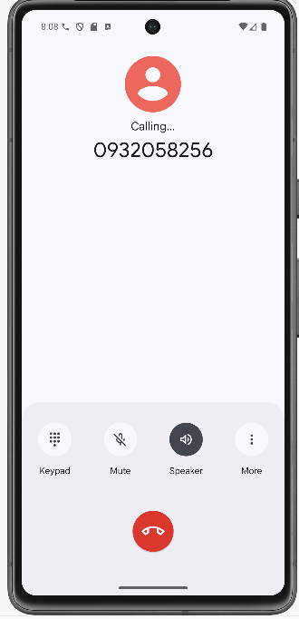

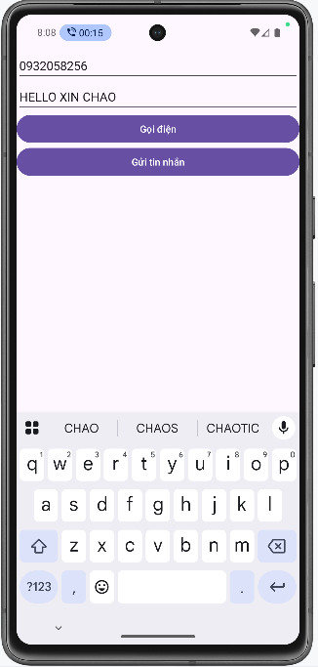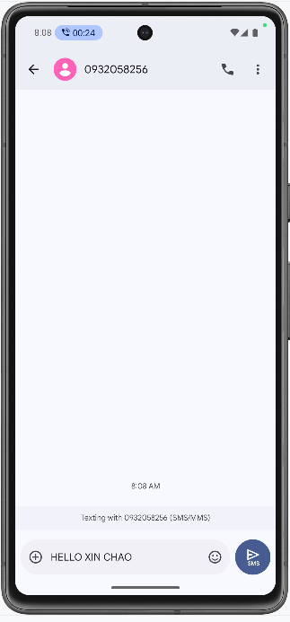

package com.example.lab01basicandroid;  
  
import android.Manifest;  
import android.content.Intent;  
import android.content.pm.PackageManager;  
import android.net.Uri;  
import android.os.Bundle;  
import android.view.View;  
import android.widget.Button;  
import android.widget.EditText;  
import android.widget.ImageView;  
import android.widget.TextView;  
import android.widget.Toast;  
  
import androidx.activity.EdgeToEdge;  
import androidx.appcompat.app.AppCompatActivity;  
import androidx.core.app.ActivityCompat;  
import androidx.core.graphics.Insets;  
import androidx.core.view.ViewCompat;  
import androidx.core.view.WindowInsetsCompat;  
  
import java.util.Random;  
  
public class MainActivity extends AppCompatActivity {  
  
 @Override  
 protected void onCreate(Bundle savedInstanceState) {  
 super.onCreate(savedInstanceState);  
 EdgeToEdge.*enable*(this);  
 setContentView(R.layout.*activity_main*);  
 ViewCompat.*setOnApplyWindowInsetsListener*(findViewById(R.id.*main*), (v, insets) -> {  
 Insets systemBars = insets.getInsets(WindowInsetsCompat.Type.*systemBars*());  
 v.setPadding(systemBars.left, systemBars.top, systemBars.right, systemBars.bottom);  
 return insets;  
 });  
 initControlLab1_1();  
*// initControlLab1_2();  
/* initControlLab1_3();*/* }  
  
  
 public void initControlLab1_1(){  
 EditText txtX = findViewById(R.id.*txtx*);  
 EditText txtY = findViewById(R.id.*txty*);  
 TextView txtResult = findViewById(R.id.*txtResult*);  
 Button btnCong = findViewById(R.id.*btnCong*);  
 Button btnTru = findViewById(R.id.*btnTru*);  
 Button BtnNhan = findViewById(R.id.*btnNhan*);  
 Button btnChia = findViewById(R.id.*btnChia*);  
 Button btnChiaLayDu = findViewById(R.id.*btnChiaLayDu*);  
 btnCong.setOnClickListener(new View.OnClickListener(){  
 @Override  
 public void onClick(View v) {  
 int x = Integer.*parseInt*(txtX.getText().toString());  
 int y = Integer.*parseInt*(txtY.getText().toString());  
 int result = x + y;  
 txtResult.setText(String.*valueOf*(result));  
 }  
 });  
 btnTru.setOnClickListener(new View.OnClickListener(){  
 @Override  
 public void onClick(View v) {  
 int x = Integer.*parseInt*(txtX.getText().toString());  
 int y = Integer.*parseInt*(txtY.getText().toString());  
 int result = x - y;  
 txtResult.setText(String.*valueOf*(result));  
 }  
 });  
 BtnNhan.setOnClickListener(new View.OnClickListener(){  
 @Override  
 public void onClick(View v) {  
 int x = Integer.*parseInt*(txtX.getText().toString());  
 int y = Integer.*parseInt*(txtY.getText().toString());  
 int result = x * y;  
 txtResult.setText(String.*valueOf*(result));  
 }  
 });  
 btnChia.setOnClickListener(new View.OnClickListener(){  
 @Override  
 public void onClick(View v) {  
 int x = Integer.*parseInt*(txtX.getText().toString());  
 int y = Integer.*parseInt*(txtY.getText().toString());  
 int result = x / y;  
 txtResult.setText(String.*valueOf*(result));  
 }  
 });  
 btnChiaLayDu.setOnClickListener(new View.OnClickListener(){  
 @Override  
 public void onClick(View v) {  
 int x = Integer.*parseInt*(txtX.getText().toString());  
 int y = Integer.*parseInt*(txtY.getText().toString());  
 int result = x % y;  
 txtResult.setText(String.*valueOf*(result));  
 }  
 });  
 }  
 public void initControlLab1_2(){  
 ImageView imgDice = findViewById(R.id.*imgDice*);  
 imgDice.setOnClickListener(new View.OnClickListener() {  
 @Override  
 public void onClick(View v) {  
 Random random = new Random();  
 int result = random.nextInt(6) + 1;  
 int resId = getResources().getIdentifier("dice" + result, "drawable", getPackageName());  
 imgDice.setImageResource(resId);  
 }  
 });  
 }  
  
 public void initControlLab1_3(){  
 TextView txtMessage = findViewById(R.id.*txtMessage*);  
 TextView txtPhone = findViewById(R.id.*txtPhone*);  
 Button btnCall = findViewById(R.id.*btnCall*);  
 Button btnSms = findViewById(R.id.*btnSms*);  
 btnCall.setOnClickListener(v -> {  
 String phone = txtPhone.getText().toString().trim();  
 if (phone.isEmpty()) {  
 Toast.*makeText*(this, "Nhập số điện thoại!", Toast.*LENGTH_SHORT*).show();  
 return;  
 }  
  
 Intent callIntent = new Intent(Intent.*ACTION_CALL*);  
 callIntent.setData(Uri.*parse*("tel:" + phone));  
  
 startActivity(callIntent);  
 });  
  
 btnSms.setOnClickListener(v -> {  
 String phone = txtPhone.getText().toString().trim();  
 String message = txtMessage.getText().toString().trim();  
 if (phone.isEmpty()) {  
 Toast.*makeText*(this, "Nhập số điện thoại!", Toast.*LENGTH_SHORT*).show();  
 return;  
 }  
  
 Intent smsIntent = new Intent(Intent.*ACTION_SENDTO*);  
 smsIntent.setData(Uri.*parse*("smsto:" + phone));  
 smsIntent.putExtra("sms_body", message);  
 startActivity(smsIntent);  
 });  
 }  
}

## Tạo 1 ứng dụng Animal sound

Bước 1: Chuẩn bị các tài nguyên

Tài nguyên màu sắc colors.xml

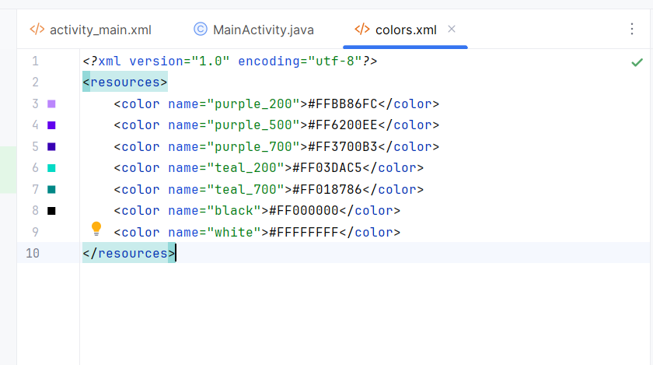

Tài nguyên Theme.xml

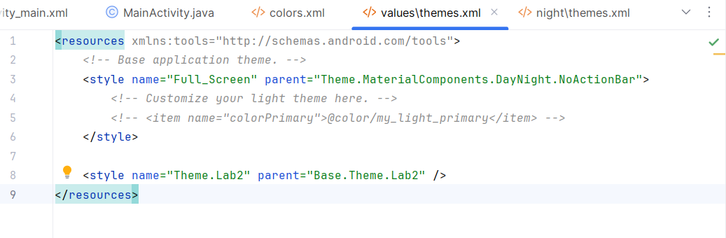

Bước 2: Cấu hình AndroidManifest

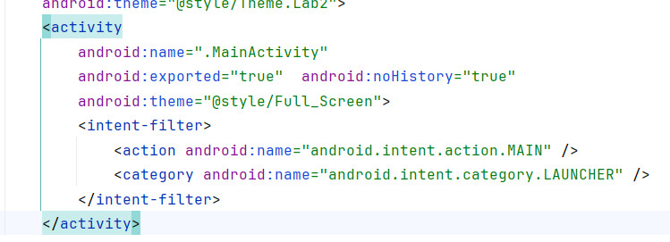

Bước 3: Thêm các giao diện thú vật vào res drawable

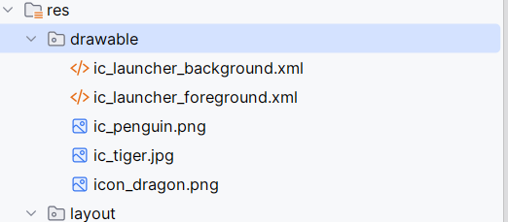

Bước 4: Ta tiến hành viết hàm điều khiển

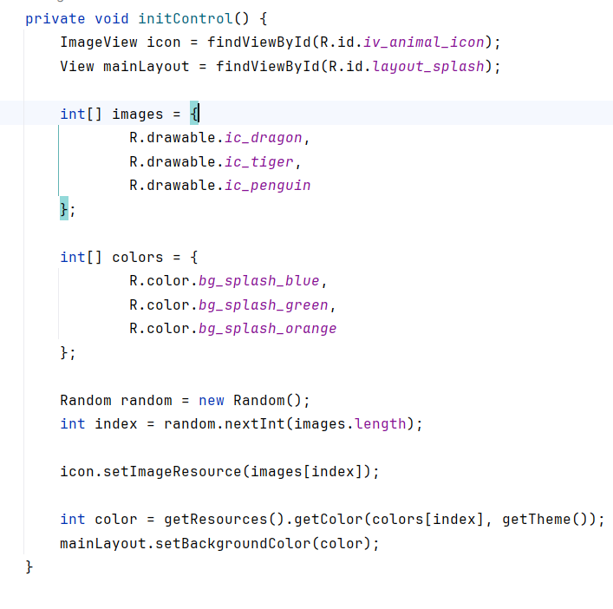

Kết quả sau khi chạy:

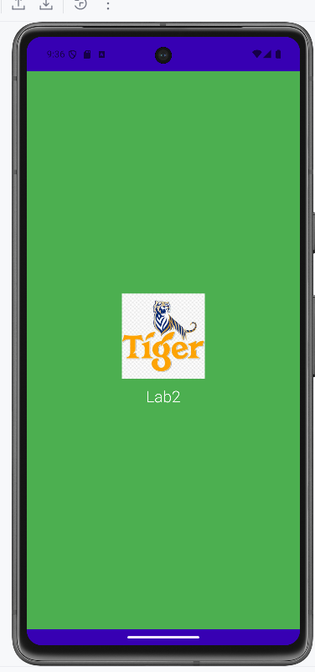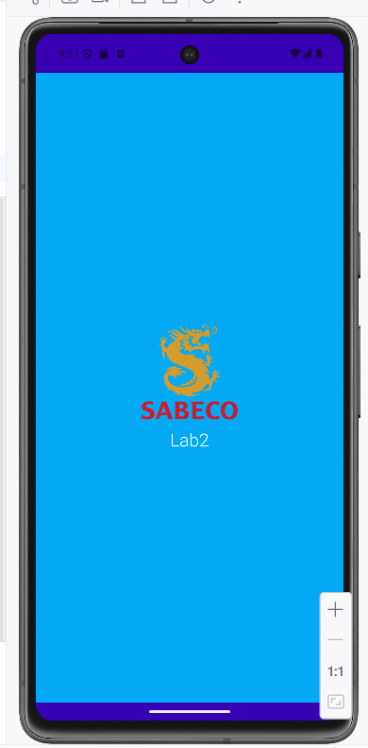

## Tạo giao diện loading

Bước 1: Thêm tài nguyên vào dự án

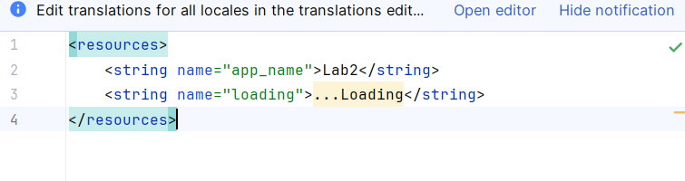

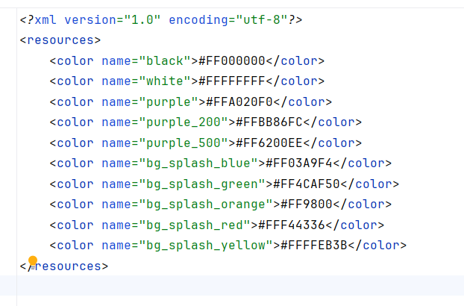

Bước 2: Tạo item_loading.xml

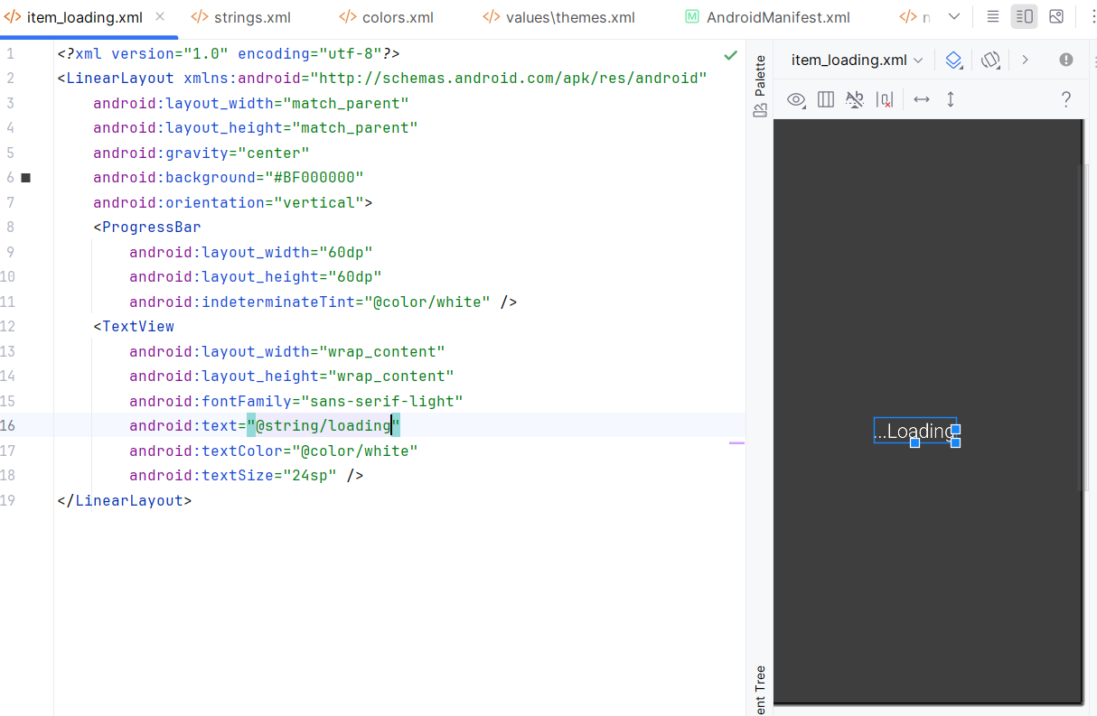

Bước 3:Ta sử dụng include để attach layout vào.

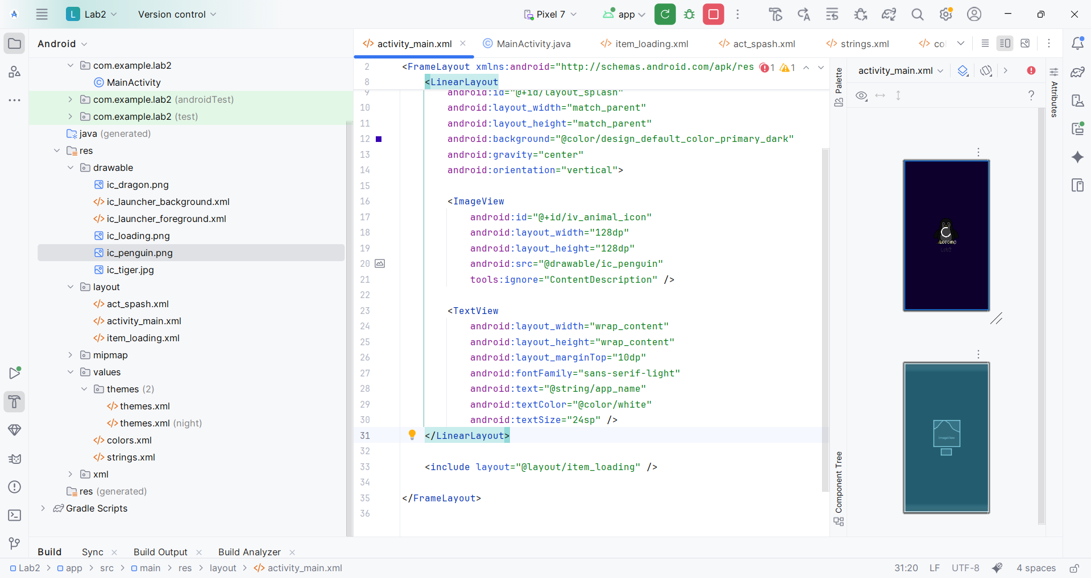

Bước 4: Tích hợp Progress Bar

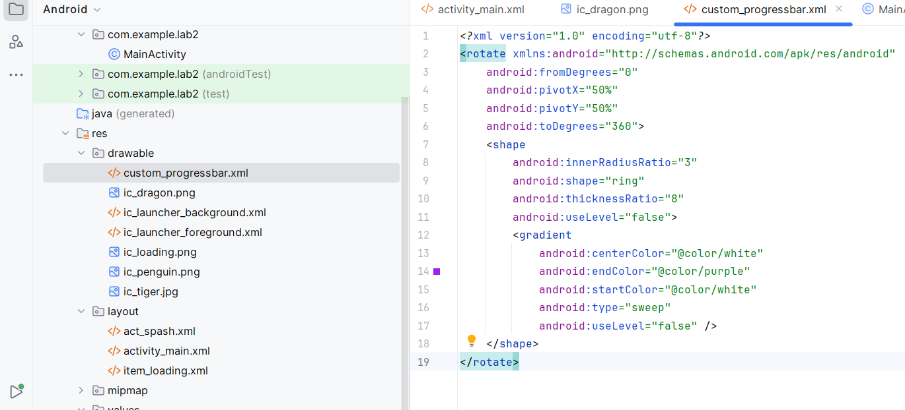

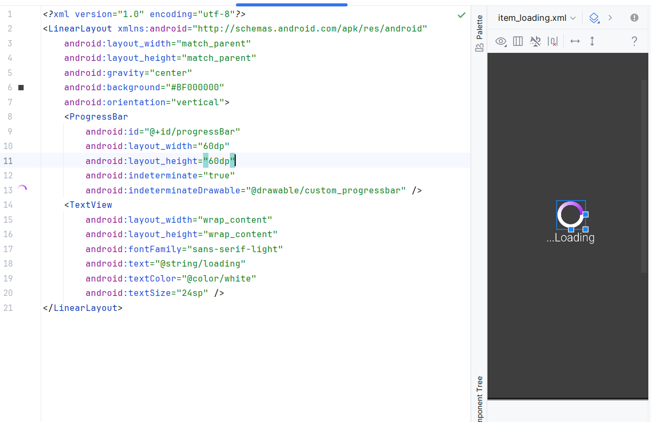

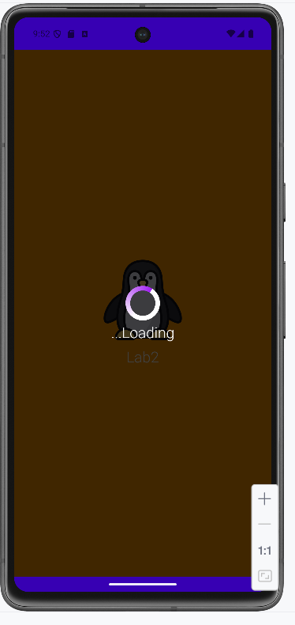

## Tạo giao diện profile

Bước 1: Thêm các tài nguyên vào

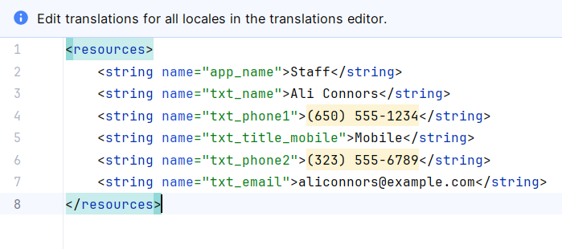

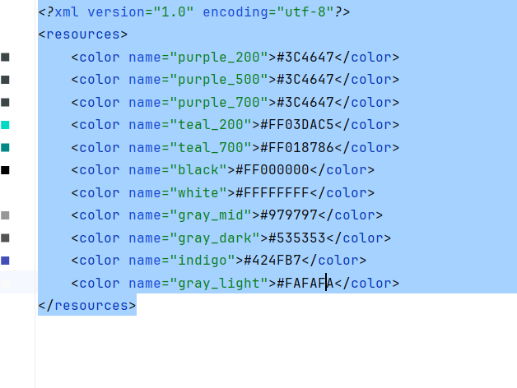

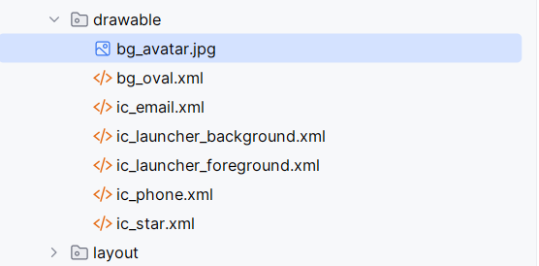

Bước 2: Code giao diện layout và thêm id imgCall và txtCall để hỗ trợ việc gọi điện

*<?*xml version="1.0" encoding="utf-8"*?>*<LinearLayout xmlns:android="http://schemas.android.com/apk/res/android"  
 xmlns:app="http://schemas.android.com/apk/res-auto"  
 xmlns:tools="http://schemas.android.com/tools"  
 android:id="@+id/main"  
 android:layout_width="match_parent"  
 android:layout_height="match_parent"  
 android:background="@color/gray_light"  
 android:orientation="vertical">  
  
 <FrameLayout  
 android:layout_width="match_parent"  
 android:layout_height="350dp">  
  
 <ImageView  
 android:layout_width="match_parent"  
 android:layout_height="300dp"  
 android:scaleType="centerCrop"  
 android:src="@drawable/bg_avatar"  
 tools:ignore="ContentDescription" />  
  
 <TextView  
 android:layout_width="wrap_content"  
 android:layout_height="wrap_content"  
 android:layout_gravity="bottom"  
 android:layout_marginStart="70dp"  
 android:layout_marginBottom="90dp"  
 android:fontFamily="sans-serif"  
 android:text="@string/txt_name"  
 android:textColor="@color/white"  
 android:textSize="40sp" />  
  
 <ImageView  
 android:layout_width="80dp"  
 android:layout_height="80dp"  
 android:layout_gravity="end|bottom"  
 android:layout_marginEnd="20dp"  
 android:layout_marginBottom="10dp"  
 android:background="@drawable/bg_oval"  
 android:padding="20dp"  
 android:src="@drawable/ic_star"  
 app:tint="@color/white"  
 tools:ignore="ContentDescription" />  
 </FrameLayout>  
  
 <TableRow  
 android:layout_width="match_parent"  
 android:layout_height="wrap_content"  
 android:padding="20dp">  
  
 <ImageView  
 android:id="@+id/imgCall"  
 android:layout_width="60dp"  
 android:layout_height="60dp"  
 android:padding="10dp"  
 android:src="@drawable/ic_phone"  
 app:tint="@color/indigo"  
 tools:ignore="ContentDescription" />  
  
 <LinearLayout  
 android:layout_width="match_parent"  
 android:layout_height="wrap_content"  
 android:layout_marginStart="30dp"  
 android:orientation="vertical">  
  
 <TextView  
 android:id="@+id/txtCall"  
 android:layout_width="match_parent"  
 android:layout_height="wrap_content"  
 android:text="@string/txt_phone1"  
 android:textColor="@color/gray_dark"  
 android:textSize="20sp" />  
  
 <TextView  
 android:layout_width="match_parent"  
 android:layout_height="wrap_content"  
 android:layout_marginTop="5dp"  
 android:text="@string/txt_title_mobile"  
 android:textColor="@color/gray_mid"  
 android:textSize="18sp" />  
  
 <TextView  
 android:layout_width="match_parent"  
 android:layout_height="wrap_content"  
 android:layout_marginTop="30dp"  
 android:text="@string/txt_phone2"  
 android:textColor="@color/gray_dark"  
 android:textSize="20sp" />  
  
 <TextView  
 android:layout_width="match_parent"  
 android:layout_height="wrap_content"  
 android:layout_marginTop="5dp"  
 android:text="@string/txt_title_mobile"  
 android:textColor="@color/gray_mid"  
 android:textSize="18sp" />  
  
 <View  
 android:layout_width="match_parent"  
 android:layout_height="0.5dp"  
 android:layout_marginTop="30dp"  
 android:background="@color/gray_mid" />  
 </LinearLayout>  
 </TableRow>  
  
 <TableRow  
 android:layout_width="match_parent"  
 android:layout_height="wrap_content"  
 android:padding="20dp">  
  
 <ImageView  
 android:layout_width="60dp"  
 android:layout_height="60dp"  
 android:padding="10dp"  
 android:src="@drawable/ic_email"  
 app:tint="@color/indigo"  
 tools:ignore="ContentDescription" />  
  
 <LinearLayout  
 android:layout_width="match_parent"  
 android:layout_height="match_parent"  
 android:layout_marginStart="30dp"  
 android:orientation="vertical">  
  
 <TextView  
 android:layout_width="match_parent"  
 android:layout_height="wrap_content"  
 android:text="@string/txt_email"  
 android:textColor="@color/gray_dark"  
 android:textSize="20sp" />  
  
 <TextView  
 android:layout_width="match_parent"  
 android:layout_height="wrap_content"  
 android:layout_marginTop="5dp"  
 android:text="@string/txt_title_mobile"  
 android:textColor="@color/gray_mid"  
 android:textSize="18sp" />  
 </LinearLayout>  
 </TableRow>  
</LinearLayout>

Bước 3:Viết hàm xử lý sự kiện tại Activity

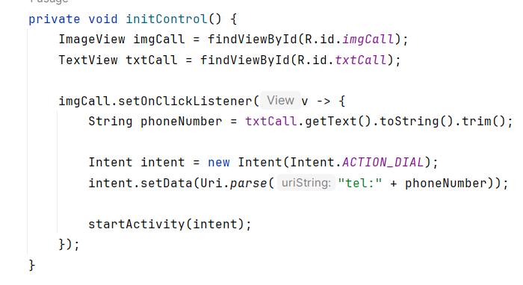

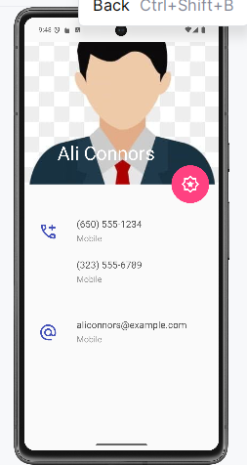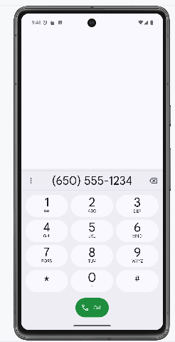

Bước 4: Tạo màn hình chính MainActivity để chuyển qua và chuyển về giữa các màn hình

Bước 5: Tạo layout activity main

*<?*xml version="1.0" encoding="utf-8"*?>*<LinearLayout xmlns:android="http://schemas.android.com/apk/res/android"  
 android:layout_width="match_parent"  
 android:layout_height="match_parent"  
 android:orientation="vertical"  
 android:gravity="center"  
 android:padding="20dp">  
  
 <Button  
 android:id="@+id/btnBai1"  
 android:layout_width="match_parent"  
 android:layout_height="wrap_content"  
 android:text="Bài tập 1" />  
  
 <Button  
 android:id="@+id/btnBai2"  
 android:layout_width="match_parent"  
 android:layout_height="wrap_content"  
 android:text="Bài tập 2"  
 android:layout_marginTop="10dp"/>  
  
 <Button  
 android:id="@+id/btnBai3"  
 android:layout_width="match_parent"  
 android:layout_height="wrap_content"  
 android:text="Bài tập 3"  
 android:layout_marginTop="10dp"/>  
</LinearLayout>

Bước 6: Viết hàm xử lý sự kiện chuyển hướng trang

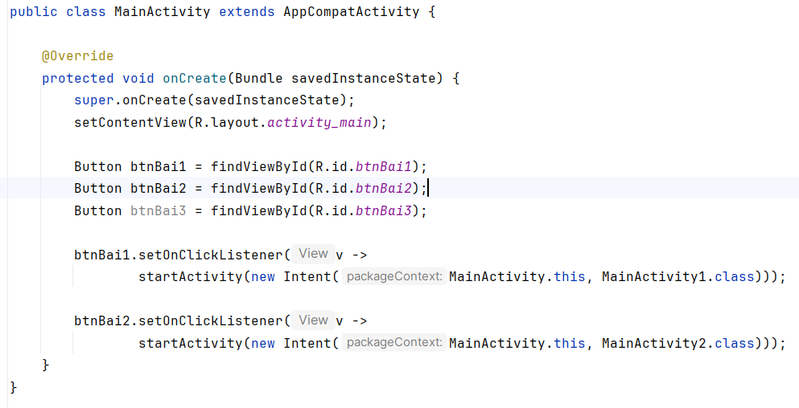

Bước 7: Thêm vào Android Manifest

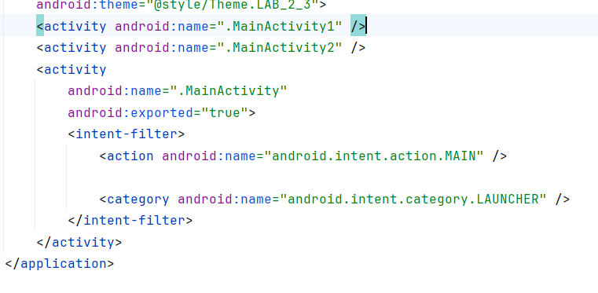

Bước 8: Kiểm tra kết quả

Nhấn bài tập 1.

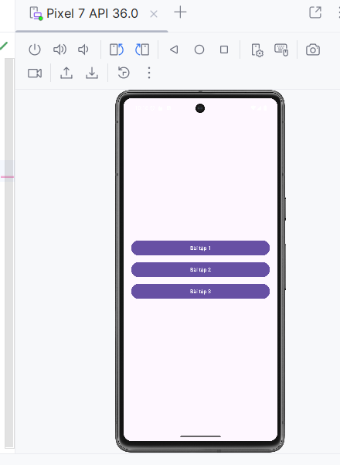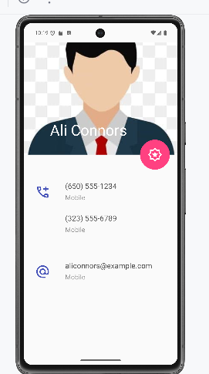

Nhấn vào bài tập 2.

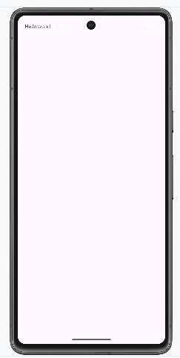

# 

## Xây dựng ứng dụng Truyện Cười

### Chuẩn bị tài nguyên cần thiết

Tài nguyên hình ảnh trong res/drawable

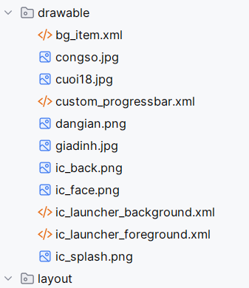

Tài nguyên chuỗi values/strings.xml

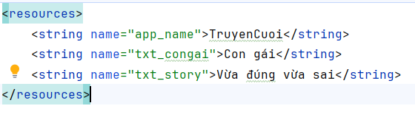

Tài nguyên chuỗi values/colors.xml

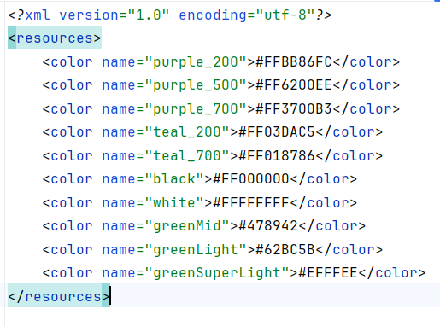

Tài nguyên về theme.xml

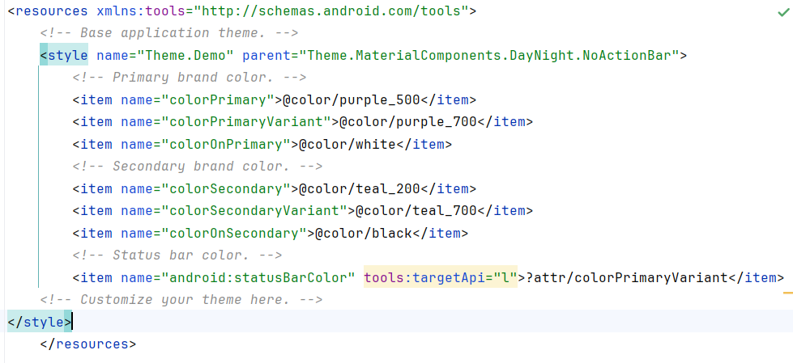

Xây dựng giao diện main_activity.xml

*<?*xml version="1.0" encoding="utf-8"*?>*<RelativeLayout xmlns:android="http://schemas.android.com/apk/res/android"  
 xmlns:tools="http://schemas.android.com/tools"  
 android:layout_width="match_parent"  
 android:layout_height="match_parent"  
 tools:context=".MainActivity"  
 android:id="@+id/ln_main">  
  
 <View  
 android:id="@+id/topBar"  
 android:layout_width="match_parent"  
 android:layout_height="50dp"  
 android:layout_alignParentTop="true"  
 android:background="@color/greenMid" />  
  
 <androidx.appcompat.widget.Toolbar  
 android:id="@+id/toolbar"  
 android:layout_width="match_parent"  
 android:layout_height="wrap_content"  
 android:layout_below="@id/topBar"  
 android:background="@color/greenLight"  
 android:title="Truyện cười 😁😋😄😍"  
 android:titleTextColor="@android:color/white" />  
  
 <androidx.recyclerview.widget.RecyclerView  
 android:id="@+id/recyclerView"  
 android:layout_width="match_parent"  
 android:layout_height="match_parent"  
 android:layout_below="@id/toolbar" />  
   
  
</RelativeLayout>

Xây dựng giao diện item_loading.xml để làm splashScreen

*<?*xml version="1.0" encoding="utf-8"*?>*<LinearLayout xmlns:android="http://schemas.android.com/apk/res/android"  
 android:layout_width="match_parent"  
 android:layout_height="match_parent"  
 android:gravity="center"  
 android:orientation="vertical">  
 <ProgressBar  
 android:id="@+id/progressBar"  
 android:layout_width="60dp"  
 android:layout_height="60dp"  
 android:indeterminate="true"  
 android:indeterminateDrawable="@drawable/custom_progressbar" />  
 <TextView  
 android:layout_width="wrap_content"  
 android:layout_height="wrap_content"  
 android:fontFamily="sans-serif-light"  
 android:text="...Loading"  
 android:textColor="@color/white"  
 android:textSize="24sp" />  
</LinearLayout>

Xây dựng splash_screen.xml để include item_loading

*<?*xml version="1.0" encoding="utf-8"*?>*<FrameLayout xmlns:android="http://schemas.android.com/apk/res/android"  
 xmlns:tools="http://schemas.android.com/tools"  
 android:layout_width="match_parent"  
 android:layout_height="match_parent"  
 android:background="@color/greenMid"  
 android:id="@+id/layoutLoading">  
 <ImageView  
 android:layout_width="200dp"  
 android:layout_height="100dp"  
 android:layout_gravity="center"  
 android:src="@drawable/ic_splash"  
 tools:ignore="ContentDescription"/>  
 <include layout="@layout/item_loading" />  
</FrameLayout>

Xây dựng giao diện item_category.xml để hiển thị lên RecycleView

*<?*xml version="1.0" encoding="utf-8"*?>*<RelativeLayout xmlns:android="http://schemas.android.com/apk/res/android"  
 android:layout_width="match_parent"  
 android:layout_height="wrap_content"  
 android:padding="8dp"  
 android:layout_margin="4dp"  
 android:background="@drawable/bg_item"  
 android:elevation="2dp"  
 android:clipToPadding="false"  
 android:clipChildren="false">  
  
 <ImageView  
 android:id="@+id/imgCategory"  
 android:layout_width="80dp"  
 android:layout_height="80dp"  
 android:scaleType="centerCrop"  
 android:src="@drawable/ic_launcher_foreground"  
 android:layout_alignParentStart="true"  
 android:layout_centerVertical="true"/>  
  
 <TextView  
 android:id="@+id/tvTitle"  
 android:layout_width="match_parent"  
 android:layout_height="wrap_content"  
 android:layout_toEndOf="@id/imgCategory"  
 android:layout_centerVertical="true"  
 android:paddingStart="12dp"  
 android:text="Tên danh mục"  
 android:textSize="18sp"  
 android:textStyle="bold"/>  
</RelativeLayout>

Thiết kế trang chứa danh sách câu chuyện activity_story_list.xml

*<?*xml version="1.0" encoding="utf-8"*?>*<RelativeLayout xmlns:android="http://schemas.android.com/apk/res/android"  
 android:layout_width="match_parent"  
 android:layout_height="match_parent">  
  
 <View  
 android:id="@+id/topBar"  
 android:layout_width="match_parent"  
 android:layout_height="50dp"  
 android:layout_alignParentTop="true"  
 android:background="@color/greenMid" />  
  
 <androidx.appcompat.widget.Toolbar  
 android:id="@+id/toolbar"  
 android:layout_width="match_parent"  
 android:layout_height="?attr/actionBarSize"  
 android:layout_below="@id/topBar"  
 android:background="@color/greenLight"  
 android:titleTextColor="@android:color/white" />  
  
 <androidx.recyclerview.widget.RecyclerView  
 android:id="@+id/recyclerViewStory"  
 android:layout_width="match_parent"  
 android:layout_height="match_parent"  
 android:layout_below="@id/toolbar" />  
  
</RelativeLayout>

Xây dựng story_item.xml để viết StoryAdapter

<RelativeLayout xmlns:android="http://schemas.android.com/apk/res/android"  
 android:layout_width="match_parent"  
 android:layout_height="wrap_content"  
 android:padding="12dp"  
 android:background="@drawable/bg_item">  
  
 <LinearLayout  
 android:layout_width="wrap_content"  
 android:layout_height="wrap_content"  
 android:orientation="horizontal"  
 android:gravity="center_vertical">  
  
 <ImageView  
 android:id="@+id/imgSmile"  
 android:layout_width="24dp"  
 android:layout_height="24dp"  
 android:src="@drawable/ic_face" />  
  
 <TextView  
 android:id="@+id/tvStoryTitle"  
 android:layout_width="wrap_content"  
 android:layout_height="wrap_content"  
 android:text="Tên truyện"  
 android:textSize="18sp"  
 android:textStyle="bold"  
 android:paddingStart="8dp"/>  
 </LinearLayout>  
  
</RelativeLayout>

Xây dựng giao diện story_detail.xml

*<?*xml version="1.0" encoding="utf-8"*?>*<RelativeLayout xmlns:android="http://schemas.android.com/apk/res/android"  
 android:layout_width="match_parent"  
 android:layout_height="match_parent">  
  
 <View  
 android:id="@+id/topBar"  
 android:layout_width="match_parent"  
 android:layout_height="50dp"  
 android:layout_alignParentTop="true"  
 android:background="@color/greenMid" />  
  
 <androidx.appcompat.widget.Toolbar  
 android:id="@+id/toolbar"  
 android:layout_width="match_parent"  
 android:layout_height="?attr/actionBarSize"  
 android:layout_below="@id/topBar"  
 android:background="@color/greenLight"  
 android:titleTextColor="@android:color/white" />  
  
 <LinearLayout  
 android:id="@+id/centerContainer"  
 android:orientation="vertical"  
 android:layout_width="match_parent"  
 android:layout_height="wrap_content"  
 android:layout_below="@id/toolbar"  
 android:layout_centerVertical="true"  
 android:paddingTop="16dp"  
 android:paddingBottom="16dp">  
  
 <TextView  
 android:id="@+id/tvDetailTitle"  
 android:layout_width="match_parent"  
 android:layout_height="wrap_content"  
 android:text="Tiêu đề"  
 android:textSize="24sp"  
 android:textStyle="bold"  
 android:gravity="center" />  
  
 <TextView  
 android:id="@+id/tvDetailDescription"  
 android:layout_width="match_parent"  
 android:layout_height="wrap_content"  
 android:text="Mô tả chi tiết"  
 android:textSize="16sp"  
 android:gravity="start"  
 android:paddingTop="8dp"  
 android:paddingLeft="16dp"  
 android:paddingRight="16dp"/>  
 </LinearLayout>  
  
  
</RelativeLayout>

### Thực hiện xử lý Logic

Bước 1: Khởi tạo các Model Category

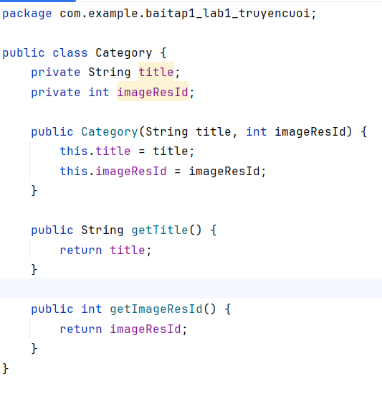

Bước 2: Khởi tạo Model Story

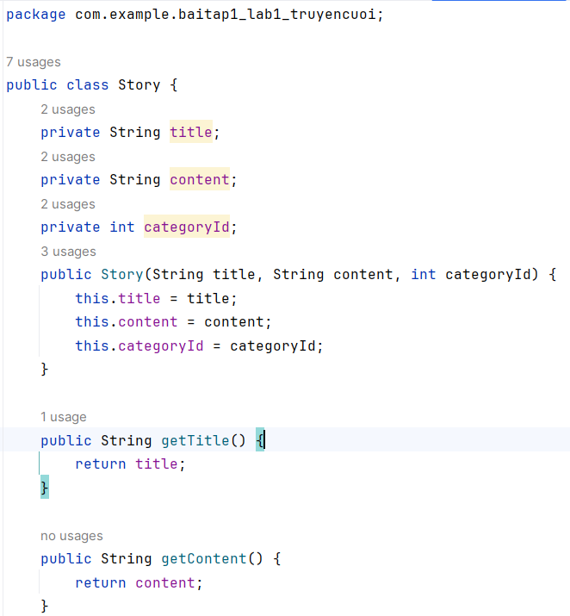

Bước 3: Chuẩn bị CategoryAdapter để có thể render danh sách Category

package com.example.truyencuoi.Adapter;  
  
import android.content.Context;  
import android.content.Intent;  
import android.view.LayoutInflater;  
import android.view.View;  
import android.view.ViewGroup;  
import android.widget.ImageView;  
import android.widget.TextView;  
  
import androidx.annotation.NonNull;  
import androidx.recyclerview.widget.RecyclerView;  
  
import com.example.baitap1_lab1_truyencuoi.Category;  
import com.example.baitap1_lab1_truyencuoi.R;  
import com.example.baitap1_lab1_truyencuoi.StoryListActivity;  
  
import java.util.List;  
  
public class CategoryAdapter extends RecyclerView.Adapter<CategoryAdapter.ViewHolder> {  
  
 private Context context;  
 private List<Category> list;  
  
 public CategoryAdapter(Context context, List<Category> list) {  
 this.context = context;  
 this.list = list;  
 }  
  
 @NonNull  
 @Override  
 public ViewHolder onCreateViewHolder(@NonNull ViewGroup parent, int viewType) {  
 View view = LayoutInflater.*from*(context).inflate(R.layout.*item_category*, parent, false);  
 return new ViewHolder(view);  
 }  
  
 @Override  
 public void onBindViewHolder(@NonNull ViewHolder holder, int position) {  
 Category category = list.get(position);  
 holder.tvTitle.setText(category.getTitle());  
 holder.imgCategory.setImageResource(category.getImageResId());  
  
 }  
  
 @Override  
 public int getItemCount() {  
 return list.size();  
 }  
  
 public static class ViewHolder extends RecyclerView.ViewHolder {  
 ImageView imgCategory;  
 TextView tvTitle;  
  
 public ViewHolder(@NonNull View itemView) {  
 super(itemView);  
 imgCategory = itemView.findViewById(R.id.*imgCategory*);  
 tvTitle = itemView.findViewById(R.id.*tvTitle*);  
 }  
 }  
}

Bước 4: Thực hiện xử lý bên trong MainActivity

Toolbar toolbar = findViewById(R.id.*toolbar*);  
setSupportActionBar(toolbar);  
getSupportActionBar().setTitle("Truyện cười 😁😋😄😍");  
  
list = new ArrayList<>();  
list.add(new Category("Công sở", R.drawable.*congso*));  
list.add(new Category("Cười 18", R.drawable.*cuoi18*));  
list.add(new Category("Dân gian", R.drawable.*dangian*));  
list.add(new Category("Gia đình", R.drawable.*giadinh*));  
  
adapter = new CategoryAdapter(this, list);  
recyclerView.setAdapter(adapter);

Bước 5: Tiến hành viết StoryAdapter

package com.example.baitap1_lab1_truyencuoi;  
  
import android.content.Context;  
import android.content.Intent;  
import android.view.LayoutInflater;  
import android.view.View;  
import android.view.ViewGroup;  
import android.widget.ImageView;  
import android.widget.TextView;  
  
import androidx.annotation.NonNull;  
import androidx.recyclerview.widget.RecyclerView;  
  
import java.util.List;  
  
public class StoryAdapter extends RecyclerView.Adapter<StoryAdapter.ViewHolder> {  
  
 private Context context;  
 private List<Story> storyList;  
  
 public StoryAdapter(Context context, List<Story> storyList) {  
 this.context = context;  
 this.storyList = storyList;  
 }  
  
 @NonNull  
 @Override  
 public ViewHolder onCreateViewHolder(@NonNull ViewGroup parent, int viewType) {  
 View view = LayoutInflater.*from*(context).inflate(R.layout.*item_story*, parent, false);  
 return new ViewHolder(view);  
 }  
  
 @Override  
 public void onBindViewHolder(@NonNull ViewHolder holder, int position) {  
 Story story = storyList.get(position);  
 holder.tvTitle.setText(story.getTitle());  
  
 }  
  
  
 @Override  
 public int getItemCount() {  
 return storyList.size();  
 }  
  
 public static class ViewHolder extends RecyclerView.ViewHolder {  
 TextView tvTitle;  
  
 public ViewHolder(@NonNull View itemView) {  
 super(itemView);  
 tvTitle = itemView.findViewById(R.id.*tvStoryTitle*);  
 }  
 }  
}

Bước 6: Bổ sung sự kiện click và gửi tên tiêu đề cho ở CategoryAdapter hiển thị đúng

holder.itemView.setOnClickListener(v -> {  
 Intent intent = new Intent(context, StoryListActivity.class);  
 intent.putExtra("categoryTitle", category.getTitle());  
 context.startActivity(intent);  
});

Bước 7: Sau đó ta nhận ở bên StoryListActivity

package com.example.baitap1_lab1_truyencuoi;  
  
import android.content.Intent;  
import android.os.Bundle;  
import androidx.appcompat.widget.Toolbar;  
  
import androidx.appcompat.app.AppCompatActivity;  
import androidx.recyclerview.widget.LinearLayoutManager;  
import androidx.recyclerview.widget.RecyclerView;  
import java.util.ArrayList;  
import java.util.List;  
  
public class StoryListActivity extends AppCompatActivity {  
  
 private RecyclerView recyclerView;  
 private StoryAdapter adapter;  
 private List<Story> storyList;  
  
 @Override  
 protected void onCreate(Bundle savedInstanceState) {  
 super.onCreate(savedInstanceState);  
 setContentView(R.layout.*activity_story_list*);  
  
 Toolbar toolbar = findViewById(R.id.*toolbar*);  
 setSupportActionBar(toolbar);  
 String categoryTitle = getIntent().getStringExtra("categoryTitle");  
 getSupportActionBar().setTitle(categoryTitle);  
 getSupportActionBar().setDisplayHomeAsUpEnabled(true);  
  
 recyclerView = findViewById(R.id.*recyclerViewStory*);  
 recyclerView.setLayoutManager(new LinearLayoutManager(this));  
  
 storyList = new ArrayList<>();  
  
 if (categoryTitle.equals("Công sở")) {  
 storyList.add(new Story("Sếp và nhân viên", "Một ngày nọ...", 1));  
 storyList.add(new Story("Báo cáo trễ", "Nhân viên nói với sếp rằng...", 1));  
 } else if (categoryTitle.equals("Gia đình")) {  
 storyList.add(new Story("Con với mẹ", "Mẹ hỏi con: ...", 2));  
 }  
  
 adapter = new StoryAdapter(this, storyList);  
 recyclerView.setAdapter(adapter);  
 toolbar.setNavigationOnClickListener(v -> onBackPressed());  
 }  
  
}

Bước 8: Ta tiếp tục viết sự kiện xử lý nhấn vào story để ra story detail

holder.itemView.setOnClickListener(v -> {  
 Intent intent = new Intent(context, StoryDetailActivity.class);  
 intent.putExtra("title", story.getTitle());  
 intent.putExtra("description", story.getContent());  
 context.startActivity(intent);  
});

Bước 9: Hiển thị dữ liệu lên storyDetail

package com.example.baitap1_lab1_truyencuoi;  
  
import android.os.Bundle;  
import android.widget.TextView;  
import androidx.appcompat.app.AppCompatActivity;  
import androidx.appcompat.widget.Toolbar;  
  
public class StoryDetailActivity extends AppCompatActivity {  
  
 private TextView tvTitle, tvDescription;  
  
 @Override  
 protected void onCreate(Bundle savedInstanceState) {  
 super.onCreate(savedInstanceState);  
 setContentView(R.layout.*activity_story_detail*);  
  
 Toolbar toolbar = findViewById(R.id.*toolbar*);  
 setSupportActionBar(toolbar);  
 getSupportActionBar().setDisplayHomeAsUpEnabled(true);  
  
 tvTitle = findViewById(R.id.*tvDetailTitle*);  
 tvDescription = findViewById(R.id.*tvDetailDescription*);  
  
 String title = getIntent().getStringExtra("title");  
 String description = getIntent().getStringExtra("description");  
  
 getSupportActionBar().setTitle(title);  
 tvTitle.setText(title);  
 tvDescription.setText(description);  
 }  
}

Bước 10: Ta tiến hành viết M000SplashFrg để xử lý việc loading khi vừa vào trang chủ

package com.example.baitap1_lab1_truyencuoi;  
import android.os.Bundle;  
import android.os.Handler;  
import android.view.LayoutInflater;  
import android.view.View;  
import android.view.ViewGroup;  
import android.widget.FrameLayout;  
  
import androidx.fragment.app.Fragment;  
public class M000SplashFrg extends Fragment {  
 @Override  
 public View onCreateView(LayoutInflater inflater, ViewGroup container, Bundle savedInstanceState) {  
 View view = inflater.inflate(R.layout.*m000_frg_splash*, container, false);  
  
 new Handler().postDelayed(() -> gotoM001Screen(view), 2000);  
  
 return view;  
 }  
  
 private void gotoM001Screen(View view) {  
 FrameLayout loading = getActivity().findViewById(R.id.*layoutLoading*);  
 if (loading != null) {  
 loading.setVisibility(View.*GONE*);  
 }  
  
 ((MainActivity) getActivity()).gotoM001Screen();  
 }  
}

Bước 11: Ở MainActivity ta tiến hành ẩn hết và sau khi showFrg chạy xong ta tiến hành hiển thị lên lại

package com.example.baitap1_lab1_truyencuoi;  
  
import android.content.pm.ActivityInfo;  
import android.os.Bundle;  
import android.widget.Button;  
import android.widget.FrameLayout;  
  
import androidx.appcompat.app.AppCompatActivity;  
import androidx.appcompat.widget.Toolbar;  
import androidx.fragment.app.Fragment;  
import androidx.recyclerview.widget.LinearLayoutManager;  
import androidx.recyclerview.widget.RecyclerView;  
  
import com.example.truyencuoi.Adapter.CategoryAdapter;  
  
import java.util.ArrayList;  
import java.util.List;  
  
public class MainActivity extends AppCompatActivity {  
 private boolean rotationEnabled = true;  
 RecyclerView recyclerView;  
 List<Category> list;  
 CategoryAdapter adapter;  
  
 @Override  
 protected void onCreate(Bundle savedInstanceState) {  
 super.onCreate(savedInstanceState);  
 setContentView(R.layout.*activity_main*);  
  
 if (savedInstanceState == null) {  
 showFrg(new M000SplashFrg());  
 }  
  
 recyclerView = findViewById(R.id.*recyclerView*);  
 recyclerView.setLayoutManager(new LinearLayoutManager(this));  
 recyclerView.setVisibility(RecyclerView.*INVISIBLE*);  
  
 Toolbar toolbar = findViewById(R.id.*toolbar*);  
 setSupportActionBar(toolbar);  
 toolbar.setVisibility(Toolbar.*INVISIBLE*);  
 getSupportActionBar().setTitle("Truyện cười 😁😋😄😍");  
  
 list = new ArrayList<>();  
 list.add(new Category("Công sở", R.drawable.*congso*));  
 list.add(new Category("Cười 18", R.drawable.*cuoi18*));  
 list.add(new Category("Dân gian", R.drawable.*dangian*));  
 list.add(new Category("Gia đình", R.drawable.*giadinh*));  
  
 adapter = new CategoryAdapter(this, list);  
 recyclerView.setAdapter(adapter);  
  
 }  
  
 private void showFrg(Fragment frg) {  
 getSupportFragmentManager()  
 .beginTransaction()  
 .replace(R.id.*ln_main*, frg, null)  
 .commit();  
 }  
  
 public void gotoM001Screen() {  
 FrameLayout loading = findViewById(R.id.*layoutLoading*);  
 if (loading != null) {  
 loading.setVisibility(FrameLayout.*GONE*);  
 }  
  
 if (recyclerView != null) recyclerView.setVisibility(RecyclerView.*VISIBLE*);  
 Toolbar toolbar = findViewById(R.id.*toolbar*);  
 if (toolbar != null) toolbar.setVisibility(Toolbar.*VISIBLE*);  
 }  
}

Bước 12: Ở Android Manifest ta tiến hành thêm các activity vào

*<?*xml version="1.0" encoding="utf-8"*?>*<manifest xmlns:android="http://schemas.android.com/apk/res/android"  
 xmlns:tools="http://schemas.android.com/tools">  
  
 <application  
 android:allowBackup="true"  
 android:dataExtractionRules="@xml/data_extraction_rules"  
 android:fullBackupContent="@xml/backup_rules"  
 android:icon="@mipmap/ic_launcher"  
 android:label="@string/app_name"  
 android:roundIcon="@mipmap/ic_launcher_round"  
 android:supportsRtl="true"  
 android:theme="@style/Theme.Demo">  
 <activity  
 android:name=".MainActivity"  
 android:exported="true">  
 <intent-filter>  
 <action android:name="android.intent.action.MAIN" />  
  
 <category android:name="android.intent.category.LAUNCHER" />  
 </intent-filter>  
 </activity>  
 <activity android:name=".StoryListActivity"  
 android:parentActivityName=".MainActivity" />  
 <activity android:name=".StoryDetailActivity"  
 android:parentActivityName=".MainActivity" />  
 </application>  
  
</manifest>

Bước 13: Sau đó ta tiến hành viết chức năng tắt và xoay bằng cách thêm button vào main_activity.xml

<Button  
 android:id="@+id/btnRotation"  
 android:layout_width="wrap_content"  
 android:layout_height="wrap_content"  
 android:text="Rotation ON"  
 android:layout_alignParentBottom="true"  
 android:layout_centerHorizontal="true"  
 android:layout_marginBottom="16dp"/>

Bước 14: Sau đó xử lý btnRotation

package com.example.baitap1_lab1_truyencuoi;  
  
import android.content.pm.ActivityInfo;  
import android.os.Bundle;  
import android.widget.Button;  
import android.widget.FrameLayout;  
  
import androidx.appcompat.app.AppCompatActivity;  
import androidx.appcompat.widget.Toolbar;  
import androidx.fragment.app.Fragment;  
import androidx.recyclerview.widget.LinearLayoutManager;  
import androidx.recyclerview.widget.RecyclerView;  
  
import com.example.truyencuoi.Adapter.CategoryAdapter;  
  
import java.util.ArrayList;  
import java.util.List;  
  
public class MainActivity extends AppCompatActivity {  
 private boolean rotationEnabled = true;  
 RecyclerView recyclerView;  
 List<Category> list;  
 CategoryAdapter adapter;  
  
 @Override  
 protected void onCreate(Bundle savedInstanceState) {  
 super.onCreate(savedInstanceState);  
 setContentView(R.layout.*activity_main*);  
  
 if (savedInstanceState == null) {  
 showFrg(new M000SplashFrg());  
 }  
  
 Button btnRotation = findViewById(R.id.*btnRotation*);  
 btnRotation.setVisibility(Button.*INVISIBLE*);  
 recyclerView = findViewById(R.id.*recyclerView*);  
 recyclerView.setLayoutManager(new LinearLayoutManager(this));  
 recyclerView.setVisibility(RecyclerView.*INVISIBLE*);  
  
 Toolbar toolbar = findViewById(R.id.*toolbar*);  
 setSupportActionBar(toolbar);  
 toolbar.setVisibility(Toolbar.*INVISIBLE*);  
 getSupportActionBar().setTitle("Truyện cười 😁😋😄😍");  
  
 list = new ArrayList<>();  
 list.add(new Category("Công sở", R.drawable.*congso*));  
 list.add(new Category("Cười 18", R.drawable.*cuoi18*));  
 list.add(new Category("Dân gian", R.drawable.*dangian*));  
 list.add(new Category("Gia đình", R.drawable.*giadinh*));  
  
 adapter = new CategoryAdapter(this, list);  
 recyclerView.setAdapter(adapter);  
  
 btnRotation.setOnClickListener(v -> {  
 if (rotationEnabled) {  
 setRequestedOrientation(ActivityInfo.*SCREEN_ORIENTATION_PORTRAIT*);  
 btnRotation.setText("Rotation OFF");  
 } else {  
 setRequestedOrientation(ActivityInfo.*SCREEN_ORIENTATION_UNSPECIFIED*);  
 btnRotation.setText("Rotation ON");  
 }  
 rotationEnabled = !rotationEnabled;  
 });  
 }  
  
 private void showFrg(Fragment frg) {  
 getSupportFragmentManager()  
 .beginTransaction()  
 .replace(R.id.*ln_main*, frg, null)  
 .commit();  
 }  
  
 public void gotoM001Screen() {  
 FrameLayout loading = findViewById(R.id.*layoutLoading*);  
 if (loading != null) {  
 loading.setVisibility(FrameLayout.*GONE*);  
 }  
  
 if (recyclerView != null) recyclerView.setVisibility(RecyclerView.*VISIBLE*);  
 Toolbar toolbar = findViewById(R.id.*toolbar*);  
 if (toolbar != null) toolbar.setVisibility(Toolbar.*VISIBLE*);  
 Button btnRotation = findViewById(R.id.*btnRotation*);  
 if (btnRotation != null) btnRotation.setVisibility(Button.*VISIBLE*);  
 }  
}

ROTATION ON thì cho phép xoay màn hình còn nếu OFF thì chỉ có thể đứng

### Kết quả sau khi thực hiện

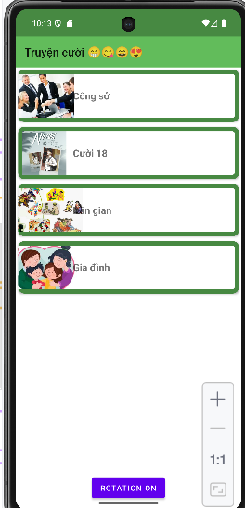

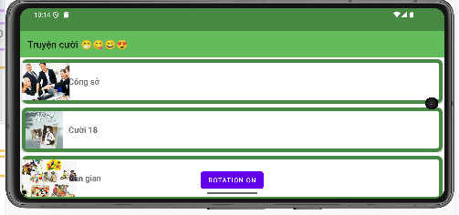

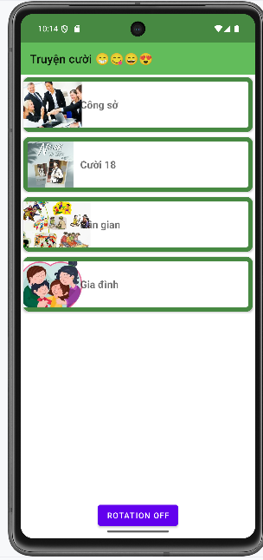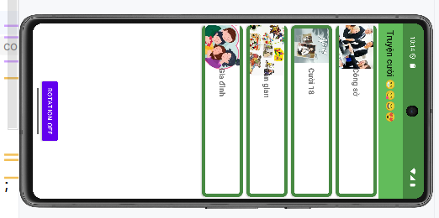

## Xử lý đa ngôn ngữ

Bước 1: Chuẩn bị tài nguyên hình ảnh

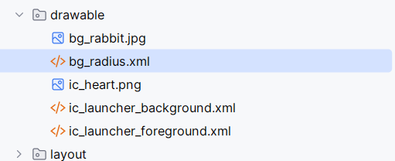

Bước 2: Chuẩn bị tài nguyên màu sắc colors.xml

*<?*xml version="1.0" encoding="utf-8"*?>*<resources>  
 <color name="purple_200">#FFBB86FC</color>  
 <color name="purple_500">#FF6200EE</color>  
 <color name="purple_700">#FF3700B3</color>  
 <color name="teal_200">#FF03DAC5</color>  
 <color name="teal_700">#FF018786</color>  
 <color name="black">#FF000000</color>  
 <color name="white">#FFFFFFFF</color>  
 <color name="greenMid">#478942</color>  
 <color name="greenLight">#62BC5B</color>  
 <color name="greenSuperLight">#EFFFEE</color>  
</resources>

Bước 3: Xây dựng tài nguyên chuỗi strings.xml

<resources>  
 <string name="app_name">Animal Sound</string>  
 <string name="txt_desc">Rabbits are small mammals in the family Leporidae (along with the  
hare) of the order Lagomorpha (along with the pika). Oryctolagus cuniculus includes the  
European rabbitspecies and its descendants, the world\'s 305 breeds[1] of domestic rabbit.  
Sylvilagus includes 13 wild rabbit species, among them the seven types of cottontail. The  
European rabbit, which has been introduced on every continent except Antarctica, isfamiliar  
throughout the world as a wild prey animal and as a domesticated form of livestock and pet.  
With its widespread effect on ecologies and cultures, the rabbit (or bunny) is, in many areas  
of the world, a part of daily life—as food, clothing, a companion, and a source of artistic  
inspiration.</string>  
 <string name="txt_name">Rabbit</string>  
</resources>

Bước 4: Xây dựng giao diện main_activity.xml

*<?*xml version="1.0" encoding="utf-8"*?>*<LinearLayout xmlns:android="http://schemas.android.com/apk/res/android"  
 xmlns:app="http://schemas.android.com/apk/res-auto"  
 xmlns:tools="http://schemas.android.com/tools"  
 android:layout_width="match_parent"  
 android:layout_height="match_parent"  
 android:orientation="vertical"  
 android:padding="10dp"  
 android:id="@+id/main">  
 <TableRow  
 android:layout_width="match_parent"  
 android:layout_height="wrap_content"  
 android:layout_marginHorizontal="10dp"  
 android:layout_marginTop="10dp">  
 <TextView  
 android:id="@+id/tv_animal_name"  
 android:layout_width="wrap_content"  
 android:layout_height="wrap_content"  
 android:layout_gravity="start"  
 android:background="@drawable/bg_radius"  
 android:fontFamily="sans-serif-light"  
 android:paddingHorizontal="20dp"  
 android:text="@string/txt_name"  
 android:textColor="@color/white"  
 android:textSize="34sp" />  
 <View  
 android:layout_width="0dp"  
 android:layout_height="match_parent"  
 android:layout_weight="1" />  
 <ImageView  
 android:id="@+id/iv_favorite"  
 android:layout_width="40dp"  
 android:layout_height="match_parent"  
 android:src="@drawable/ic_heart_empty"  
 app:tint="#FF0000"  
 tools:ignore="ContentDescription" />  
 </TableRow>  
 <ScrollView  
 android:layout_width="match_parent"  
 android:layout_height="300dp"  
 android:layout_marginBottom="10dp">  
 <LinearLayout  
 android:layout_width="match_parent"  
 android:layout_height="wrap_content"  
 android:orientation="vertical">  
 <TextView  
 android:id="@+id/tv_animal_desc"  
 android:layout_width="match_parent"  
 android:layout_height="wrap_content"  
 android:layout_gravity="center"  
 android:fontFamily="sans-serif-light"  
 android:lineSpacingExtra="5dp"  
 android:padding="10dp"  
 android:text="@string/txt_desc"  
 android:textColor="@color/black"  
 android:textSize="18sp" />  
 </LinearLayout>  
 </ScrollView>  
 <ImageView  
 android:id="@+id/iv_animal"  
 android:layout_width="match_parent"  
 android:layout_height="0dp"  
 android:layout_weight="1"  
 android:scaleType="centerCrop"  
 android:src="@drawable/bg_rabbit"  
 tools:ignore="ContentDescription" />  
</LinearLayout>

Bước 5: Tạo tài nguyên chuỗi tiếng việt bằng Android Resource File tạo file có trên values-vi-rVN

*<?*xml version="1.0" encoding="utf-8"*?>*<resources>  
 <string name="txt_name">Thỏ</string>  
 <string name="app_name">Âm thanh động vật</string>  
 <string name="txt_desc"> Thỏ là loài động vật có vú nhỏ trong họ Leporidae (cùng với thỏ  
rừng) thuộc bộ Lagomorpha (cùng với pika). Oryctolagus cuniculus bao gồm các loài thỏ châu  
Âu và con cháu của nó, 305 giống thỏ nhà trên thế giới [1]. Sylvilagus bao gồm 13 loài thỏ  
hoang dã, trong số đó có bảy loại cottontail. Loài thỏ châu Âu, đã được giới thiệu ở mọi lục  
địa, ngoại trừ Nam Cực, đã quen thuộc trên khắp thế giới như một loài động vật sǎn mồi  
hoang dã và là một dạng vật nuôi và vật nuôi đã được thuần hóa. Với ảnh hưởng rộng rãi  
của nó đối với hệ sinh thái và vǎn hóa, ở nhiều khu vực trên thế giới, thỏ (hoặc thỏ) là một  
phần của cuộc sống hàng ngày — như thức ǎn, quần áo, bạn đồng hành và là nguồn cảm  
hứng nghệ thuật.</string>  
</resources>

Bước 6: Hiển thị kết quả

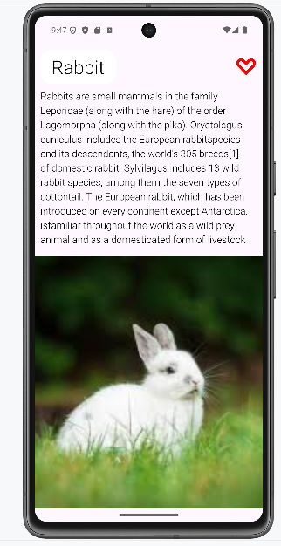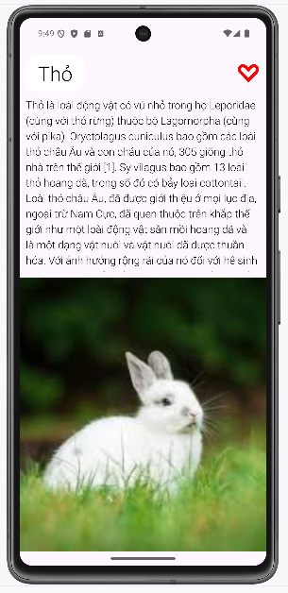

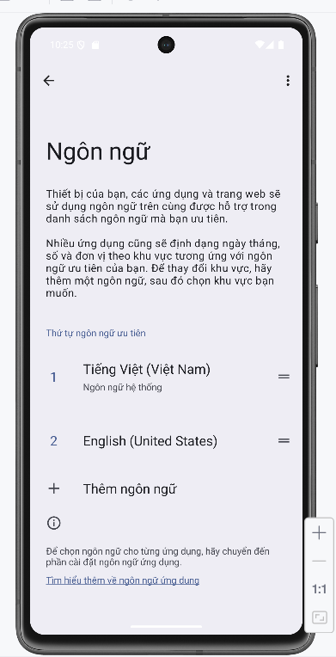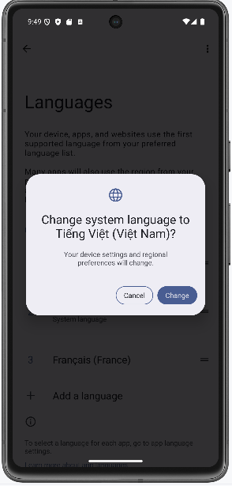

## Thiết kế giao diện Login/ Register

### Chuẩn bị tài nguyên

Chuẩn bị tài nguyên màu sắc colors.xml

*<?*xml version="1.0" encoding="utf-8"*?>*<resources>  
 <color name="purple_200">#FFBB86FC</color>  
 <color name="purple_500">#FF6200EE</color>  
 <color name="purple_700">#F4511E</color>  
 <color name="teal_200">#FF03DAC5</color>  
 <color name="teal_700">#FF018786</color>  
 <color name="black">#FF000000</color>  
 <color name="white">#FFFFFFFF</color>  
 <color name="orange">#FB8C00</color>  
 <color name="gray">#EAE5E3</color>  
 <color name="orangeMid">#F4511E</color>  
</resources>

Chuẩn bị tài nguyên màu sắc strings.xml

<resources xmlns:tools="http://schemas.android.com/tools">  
 <string name="app_name">Login</string>  
 <string name="txt_login">Login</string>  
 <string name="hint_email">Email</string>  
 <string name="hint_password">Password</string>  
 <string name="txt_forgot_pass">Forgot password?</string>  
 <string name="txt_no_account" tools:ignore="StringEscaping">Don\'t have an account ?</string>  
  
 <string name="txt_register">Register</string>  
</resources>

**Chuẩn bị tài nguyên về icon, bg trong drawable**

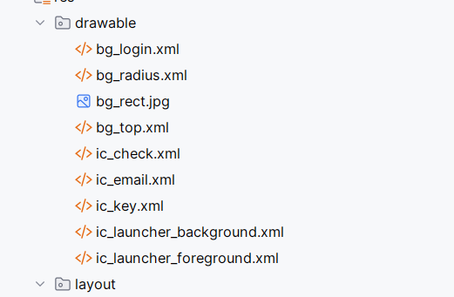

Xây dựng giao diện

*<?*xml version="1.0" encoding="utf-8"*?>*<LinearLayout xmlns:android="http://schemas.android.com/apk/res/android"  
 android:layout_width="match_parent"  
 android:layout_height="match_parent"  
 android:background="@color/gray" android:orientation="vertical">  
 <FrameLayout  
 android:layout_width="match_parent"  
 android:layout_height="wrap_content">  
 <View  
 android:layout_width="match_parent"  
 android:layout_height="300dp"  
 android:background="@drawable/bg_top"/>  
 <TextView  
 android:layout_width="wrap_content"  
 android:layout_height="wrap_content"  
 android:layout_gravity="end"  
 android:layout_marginTop="220dp"  
 android:layout_marginEnd="30dp"  
 android:text="@string/txt_login"  
 android:textColor="@color/white"  
 android:textSize="20sp" />  
 </FrameLayout>  
 <EditText  
 android:id="@+id/edtEmail"  
 android:layout_width="match_parent"  
 android:layout_height="50dp"  
 android:layout_marginHorizontal="30dp"  
 android:layout_marginTop="50dp"  
 android:layout_marginBottom="3dp"  
 android:background="@drawable/bg_radius"  
 android:drawableStart="@drawable/ic_email"  
 android:drawablePadding="10dp"  
 android:hint="@string/hint_email"  
 android:padding="10dp"  
 android:textSize="18sp" />  
 <EditText  
 android:id="@+id/edtPassword"  
 android:layout_width="match_parent"  
 android:layout_height="50dp"  
 android:layout_marginHorizontal="30dp"  
 android:layout_marginTop="20dp"  
 android:layout_marginBottom="3dp"  
 android:background="@drawable/bg_radius"  
 android:drawableStart="@drawable/ic_key"  
 android:drawablePadding="10dp"  
 android:hint="@string/hint_password"  
 android:padding="10dp"  
 android:textSize="18sp" />  
 <TextView  
 android:layout_width="wrap_content"  
 android:layout_height="wrap_content"  
 android:layout_gravity="end"  
 android:layout_marginTop="10dp"  
 android:layout_marginEnd="30dp"  
 android:text="@string/txt_forgot_pass"  
 android:textColor="@color/black"  
 android:textSize="18sp" />  
 <Button  
 android:id="@+id/btnLogin"  
 android:layout_width="match_parent"  
 android:layout_height="50dp"  
 android:layout_gravity="end"  
 android:layout_marginHorizontal="30dp"  
 android:layout_marginTop="50dp"  
 android:background="@drawable/bg_login"  
 android:gravity="center"  
 android:padding="10dp"  
 android:text="@string/txt_login"  
 android:textColor="@color/white"  
 android:textSize="18sp" />  
 <TableRow  
 android:layout_width="match_parent"  
 android:layout_height="wrap_content"  
 android:layout_marginTop="50dp"  
 android:gravity="center">  
 <TextView  
 android:layout_width="wrap_content"  
 android:layout_height="wrap_content"  
 android:layout_gravity="end"  
 android:text="@string/txt_no_account"  
 android:textColor="@color/black"  
 android:textSize="14sp" />  
 <TextView  
 android:layout_width="wrap_content"  
 android:layout_height="wrap_content"  
 android:layout_gravity="end"  
 android:text="@string/txt_register"  
 android:textColor="@color/orange"  
 android:textSize="14sp"  
 android:textStyle="bold" />  
 </TableRow>  
</LinearLayout>

Tiến hành thêm layout custom toast

*<?*xml version="1.0" encoding="utf-8"*?>*<LinearLayout xmlns:android="http://schemas.android.com/apk/res/android"  
 android:orientation="horizontal"  
 android:padding="12dp"  
 android:background="@drawable/bg_radius"  
 android:gravity="center_vertical"  
 android:layout_width="wrap_content"  
 android:layout_height="wrap_content">  
 <ImageView  
 android:src="@drawable/ic_check"  
 android:layout_width="24dp"  
 android:layout_height="24dp"  
 android:layout_marginEnd="8dp" />  
 <TextView  
 android:id="@+id/tvToastMessage"  
 android:textColor="@color/black"  
 android:textSize="16sp"  
 android:text="Message here"  
 android:layout_width="wrap_content"  
 android:layout_height="wrap_content" />  
</LinearLayout>

### Thực hiện xử lý Logic

Bước 1: Xử lý sự kiện hiển thị Custom Toast

package com.example.lab2_baitap2_1;  
  
import android.os.Bundle;  
import android.view.LayoutInflater;  
import android.view.View;  
import android.widget.Button;  
import android.widget.EditText;  
import android.widget.TextView;  
import android.widget.Toast;  
import androidx.appcompat.app.AppCompatActivity;  
  
  
public class MainActivity extends AppCompatActivity {  
  
 private EditText edtEmail, edtPassword;  
 private Button btnLogin;  
  
 @Override  
 protected void onCreate(Bundle savedInstanceState) {  
 super.onCreate(savedInstanceState);  
 setContentView(R.layout.*activity_main*);  
  
 edtEmail = findViewById(R.id.*edtEmail*);  
 edtPassword = findViewById(R.id.*edtPassword*);  
 btnLogin = findViewById(R.id.*btnLogin*);  
  
 btnLogin.setOnClickListener(v -> showCustomToast());  
 }  
  
 private void showCustomToast() {  
 String email = edtEmail.getText().toString().trim();  
 String password = edtPassword.getText().toString().trim();  
  
 LayoutInflater inflater = getLayoutInflater();  
 View layout = inflater.inflate(R.layout.*custom_toast*, findViewById(android.R.id.*content*), false);  
  
 TextView tvMessage = layout.findViewById(R.id.*tvToastMessage*);  
 tvMessage.setText("Bạn đã đăng nhập thành công với email: " + email + " và mật khẩu: " + password);  
  
 Toast toast = new Toast(getApplicationContext());  
 toast.setDuration(Toast.*LENGTH_LONG*);  
 toast.setView(layout);  
 toast.show();  
 }  
}

### Kết quả sau khi thực hiện

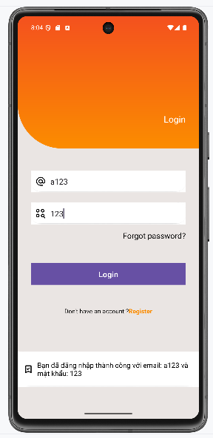

## Tạo giao diện menu

### Chuẩn bị tài nguyên cần thiết

Tài nguyên chuỗi strings.xml

<resources>  
 <string name="app_name">Từ vựng</string>  
 <string name="txt_flight">Flight</string>  
 <string name="txt_bonfire">Bonfire</string>  
 <string name="txt_camera">Camera</string>  
 <string name="txt_map">Map</string>  
 <string name="txt_melon">Melon</string>  
 <string name="txt_mountain">Mountain</string>  
 <string name="txt_sunglasses">Sunglasses</string>  
 <string name="txt_world">World</string>  
 <string name="txt_mess">Mess</string>  
</resources>

Tài nguyên màu sắc colors.xml

*<?*xml version="1.0" encoding="utf-8"*?>*<resources>  
 <color name="purple_200">#319FFF</color>  
 <color name="purple_500">#1E88E5</color>  
 <color name="purple_700">#1E88E5</color>  
 <color name="teal_200">#FF03DAC5</color>  
 <color name="teal_700">#FF018786</color>  
 <color name="black">#FF000000</color>  
 <color name="white">#FFFFFFFF</color>  
 <color name="orange">#FB8C00</color>  
 <color name="gray">#EAE5E3</color>  
 <color name="orangeMid">#F4511E</color>  
</resources>

Tài nguyên ảnh vào drawable

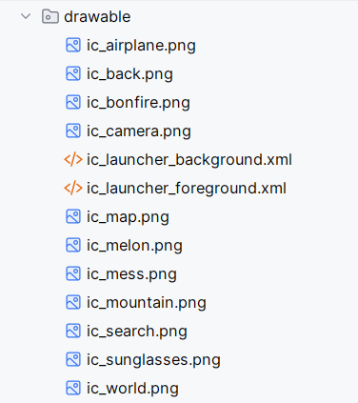

Xây dựng giao diện actionbar.xml

*<?*xml version="1.0" encoding="utf-8"*?>*<LinearLayout xmlns:android="http://schemas.android.com/apk/res/android"  
 xmlns:app="http://schemas.android.com/apk/res-auto"  
 xmlns:tools="http://schemas.android.com/tools"  
 android:layout_width="match_parent"  
 android:layout_height="wrap_content"  
 android:background="@color/purple_200"  
 android:orientation="horizontal">  
 <ImageView  
 android:id="@+id/iv_back"  
 android:layout_width="60dp"  
 android:layout_height="match_parent"  
 android:layout_marginEnd="10dp"  
 android:padding="10dp"  
 android:src="@drawable/ic_back"  
 app:tint="@color/white"  
 tools:ignore="ContentDescription" />  
 <TextView  
 android:layout_width="0dp"  
 android:layout_height="56dp"  
 android:layout_weight="1"  
 android:gravity="center_vertical"  
 android:paddingStart="16dp"  
 android:text="@string/app_name"  
 android:textColor="@color/white"  
 android:textSize="24sp"  
 tools:ignore="RtlSymmetry" />  
 <ImageView  
 android:id="@+id/iv_dialer"  
 android:layout_width="60dp"  
 android:layout_height="match_parent"  
 android:layout_marginEnd="10dp"  
 android:padding="10dp"  
 android:src="@drawable/ic_search"  
 app:tint="@color/white"  
 tools:ignore="ContentDescription" />  
</LinearLayout>

Xây dựng giao diện item_topic.xml

*<?*xml version="1.0" encoding="utf-8"*?>*<LinearLayout xmlns:android="http://schemas.android.com/apk/res/android"  
 xmlns:tools="http://schemas.android.com/tools"  
 android:layout_width="match_parent"  
 android:layout_height="match_parent"  
 android:orientation="horizontal">  
 <ImageView  
 android:id="@+id/iv_topic"  
 android:layout_width="64dp"  
 android:layout_height="match_parent"  
 android:src="@drawable/ic_mess"  
 tools:ignore="ContentDescription" />  
 <TextView  
 android:id="@+id/tv_topic"  
 android:layout_width="match_parent"  
 android:layout_height="match_parent"  
 android:layout_marginStart="10dp"  
 android:gravity="center_vertical"  
 android:text="@string/txt_mess"  
 android:textColor="@color/black"  
 android:textSize="18sp" />  
</LinearLayout>

Xây dựng giao diện main_activity.xml

*<?*xml version="1.0" encoding="utf-8"*?>*<LinearLayout xmlns:android="http://schemas.android.com/apk/res/android"  
 xmlns:tools="http://schemas.android.com/tools"  
 android:layout_width="match_parent"  
 android:layout_height="match_parent"  
 android:orientation="vertical"  
 tools:context=".MainActivity">  
 <include layout="@layout/actionbar_home" />  
 <LinearLayout  
 android:id="@+id/ln_main"  
 android:padding="10dp"  
 android:layout_width="match_parent"  
 android:layout_height="match_parent"  
 android:orientation="vertical" />  
</LinearLayout>

### Thực hiện xử lý logic

Bước 1: Thực hiện xử lý logic trong MainActivity

package com.example.lab2_bai2_2;  
import android.graphics.Insets;  
import android.os.Bundle;  
import android.view.LayoutInflater;  
import android.view.View;  
import android.widget.ImageView;  
import android.widget.LinearLayout;  
import android.widget.TextView;  
  
import androidx.appcompat.app.AppCompatActivity;  
import androidx.core.view.ViewCompat;  
import androidx.core.view.WindowInsetsCompat;  
import androidx.core.view.WindowInsetsCompat.Type;  
  
  
public class MainActivity extends AppCompatActivity {  
 private static final int[] *ID_DRAWABLES* = {R.drawable.*ic_airplane*, R.drawable.*ic_bonfire*,  
 R.drawable.*ic_camera*,  
 R.drawable.*ic_map*, R.drawable.*ic_melon*, R.drawable.*ic_mountain*,  
 R.drawable.*ic_sunglasses*, R.drawable.*ic_world*};  
 private static final int[] *ID_TEXTS* = {  
 R.string.*txt_flight*,  
 R.string.*txt_bonfire*,  
 R.string.*txt_camera*,  
 R.string.*txt_map*,  
 R.string.*txt_melon*,  
 R.string.*txt_mountain*,  
 R.string.*txt_sunglasses*,  
 R.string.*txt_world* };  
  
 @Override  
 protected void onCreate(Bundle savedInstanceState) {  
 super.onCreate(savedInstanceState);  
 setContentView(R.layout.*activity_main*);  
  
 View mainLayout = findViewById(R.id.*ln_main*);  
  
 ViewCompat.*setOnApplyWindowInsetsListener*(mainLayout, (v, insets) -> {  
 Insets systemInsets = insets.getInsets(Type.*systemBars*()).toPlatformInsets();  
 v.setPadding(  
 systemInsets.left,  
 systemInsets.top,  
 systemInsets.right,  
 systemInsets.bottom  
 );  
 return insets;  
 });  
 initView();  
 }  
 private void initView() {  
 LinearLayout lnMain = findViewById(R.id.*ln_main*);  
 lnMain.removeAllViews();  
 for (int i = 0; i < *ID_DRAWABLES*.length; i++) {  
 View v = LayoutInflater.*from*(this).inflate(R.layout.*item_topic*, null);  
 ImageView ivTopic = v.findViewById(R.id.*iv_topic*);  
 TextView tvTopic = v.findViewById(R.id.*tv_topic*);  
 ivTopic.setImageResource(*ID_DRAWABLES*[i]);  
 tvTopic.setText(*ID_TEXTS*[i]);  
 LinearLayout.LayoutParams param = new LinearLayout.LayoutParams(  
 LinearLayout.LayoutParams.*MATCH_PARENT*,  
 LinearLayout.LayoutParams.*MATCH_PARENT*,  
 1.0f  
 );  
 v.setLayoutParams(param);  
 lnMain.addView(v);  
 }  
 }  
}

**Kết quả sau khi thực hiện**

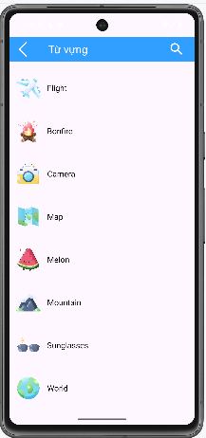

Bước 2: Tiến hành thêm giao diện topic_detail.xml

*<?*xml version="1.0" encoding="utf-8"*?>*<LinearLayout xmlns:android="http://schemas.android.com/apk/res/android"  
 android:orientation="vertical"  
 android:padding="16dp"  
 android:layout_width="match_parent"  
 android:layout_height="match_parent">  
  
 <ListView  
 android:id="@+id/lv_words"  
 android:layout_width="match_parent"  
 android:layout_height="match_parent"/>  
</LinearLayout>

Bước 3: Tiến hành thêm Activity Topic Detail

package com.example.lab2_bai2_2;  
  
import android.os.Bundle;  
import android.widget.ArrayAdapter;  
import android.widget.ListView;  
  
import androidx.appcompat.app.AppCompatActivity;  
  
public class TopicDetailActivity extends AppCompatActivity {  
  
 public static final String *EXTRA_TOPIC_INDEX* = "topic_index";  
  
 @Override  
 protected void onCreate(Bundle savedInstanceState) {  
 super.onCreate(savedInstanceState);  
 setContentView(R.layout.*activity_topic_detail*);  
  
 ListView listView = findViewById(R.id.*lv_words*);  
  
  
 int topicIndex = getIntent().getIntExtra(*EXTRA_TOPIC_INDEX*, 0);  
  
  
 String[][] wordsByTopic = {  
 {"Airplane", "Pilot", "Airport"},  
 {"Firewood", "Campfire", "Night"},  
 {"Camera", "Photo", "Lens"},  
 {"Map", "Compass", "Direction"},  
 {"Melon", "Watermelon", "Fruit"},  
 {"Mountain", "Peak", "Climb"},  
 {"Sunglasses", "Shade", "Sun"},  
 {"World", "Country", "Continent"}  
 };  
  
 String[] words = wordsByTopic[topicIndex];  
  
 ArrayAdapter<String> adapter = new ArrayAdapter<>(this,  
 android.R.layout.*simple_list_item_1*,  
 words);  
 listView.setAdapter(adapter);  
 }  
}

Bước 4: Trong activity main thêm sự kiện nhấn vào view

private void initView() {  
 LinearLayout lnMain = findViewById(R.id.*ln_main*);  
 lnMain.removeAllViews();  
 for (int i = 0; i < *ID_DRAWABLES*.length; i++) {  
 final int index = i;  
 View v = LayoutInflater.*from*(this).inflate(R.layout.*item_topic*, null);  
 v.setOnClickListener(view -> {  
 Intent intent = new Intent(MainActivity.this, TopicDetailActivity.class);  
 intent.putExtra(TopicDetailActivity.*EXTRA_TOPIC_INDEX*, index);  
 startActivity(intent);  
 });  
 ImageView ivTopic = v.findViewById(R.id.*iv_topic*);  
 TextView tvTopic = v.findViewById(R.id.*tv_topic*);  
 ivTopic.setImageResource(*ID_DRAWABLES*[i]);  
 tvTopic.setText(*ID_TEXTS*[i]);  
 LinearLayout.LayoutParams param = new LinearLayout.LayoutParams(  
 LinearLayout.LayoutParams.*MATCH_PARENT*,  
 LinearLayout.LayoutParams.*MATCH_PARENT*,  
 1.0f  
 );  
 v.setLayoutParams(param);  
 lnMain.addView(v);  
  
  
 }  
}

Bước 5: Khai báo android manifest

<activity android:name=".TopicDetailActivity" />

Kết quả sau khi bấm vào Flight

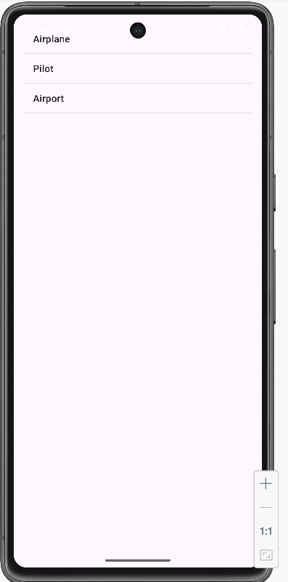

## Face Emoji

### Chuẩn bị tài nguyên cần thiết

Tài nguyên chuỗi strings.xml

<resources>  
 <string name="app_name">Face Emoij</string>  
</resources>

Tài nguyên màu sắc colors.xml

*<?*xml version="1.0" encoding="utf-8"*?>*<resources>  
 <color name="purple_200">#FFBB86FC</color>  
 <color name="purple_500">#FF9800</color>  
 <color name="purple_700">#FF6F00</color>  
 <color name="teal_200">#FF03DAC5</color>  
 <color name="teal_700">#FF018786</color>  
 <color name="black">#FF000000</color>  
 <color name="white">#FFFFFFFF</color>  
</resources>

Tài nguyên hình ảnh

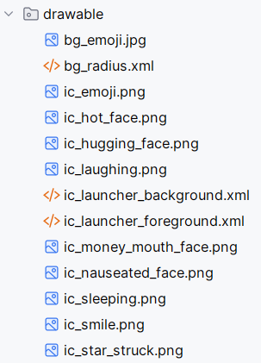

Xây dựng gio diện emoji_frag.xml

*<?*xml version="1.0" encoding="utf-8"*?>*<FrameLayout xmlns:android="http://schemas.android.com/apk/res/android"  
 xmlns:tools="http://schemas.android.com/tools"  
 android:layout_width="match_parent"  
 android:layout_height="match_parent"  
 android:orientation="vertical">  
  
 <ImageView  
 android:layout_width="wrap_content"  
 android:layout_height="match_parent"  
 android:scaleType="centerCrop"  
 android:src="@drawable/bg_emoji" />  
  
 <LinearLayout  
 android:layout_width="match_parent"  
 android:layout_height="match_parent"  
 android:background="#A6000000"  
 android:orientation="vertical"  
 android:paddingHorizontal="10dp"  
 android:paddingTop="30dp">  
  
 <TableRow  
 android:layout_width="match_parent"  
 android:layout_height="wrap_content"  
 android:gravity="center">  
  
 <ImageView  
 android:id="@+id/iv_face1"  
 android:layout_width="100dp"  
 android:layout_height="100dp"  
 android:background="@drawable/bg_radius"  
 android:padding="10dp"  
 android:src="@drawable/ic_sleeping"  
 tools:ignore="ContentDescription" />  
  
 <ImageView  
 android:id="@+id/iv_face2"  
 android:layout_width="100dp"  
 android:layout_height="100dp"  
 android:layout_marginStart="10dp"  
 android:background="@drawable/bg_radius"  
 android:padding="10dp"  
 android:src="@drawable/ic_hot_face"  
 tools:ignore="ContentDescription" />  
  
 <ImageView  
 android:id="@+id/iv_face3"  
 android:layout_width="100dp"  
 android:layout_height="100dp"  
 android:layout_marginStart="10dp"  
 android:background="@drawable/bg_radius"  
 android:padding="10dp"  
 android:src="@drawable/ic_nauseated_face"  
 tools:ignore="ContentDescription" />  
 </TableRow>  
  
 <TableRow  
 android:layout_width="match_parent"  
 android:layout_height="wrap_content"  
 android:layout_marginTop="10dp"  
 android:gravity="center">  
  
 <ImageView  
 android:id="@+id/iv_face4"  
 android:layout_width="100dp"  
 android:layout_height="100dp"  
 android:background="@drawable/bg_radius"  
 android:padding="10dp"  
 android:src="@drawable/ic_hugging_face"  
 tools:ignore="ContentDescription" />  
  
 <ImageView  
 android:id="@+id/iv_face5"  
 android:layout_width="100dp"  
 android:layout_height="100dp"  
 android:layout_marginStart="10dp"  
 android:background="@drawable/bg_radius"  
 android:padding="10dp"  
 android:src="@drawable/ic_money_mouth_face"  
 tools:ignore="ContentDescription" />  
  
 <ImageView  
 android:id="@+id/iv_face6"  
 android:layout_width="100dp"  
 android:layout_height="100dp"  
 android:layout_marginStart="10dp"  
 android:background="@drawable/bg_radius"  
 android:padding="10dp"  
 android:src="@drawable/ic_star_struck"  
 tools:ignore="ContentDescription" />  
 </TableRow>  
  
 <TableRow  
 android:layout_width="match_parent"  
 android:layout_height="wrap_content"  
 android:layout_marginTop="10dp"  
 android:gravity="center">  
  
 <ImageView  
 android:id="@+id/iv_face7"  
 android:layout_width="100dp"  
 android:layout_height="100dp"  
 android:background="@drawable/bg_radius"  
 android:padding="10dp"  
 android:src="@drawable/ic_laughing"  
 tools:ignore="ContentDescription" />  
  
 <ImageView  
 android:id="@+id/iv_face8"  
 android:layout_width="100dp"  
 android:layout_height="100dp"  
 android:layout_marginStart="10dp"  
 android:background="@drawable/bg_radius"  
 android:padding="10dp"  
 android:src="@drawable/ic_smile"  
 tools:ignore="ContentDescription" />  
  
 <ImageView  
 android:id="@+id/iv_face9"  
 android:layout_width="100dp"  
 android:layout_height="100dp"  
 android:layout_marginStart="10dp"  
 android:background="@drawable/bg_radius"  
 android:padding="10dp"  
 android:src="@drawable/ic_emoji"  
 tools:ignore="ContentDescription"/>  
 </TableRow>  
  
 </LinearLayout>  
   
</FrameLayout>

Thiết kế layout main_activity.xml

*<?*xml version="1.0" encoding="utf-8"*?>*<FrameLayout xmlns:android="http://schemas.android.com/apk/res/android"  
 android:layout_width="match_parent"  
 android:layout_height="match_parent"  
 android:orientation="vertical">  
 <fragment  
 android:id="@+id/frg_face_emoij"  
 class="com.example.lab2_bai2_3.FragmentFaceEmoij"  
 android:layout_width="match_parent"  
 android:layout_height="match_parent" />  
</FrameLayout>

### Thực hiện xử lý logic

Bước 1: Xử lý logic ở Activity

package com.example.lab2_bai2_3;  
  
import android.os.Bundle;  
import androidx.appcompat.app.AppCompatActivity;  
public class MainActivity extends AppCompatActivity {  
 @Override  
 protected void onCreate(Bundle savedInstanceState) {  
 super.onCreate(savedInstanceState);  
 setContentView(R.layout.*activity_main*);  
 }  
}

Bước 2: Xử lý logic ở FragmentFaceEmoji

package com.example.lab2_bai2_3;  
  
import android.content.Context;  
import android.graphics.drawable.Drawable;  
import android.os.Bundle;  
import android.view.LayoutInflater;  
import android.view.View;  
import android.view.ViewGroup;  
import android.widget.Button;  
import android.widget.ImageView;  
import android.widget.Toast;  
import androidx.fragment.app.Fragment;  
public class FragmentFaceEmoij extends Fragment implements View.OnClickListener {  
 private static final int[] *ids* = {R.id.*iv_face1*, R.id.*iv_face2*, R.id.*iv_face3*, R.id.*iv_face4*,  
 R.id.*iv_face5*, R.id.*iv_face6*, R.id.*iv_face7*, R.id.*iv_face8*, R.id.*iv_face9*};  
  
  
  
 private Context mContext;  
 @Override  
 public View onCreateView(LayoutInflater inflater, ViewGroup container,  
  
 Bundle savedInstanceState) {  
 View rootView = inflater.inflate(R.layout.*m001_frg_face_emoij*, container, false);  
 initViews(rootView);  
 return rootView;  
 }  
 @Override  
 public void onAttach(Context context) {  
 mContext = context;  
 super.onAttach(context);  
 }  
 private void initViews(View v) {  
 for (id : ids) {  
 v.findViewById(id).setOnClickListener(this);  
 }  
  
 }  
 @Override  
 public void onClick(View v) {  
 ImageView ivFace = (ImageView) v;  
 showToast(ivFace.getDrawable());  
 }  
 private void showToast(Drawable drawable) {  
 Toast toast = new Toast(mContext);  
 ImageView ivEmoij = new ImageView(mContext);  
 ivEmoij.setImageDrawable(drawable);  
 toast.setView(ivEmoij);  
 toast.show();  
 }  
  
   
}

Bước 3: Tiến hành cải tiến thêm button vào emoji

<Button  
 android:id="@+id/btn_random"  
 android:layout_width="wrap_content"  
 android:layout_height="wrap_content"  
 android:text="Random Emoji"  
 android:layout_gravity="center"  
 android:layout_marginTop="20dp"/>

Bước 4: Sau đó thêm danh sách drawable icon và hàm random và thêm sự kiện cho button

package com.example.lab2_bai2_3;  
  
import android.content.Context;  
import android.graphics.drawable.Drawable;  
import android.os.Bundle;  
import android.view.LayoutInflater;  
import android.view.View;  
import android.view.ViewGroup;  
import android.widget.Button;  
import android.widget.ImageView;  
import android.widget.Toast;  
import androidx.fragment.app.Fragment;  
public class FragmentFaceEmoij extends Fragment implements View.OnClickListener {  
 private static final int[] *ids* = {R.id.*iv_face1*, R.id.*iv_face2*, R.id.*iv_face3*, R.id.*iv_face4*,  
 R.id.*iv_face5*, R.id.*iv_face6*, R.id.*iv_face7*, R.id.*iv_face8*, R.id.*iv_face9*};  
  
 *// 10 icon* private static final int[] *allDrawables* = {  
 R.drawable.*ic_sleeping*,  
 R.drawable.*ic_hot_face*,  
 R.drawable.*ic_nauseated_face*,  
 R.drawable.*ic_hugging_face*,  
 R.drawable.*ic_money_mouth_face*,  
 R.drawable.*ic_star_struck*,  
 R.drawable.*ic_laughing*,  
 R.drawable.*ic_smile*,  
 R.drawable.*ic_emoji* };  
  
  
 private Context mContext;  
 @Override  
 public View onCreateView(LayoutInflater inflater, ViewGroup container,  
  
 Bundle savedInstanceState) {  
 View rootView = inflater.inflate(R.layout.*m001_frg_face_emoij*, container, false);  
 initViews(rootView);  
 return rootView;  
 }  
 @Override  
 public void onAttach(Context context) {  
 mContext = context;  
 super.onAttach(context);  
 }  
 private void initViews(View rootView) {  
 for (int i = 0; i < *ids*.length; i++) {  
 ImageView iv = rootView.findViewById(*ids*[i]);  
 iv.setImageResource(*allDrawables*[i % *allDrawables*.length]);  
 iv.setOnClickListener(this);  
 }  
  
 Button btnRandom = rootView.findViewById(R.id.*btn_random*);  
 btnRandom.setOnClickListener(v -> randomizeEmojis(rootView));  
 }  
 @Override  
 public void onClick(View v) {  
 ImageView ivFace = (ImageView) v;  
 showToast(ivFace.getDrawable());  
 }  
 private void showToast(Drawable drawable) {  
 Toast toast = new Toast(mContext);  
 ImageView ivEmoij = new ImageView(mContext);  
 ivEmoij.setImageDrawable(drawable);  
 toast.setView(ivEmoij);  
 toast.show();  
 }  
  
 private void randomizeEmojis(View rootView) {  
 for (int id : *ids*) {  
 ImageView iv = rootView.findViewById(id);  
 int randomIndex = (int) (Math.*random*() * *allDrawables*.length);  
 iv.setImageResource(*allDrawables*[randomIndex]);  
 }  
 }  
  
}

### Kết quả sau khi thực hiện

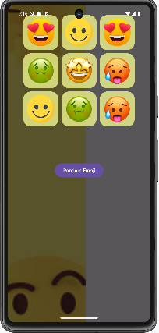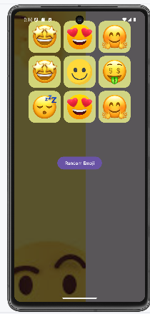

## Hiệu ứng

### Chuẩn bị tài nguyên cần thiết

Tài nguyên chuỗi values/strings.xml

<resources>  
 <string name="app_name">Animation</string>  
 <string name="txt_scale">Scale</string>  
 <string name="txt_trans">Trans</string>  
 <string name="txt_rotate">Rotate</string>  
 <string name="txt_alpha">Alpha</string>  
</resources>

Tài nguyên hình ảnh và icon và anim

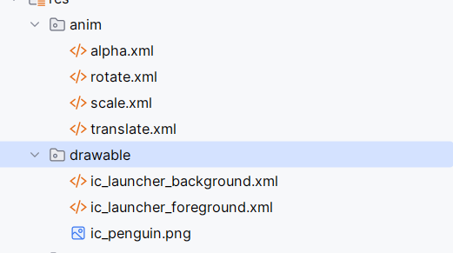

Xây dựng giao diện main_activity.xml

*<?*xml version="1.0" encoding="utf-8"*?>*<LinearLayout xmlns:android="http://schemas.android.com/apk/res/android"  
 xmlns:tools="http://schemas.android.com/tools"  
 android:layout_width="match_parent"  
 android:layout_height="match_parent"  
 android:gravity="center_horizontal"  
 android:orientation="vertical"  
 android:padding="20dp"  
 tools:context=".MainActivity">  
 <ImageView  
 android:id="@+id/iv_animal"  
 android:layout_width="128dp"  
 android:layout_height="128dp"  
 android:layout_marginTop="50dp"  
 android:src="@drawable/ic_penguin"  
 tools:ignore="ContentDescription" />  
 <TableRow  
 android:layout_width="match_parent"  
 android:layout_height="wrap_content"  
 android:layout_marginTop="200dp">  
 <Button  
 android:id="@+id/bt_alpha"  
 style="?android:attr/buttonBarStyle"  
 android:layout_width="0dp"  
 android:layout_height="wrap_content"  
 android:layout_weight="1"android:width="0dp"  
 android:backgroundTint="@color/design_default_color_primary"  
 android:text="@string/txt_alpha"  
 android:textAllCaps="true"  
 android:textColor="@color/white"  
 android:textSize="14sp" />  
 <Button  
 android:id="@+id/bt_scale"  
 style="?android:attr/buttonBarStyle"  
 android:layout_width="0dp"  
 android:layout_height="wrap_content"  
 android:layout_marginStart="5dp"  
 android:layout_weight="1"  
 android:width="0dp"  
 android:backgroundTint="@color/design_default_color_primary"  
 android:text="@string/txt_scale"  
 android:textAllCaps="true"  
 android:textSize="14sp" />  
 <Button  
 android:id="@+id/bt_trans"  
 style="?android:attr/buttonBarStyle"  
 android:layout_width="0dp"  
 android:layout_height="wrap_content"  
 android:layout_marginStart="5dp"  
 android:layout_weight="1"  
 android:width="0dp"  
 android:backgroundTint="@color/design_default_color_primary"  
 android:text="@string/txt_trans"  
 android:textAllCaps="true"  
 android:textSize="14sp" />  
 <Button  
 android:id="@+id/bt_rotate"  
 style="?android:attr/buttonBarStyle"  
 android:layout_width="0dp"  
 android:layout_height="wrap_content"  
 android:layout_marginStart="5dp"  
 android:layout_weight="1"  
 android:width="0dp"  
 android:backgroundTint="@color/design_default_color_primary"  
 android:text="@string/txt_rotate"  
 android:textAllCaps="true"  
 android:textSize="14sp" />  
 </TableRow>  
</LinearLayout>

### Thực hiện xử lý logic

Bước 1: Xử lý button trong MainActivity

package com.example.lab2_bai3_1;  
  
import android.os.Bundle;  
  
import androidx.appcompat.app.AppCompatActivity;  
  
import android.view.View;  
import android.view.animation.AnimationUtils;  
import android.widget.ImageView;  
public class MainActivity extends AppCompatActivity implements View.OnClickListener {  
 private ImageView ivAnimal;  
 @Override  
 protected void onCreate(Bundle savedInstanceState) {  
 super.onCreate(savedInstanceState);  
 setContentView(R.layout.*activity_main*);  
 initViews();  
 }  
 private void initViews() {  
 ivAnimal = findViewById(R.id.*iv_animal*);  
 findViewById(R.id.*bt_alpha*).setOnClickListener(this);  
 findViewById(R.id.*bt_rotate*).setOnClickListener(this);  
 findViewById(R.id.*bt_scale*).setOnClickListener(this);  
 findViewById(R.id.*bt_trans*).setOnClickListener(this);  
 }  
 @Override  
 public void onClick(View v) {  
 if (v.getId() == R.id.*bt_alpha*) {  
 ivAnimal.startAnimation(AnimationUtils.*loadAnimation*(this, R.anim.*alpha*));  
 } else if (v.getId() == R.id.*bt_rotate*) {  
 ivAnimal.startAnimation(AnimationUtils.*loadAnimation*(this, R.anim.*rotate*));  
 } else if (v.getId() == R.id.*bt_scale*) {  
 ivAnimal.startAnimation(AnimationUtils.*loadAnimation*(this, R.anim.*scale*));  
 } else if (v.getId() == R.id.*bt_trans*) {  
 ivAnimal.startAnimation(AnimationUtils.*loadAnimation*(this, R.anim.*translate*));  
 }  
 }  
}

Bước 2: Ta tiến hành Thêm bên dưới TableRow một button random cho bài tập

<Button  
 android:id="@+id/bt_random"  
 android:layout_width="wrap_content"  
 android:layout_height="wrap_content"  
 android:layout_marginTop="20dp"  
 android:text="Random"  
 android:backgroundTint="@color/design_default_color_primary"  
 android:textColor="@color/white" />

Bước 3: Sau đó tiến hành xử lý sự kiện nút button

private void runRandomAnimation() {  
 int choice = random.nextInt(4); *// 0..3* Animation anim;  
  
 switch (choice) {  
 case 0:  
 anim = AnimationUtils.*loadAnimation*(this, R.anim.*alpha*);  
 break;  
 case 1:  
 anim = AnimationUtils.*loadAnimation*(this, R.anim.*rotate*);  
 break;  
 case 2:  
 anim = AnimationUtils.*loadAnimation*(this, R.anim.*scale*);  
 break;  
 case 3:  
 default:  
 anim = AnimationUtils.*loadAnimation*(this, R.anim.*translate*);  
 break;  
 }  
  
 ivAnimal.startAnimation(anim);  
}

Bước 4: Thêm sự kiện vào nút button

btRandom = findViewById(R.id.bt_random);

btRandom.setOnClickListener(new View.OnClickListener() {

@Override

public void onClick(View v) {

runRandomAnimation();

}

});

### Kết quả sau khi thực hiện

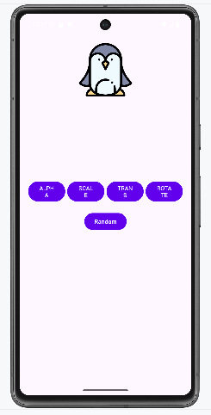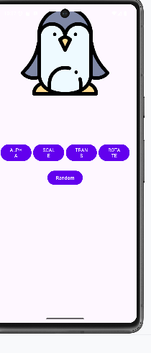

## Hiệu ứng điện thoại

### Chuẩn bị tài nguyên cần thiết

Tài nguyên chuỗi strings.xml

<resources>  
 <string name="app_name">Quick Call</string>  
 <string name="txt_mom">Mom</string>  
 <string name="txt_dad">Dad</string>  
 <string name="txt_crush">Crush</string>  
 <string name="txt_best_friend">Best friend</string>  
 <string name="phone_mom">096666543</string>  
 <string name="phone_dad">096666544</string>  
 <string name="phone_crush">096886543</string>  
 <string name="phone_best_friend">099966543</string>  
</resources>

Tài nguyên màu sắc colors.xml

*<?*xml version="1.0" encoding="utf-8"*?>*<resources>  
 <color name="purple_200">#FFBB86FC</color>  
 <color name="purple_500">#FF6200EE</color>  
 <color name="purple_700">#F4511E</color>  
 <color name="teal_200">#FF03DAC5</color>  
 <color name="teal_700">#FF018786</color>  
 <color name="black">#FF000000</color>  
 <color name="white">#FFFFFFFF</color>  
 <color name="orange">#FB8C00</color>  
 <color name="gray">#EAE5E3</color>  
 <color name="orangeMid">#F4511E</color>  
</resources>

Tài nguyên theme.xml

<resources xmlns:tools="http://schemas.android.com/tools"><style name="Theme.Lab2_BaiTap3_2" parent="Theme.MaterialComponents.DayNight.NoActionBar"><item name="colorPrimary">@color/purple_500</item>  
 <item name="colorPrimaryVariant">@color/purple_700</item>  
 <item name="colorOnPrimary">@color/white</item><item name="colorSecondary">@color/teal_200</item>  
 <item name="colorSecondaryVariant">@color/teal_700</item>  
 <item name="colorOnSecondary">@color/black</item><item name="android:statusBarColor" tools:targetApi="l">?attr/colorPrimaryVariant</item></style>  
 </resources>

Tài nguyên hình ảnh, icon

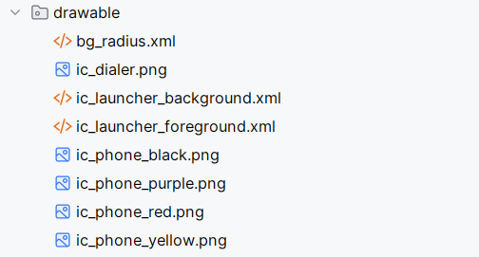

Tài nguyên animation 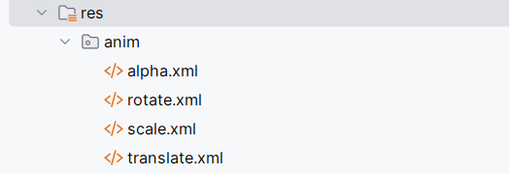

Xây dựng giao diện actionbar_home

*<?*xml version="1.0" encoding="utf-8"*?>*<LinearLayout xmlns:android="http://schemas.android.com/apk/res/android"  
 xmlns:app="http://schemas.android.com/apk/res-auto"  
 xmlns:tools="http://schemas.android.com/tools"  
 android:layout_width="match_parent"  
 android:layout_height="wrap_content"  
 android:background="@color/design_default_color_primary"  
 android:orientation="horizontal">  
  
 <TextView  
 android:layout_width="0dp"  
 android:layout_height="56dp"  
 android:layout_weight="1"  
 android:gravity="center_vertical"  
 android:paddingStart="16dp"  
 android:text="@string/app_name"  
 android:textColor="@color/white"  
 android:textSize="24sp"  
 tools:ignore="RtlSymmetry" />  
  
 <ImageView  
 android:id="@+id/iv_dialer"  
 android:layout_width="60dp"  
 android:layout_height="match_parent"  
 android:padding="10dp"  
 android:layout_marginEnd="10dp"  
 android:src="@drawable/ic_dialer"  
 app:tint="@color/white"  
 tools:ignore="ContentDescription" />  
</LinearLayout>

Xây dựng giao diện main_activity.xml

*<?*xml version="1.0" encoding="utf-8"*?>*<LinearLayout xmlns:android="http://schemas.android.com/apk/res/android"  
 xmlns:tools="http://schemas.android.com/tools"  
 android:layout_width="match_parent"  
 android:layout_height="match_parent"  
 android:orientation="vertical"  
 tools:context=".MainActivity">  
  
 <include layout="@layout/actionbar_home" />  
  
 <LinearLayout  
 android:layout_width="match_parent"  
 android:layout_height="match_parent"  
 android:gravity="center_vertical"  
 android:orientation="vertical"  
 android:padding="20dp">  
  
 <FrameLayout  
 android:id="@+id/fr_mom"  
 android:layout_width="match_parent"  
 android:layout_height="wrap_content"  
 android:background="@drawable/bg_radius"  
 android:backgroundTint="#FFD54F"  
 android:gravity="center_vertical"  
 android:padding="10dp"  
 android:tag="@string/phone_mom">  
 <ImageView  
 android:layout_width="60dp"  
 android:layout_height="60dp"  
 android:src="@drawable/ic_phone_yellow"  
 tools:ignore="ContentDescription" />  
 <TextView  
 android:layout_width="match_parent"  
 android:layout_height="wrap_content"  
 android:gravity="center"  
 android:text="@string/txt_mom"  
 android:textColor="@color/black"  
 android:textSize="40sp" />  
 </FrameLayout>  
  
 <FrameLayout  
 android:id="@+id/fr_dad"  
 android:layout_width="match_parent"  
 android:layout_height="wrap_content"  
 android:layout_marginTop="20dp"  
 android:background="@drawable/bg_radius"  
 android:backgroundTint="#B39DDB"  
 android:gravity="center_vertical"  
 android:padding="10dp"  
 android:tag="@string/phone_dad">  
 <ImageView  
 android:layout_width="60dp"  
 android:layout_height="60dp"  
 android:src="@drawable/ic_phone_purple"  
 tools:ignore="ContentDescription" />  
 <TextView  
 android:layout_width="match_parent"  
 android:layout_height="wrap_content"  
 android:gravity="center"  
 android:text="@string/txt_dad"  
 android:textColor="@color/black"  
 android:textSize="40sp" />  
 </FrameLayout>  
  
 <FrameLayout  
 android:id="@+id/fr_crush"  
 android:layout_width="match_parent"  
 android:layout_height="wrap_content"  
 android:layout_marginTop="20dp"  
 android:background="@drawable/bg_radius"  
 android:gravity="center_vertical"  
 android:padding="10dp"  
 android:tag="@string/phone_crush">  
 <ImageView  
 android:layout_width="60dp"  
 android:layout_height="60dp"  
 android:src="@drawable/ic_phone_red"  
 tools:ignore="ContentDescription" />  
 <TextView  
 android:layout_width="match_parent"  
 android:layout_height="wrap_content"  
 android:gravity="center"  
 android:text="@string/txt_crush"  
 android:textColor="@color/white"  
 android:textSize="40sp" />  
 </FrameLayout>  
  
 <FrameLayout  
 android:id="@+id/fr_best_friend"  
 android:layout_width="match_parent"  
 android:layout_height="wrap_content"  
 android:layout_marginTop="20dp"  
 android:background="@drawable/bg_radius"  
 android:backgroundTint="#9E9E9E"  
 android:gravity="center_vertical"  
 android:padding="10dp"  
 android:tag="@string/phone_best_friend">  
 <ImageView  
 android:layout_width="60dp"  
 android:layout_height="60dp"  
 android:src="@drawable/ic_phone_black"  
 tools:ignore="ContentDescription" />  
 <TextView  
 android:layout_width="match_parent"  
 android:layout_height="wrap_content"  
 android:gravity="center"  
 android:text="@string/txt_best_friend"  
 android:textColor="@color/black"  
 android:textSize="40sp" />  
</FrameLayout>  
  
 </LinearLayout>  
 </LinearLayout>

### Thực hiện xử lý Logic

Bước 1: Xử lý Logic ở MainActivity

package com.example.lab2_baitap3_2;  
  
import android.Manifest;  
import android.content.Intent;  
import android.content.pm.PackageManager;  
import android.net.Uri;  
import android.os.Bundle;  
import android.view.View;  
import android.view.animation.Animation;  
import android.view.animation.AnimationUtils;  
import android.widget.FrameLayout;  
import android.widget.Toast;  
  
import androidx.appcompat.app.AppCompatActivity;  
  
import java.util.Random;  
  
public class MainActivity extends AppCompatActivity implements View.OnClickListener {  
  
 private int[] anims = {  
 R.anim.*alpha*,  
 R.anim.*rotate*,  
 R.anim.*scale*,  
 R.anim.*translate* };  
 private Random random = new Random();  
  
 @Override  
 protected void onCreate(Bundle savedInstanceState) {  
 super.onCreate(savedInstanceState);  
 setContentView(R.layout.*activity_main*);  
 initView();  
 }  
  
 private void initView() {  
 findViewById(R.id.*fr_mom*).setOnClickListener(this);  
 findViewById(R.id.*fr_dad*).setOnClickListener(this);  
 findViewById(R.id.*fr_crush*).setOnClickListener(this);  
 findViewById(R.id.*fr_best_friend*).setOnClickListener(this);  
 findViewById(R.id.*iv_dialer*).setOnClickListener(this);  
 }  
  
 @Override  
 public void onClick(View v) {int animId = anims[random.nextInt(anims.length)];  
 Animation animation = AnimationUtils.*loadAnimation*(this, animId);  
 v.startAnimation(animation);  
  
 if (v instanceof FrameLayout) {  
 processCall((String) v.getTag());  
 } else {  
 gotoDialPad();  
 }  
 }  
  
 private void gotoDialPad() {  
 Intent intent = new Intent(Intent.*ACTION_DIAL*);  
 startActivity(intent);  
 }  
  
 private void processCall(String phone) {  
 if (checkSelfPermission(Manifest.permission.*CALL_PHONE*) != PackageManager.*PERMISSION_GRANTED*) {  
 requestPermissions(new String[]{Manifest.permission.*CALL_PHONE*}, 101);  
 Toast.*makeText*(this, "Hãy thực hiện lại sau khi cấp quyền!", Toast.*LENGTH_SHORT*).show();  
 return;  
 }  
 Intent intent = new Intent(Intent.*ACTION_CALL*);  
 intent.setData(Uri.*parse*("tel:" + phone));  
 startActivity(intent);  
 }  
}

### Kết quả sau khi thực hiện

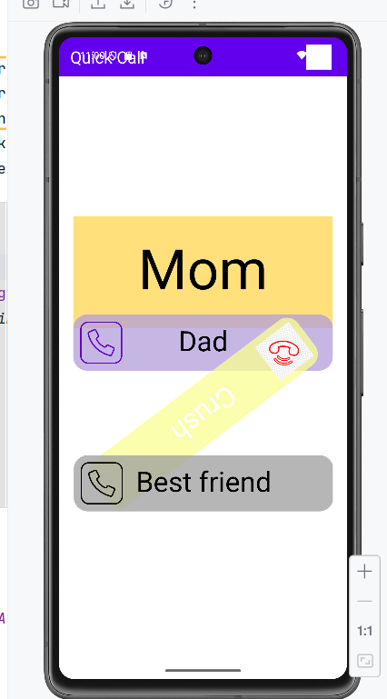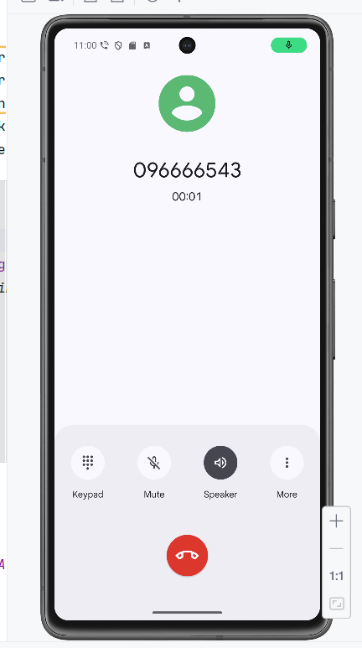

# 

## Xây dựng chương trình đổi tiền tệ

### Chuẩn bị tài nguyên cần thiết

Chuẩn bị tài nguyên chuỗi values/strings.xml

<resources>  
 <string name="author">Điền họ và tên của bạn</string>  
 <string name="computer">Điền tên máy đang dùng</string>  
 <string name="textbox_hint">Nhập số tiền</string>  
 <string name="app_name">Chương trình đổi tiền</string>  
 <string name="usd_name">American Dollar</string>  
 <string name="eur_name">European Cash</string>  
 <string name="gbp_name">Greate Britain</string>  
 <string name="aud_name">Australia Dollar</string>  
 <string name="cad_name">Canadian Dollar</string>  
 <string name="zar_name">South Africa Rand</string>  
 <string name="nzd_name">New Zealand Dollar</string>  
 <string name="vnd_name">Việt Nam Đồng</string>  
  
 <string name="inr_name">Indian Rupe</string>  
 <string name="jpy_name">Yên Nhật</string>  
 <string name="usd_unit">USD</string>  
 <string name="eur_unit">EUR</string>  
 <string name="gbp_unit">GBP</string>  
 <string name="inr_unit">INR</string>  
 <string name="aud_unit">AUD</string>  
 <string name="cad_unit">CAD</string>  
 <string name="zar_unit">ZAR</string>  
 <string name="nzd_unit">NZD</string>  
 <string name="jpy_unit">JPY</string>  
 <string name="vnd_unit">VND</string>  
</resources>

Xây dựng giao diện ứng dụng main_activity.xml

*<?*xml version="1.0" encoding="utf-8"*?>*<LinearLayout  
 xmlns:android="http://schemas.android.com/apk/res/android"  
 xmlns:tools="http://schemas.android.com/tools"  
 android:id="@+id/mainLayout"  
 android:layout_width="match_parent"  
 android:layout_height="match_parent"  
 android:orientation="vertical"  
 android:padding="16dp"  
 android:background="#FAFAFA"  
 tools:context=".MainActivity">  
 <LinearLayout  
 android:id="@+id/inputLayout"  
 android:layout_width="match_parent"  
 android:layout_height="wrap_content"  
 android:orientation="horizontal"  
 android:gravity="center_vertical"  
 android:padding="8dp"  
 android:layout_marginTop="50dp">  
 <EditText  
 android:id="@+id/txtNumber"  
 android:layout_width="0dp"  
 android:layout_height="48dp"  
 android:layout_weight="1"  
 android:background="@android:drawable/edit_text"  
 android:padding="12dp"  
 android:textSize="16sp"  
 android:hint="@string/textbox_hint"  
 android:inputType="numberDecimal" />  
 <Spinner  
 android:id="@+id/spnUnit"  
 android:layout_width="0dp"  
 android:layout_height="48dp"  
 android:layout_weight="1"  
 android:paddingLeft="12dp"  
 android:paddingRight="12dp"  
 android:spinnerMode="dropdown" />  
 </LinearLayout><ScrollView  
 android:id="@+id/resultsScrollView"  
 android:layout_width="match_parent"  
 android:layout_height="match_parent">  
 <TableLayout  
 android:id="@+id/resultsTable"  
 android:layout_width="match_parent"  
 android:layout_height="wrap_content"  
 android:padding="8dp"><TableRow  
 android:id="@+id/rowUsd"  
 android:layout_width="match_parent"  
 android:layout_height="wrap_content"  
 android:gravity="center_vertical"  
 android:padding="6dp">  
 <TextView  
 android:id="@+id/flagUsd"  
 android:layout_width="wrap_content"  
 android:layout_height="wrap_content"  
 android:text="🇺🇸"  
 android:textSize="26sp" />  
 <TextView  
 android:id="@+id/unitUsd"  
 android:layout_width="0dp"  
 android:layout_height="wrap_content"  
 android:layout_weight="1"  
 android:paddingLeft="12dp"  
 android:text="USD 💵"  
 android:textSize="16sp" />  
 <TextView  
 android:id="@+id/lblUsd"  
 android:layout_width="wrap_content"  
 android:layout_height="wrap_content"  
 android:text="0"  
 android:textSize="16sp" />  
 </TableRow><TableRow  
 android:id="@+id/rowEur"  
 android:layout_width="match_parent"  
 android:layout_height="wrap_content"  
 android:gravity="center_vertical"  
 android:padding="6dp">  
 <TextView  
 android:id="@+id/flagEur"  
 android:layout_width="wrap_content"  
 android:layout_height="wrap_content"  
 android:text="🇪🇺"  
 android:textSize="26sp" />  
 <TextView  
 android:id="@+id/unitEur"  
 android:layout_width="0dp"  
 android:layout_height="wrap_content"  
 android:layout_weight="1"  
 android:paddingLeft="12dp"  
 android:text="EUR 💶"  
 android:textSize="16sp" />  
 <TextView  
 android:id="@+id/lblEur"  
 android:layout_width="wrap_content"  
 android:layout_height="wrap_content"  
 android:text="0"  
 android:textSize="16sp" />  
 </TableRow><TableRow  
 android:id="@+id/rowGbp"  
 android:layout_width="match_parent"  
 android:layout_height="wrap_content"  
 android:gravity="center_vertical"  
 android:padding="6dp">  
 <TextView  
 android:id="@+id/flagGbp"  
 android:layout_width="wrap_content"  
 android:layout_height="wrap_content"  
 android:text="🇬🇧"  
 android:textSize="26sp" />  
 <TextView  
 android:id="@+id/unitGbp"  
 android:layout_width="0dp"  
 android:layout_height="wrap_content"  
 android:layout_weight="1"  
 android:paddingLeft="12dp"  
 android:text="GBP 💷"  
 android:textSize="16sp" />  
 <TextView  
 android:id="@+id/lblGbp"  
 android:layout_width="wrap_content"  
 android:layout_height="wrap_content"  
 android:text="0"  
 android:textSize="16sp" />  
 </TableRow>  
  
 <TableRow  
 android:id="@+id/rowAud"  
 android:layout_width="match_parent"  
 android:layout_height="wrap_content"  
 android:gravity="center_vertical"  
 android:padding="6dp">  
 <TextView  
 android:id="@+id/flagAud"  
 android:layout_width="wrap_content"  
 android:layout_height="wrap_content"  
 android:text="🇦🇺"  
 android:textSize="26sp" />  
 <TextView  
 android:id="@+id/unitAud"  
 android:layout_width="0dp"  
 android:layout_height="wrap_content"  
 android:layout_weight="1"  
 android:paddingLeft="12dp"  
 android:text="AUD 💴"  
 android:textSize="16sp" />  
 <TextView  
 android:id="@+id/lblAud"  
 android:layout_width="wrap_content"  
 android:layout_height="wrap_content"  
 android:text="0"  
 android:textSize="16sp" />  
 </TableRow> <TableRow  
 android:id="@+id/rowCad"  
 android:layout_width="match_parent"  
 android:layout_height="wrap_content"  
 android:gravity="center_vertical"  
 android:padding="6dp">  
 <TextView  
 android:id="@+id/flagCad"  
 android:layout_width="wrap_content"  
 android:layout_height="wrap_content"  
 android:text="🇨🇦"  
 android:textSize="26sp" />  
 <TextView  
 android:id="@+id/unitCad"  
 android:layout_width="0dp"  
 android:layout_height="wrap_content"  
 android:layout_weight="1"  
 android:paddingLeft="12dp"  
 android:text="CAD 💰"  
 android:textSize="16sp" />  
 <TextView  
 android:id="@+id/lblCad"  
 android:layout_width="wrap_content"  
 android:layout_height="wrap_content"  
 android:text="0"  
 android:textSize="16sp" />  
 </TableRow>  
  
<TableRow  
 android:id="@+id/rowZar"  
 android:layout_width="match_parent"  
 android:layout_height="wrap_content"  
 android:gravity="center_vertical"  
 android:padding="6dp">  
 <TextView  
 android:id="@+id/flagZar"  
 android:layout_width="wrap_content"  
 android:layout_height="wrap_content"  
 android:text="🇿🇦"  
 android:textSize="26sp" />  
 <TextView  
 android:id="@+id/unitZar"  
 android:layout_width="0dp"  
 android:layout_height="wrap_content"  
 android:layout_weight="1"  
 android:paddingLeft="12dp"  
 android:text="ZAR 🪙"  
 android:textSize="16sp" />  
 <TextView  
 android:id="@+id/lblZar"  
 android:layout_width="wrap_content"  
 android:layout_height="wrap_content"  
 android:text="0"  
 android:textSize="16sp" />  
 </TableRow><TableRow  
 android:id="@+id/rowNzd"  
 android:layout_width="match_parent"  
 android:layout_height="wrap_content"  
 android:gravity="center_vertical"  
 android:padding="6dp">  
 <TextView  
 android:id="@+id/flagNzd"  
 android:layout_width="wrap_content"  
 android:layout_height="wrap_content"  
 android:text="🇳🇿"  
 android:textSize="26sp" />  
 <TextView  
 android:id="@+id/unitNzd"  
 android:layout_width="0dp"  
 android:layout_height="wrap_content"  
 android:layout_weight="1"  
 android:paddingLeft="12dp"  
 android:text="NZD 💱"  
 android:textSize="16sp" />  
 <TextView  
 android:id="@+id/lblNzd"  
 android:layout_width="wrap_content"  
 android:layout_height="wrap_content"  
 android:text="0"  
 android:textSize="16sp" />  
 </TableRow>  
<TableRow  
 android:id="@+id/rowInr"  
 android:layout_width="match_parent"  
 android:layout_height="wrap_content"  
 android:gravity="center_vertical"  
 android:padding="6dp">  
 <TextView  
 android:id="@+id/flagInr"  
 android:layout_width="wrap_content"  
 android:layout_height="wrap_content"  
 android:text="🇮🇳"  
 android:textSize="26sp" />  
 <TextView  
 android:id="@+id/unitInr"  
 android:layout_width="0dp"  
 android:layout_height="wrap_content"  
 android:layout_weight="1"  
 android:paddingLeft="12dp"  
 android:text="INR 🪙"  
 android:textSize="16sp" />  
 <TextView  
 android:id="@+id/lblInr"  
 android:layout_width="wrap_content"  
 android:layout_height="wrap_content"  
 android:text="0"  
 android:textSize="16sp" />  
 </TableRow><TableRow  
 android:id="@+id/rowJpy"  
 android:layout_width="match_parent"  
 android:layout_height="wrap_content"  
 android:gravity="center_vertical"  
 android:padding="6dp">  
 <TextView  
 android:id="@+id/flagJpy"  
 android:layout_width="wrap_content"  
 android:layout_height="wrap_content"  
 android:text="🇯🇵"  
 android:textSize="26sp" />  
 <TextView  
 android:id="@+id/unitJpy"  
 android:layout_width="0dp"  
 android:layout_height="wrap_content"  
 android:layout_weight="1"  
 android:paddingLeft="12dp"  
 android:text="JPY 💴"  
 android:textSize="16sp" />  
 <TextView  
 android:id="@+id/lblJpy"  
 android:layout_width="wrap_content"  
 android:layout_height="wrap_content"  
 android:text="0"  
 android:textSize="16sp" />  
 </TableRow>  
  
<TableRow  
 android:id="@+id/rowVnd"  
 android:layout_width="match_parent"  
 android:layout_height="wrap_content"  
 android:gravity="center_vertical"  
 android:padding="6dp">  
 <TextView  
 android:id="@+id/flagVnd"  
 android:layout_width="wrap_content"  
 android:layout_height="wrap_content"  
 android:text="🇻🇳"  
 android:textSize="26sp" />  
 <TextView  
 android:id="@+id/unitVnd"  
 android:layout_width="0dp"  
 android:layout_height="wrap_content"  
 android:layout_weight="1"  
 android:paddingLeft="12dp"  
 android:text="VND 🧧"  
 android:textSize="16sp" />  
 <TextView  
 android:id="@+id/lblVnd"  
 android:layout_width="wrap_content"  
 android:layout_height="wrap_content"  
 android:text="0"  
 android:textSize="16sp" />  
 </TableRow>  
 </TableLayout>  
 </ScrollView>  
</LinearLayout>

Chuẩn bị ma trận tỉ giá và, mảng mã quốc gia

private String[] units = {  
 "USD", "EUR", "GBP", "INR", "AUD",  
 "CAD", "ZAR", "NZD", "JPY", "VND"  
};  
  
private double[][] ratio = {  
 {1.00000, 0.80518, 0.64070, 63.3318, 1.21828, 1.16236, 11.7129, 1.29310, 118.337, 21385.7},  
 {1.24172, 1.00000, 0.79575, 78.6084, 1.51266, 1.44314, 14.5371, 1.60576, 146.927, 26561.8},  
 {1.56044, 1.25667, 1.00000, 98.7848, 1.90091, 1.81355, 18.2683, 2.01791, 184.638, 33374.9},  
 {0.01580, 0.01272, 0.01012, 1.00000, 0.01924, 0.01836, 0.18493, 0.02043, 1.86910, 337.811},  
 {0.82114, 0.66119, 0.52620, 52.0860, 1.00000, 0.95416, 9.61148, 1.06158, 97.1120, 17567.9},  
 {0.86059, 0.69296, 0.55148, 54.5885, 1.04804, 1.00000, 10.0732, 1.11258, 101.777, 18401.7},  
 {0.08541, 0.06877, 0.05473, 5.40852, 0.10398, 0.09924, 1.00000, 0.11037, 10.0996, 1825.87},  
 {0.77402, 0.62319, 0.49597, 49.0031, 0.94215, 0.89951, 9.06754, 1.00000, 91.5139, 16552.1},  
 {0.00846, 0.00681, 0.00542, 0.53547, 0.01030, 0.00983, 0.09908, 0.01093, 1.00000, 180.837},  
 {0.00005, 0.00004, 0.00003, 0.00296, 0.00006, 0.00005, 0.00055, 0.00006, 0.00553, 1.00000}  
};

### Thực hiện xử lý logic

Bước 1: Chuẩn bị các thành phần tương tác gồm Spinner, EditText và TextView

private EditText txtNumber;  
private Spinner spnUnits;  
private TextView[] lblResults;

Bước 2: Chuẩn bị hàm chuyển tiền tệ

private void changeMoneyUnit() {  
 int rowIdx = spnUnits.getSelectedItemPosition();  
  
 if (rowIdx < 0) rowIdx = 0;  
  
 String input = txtNumber.getText().toString();  
  
 if (input.isEmpty()) {  
 input = "0";  
 }  
 if (input.equals(".")) {  
 input = "0.";  
 }  
  
 double number = 0;  
 try {  
 number = Double.*valueOf*(input);  
 } catch (NumberFormatException e) {  
 number = 0;  
 }  
  
  
 for (int i = 0; i < lblResults.length; i++) {  
 double temp = number * ratio[rowIdx][i];  
  
 lblResults[i].setText(String.*valueOf*(temp));  
 }  
}

Bước 3: Khởi tạo các biến thành viên

txtNumber = (EditText) findViewById(R.id.*txtNumber*);  
spnUnits = (Spinner) findViewById(R.id.*spnUnit*);  
  
lblResults = new TextView[]{  
 (TextView) findViewById(R.id.*lblUsd*),  
 (TextView) findViewById(R.id.*lblEur*),  
 (TextView) findViewById(R.id.*lblGbp*),  
 (TextView) findViewById(R.id.*lblInr*),  
 (TextView) findViewById(R.id.*lblAud*),  
 (TextView) findViewById(R.id.*lblCad*),  
 (TextView) findViewById(R.id.*lblZar*),  
 (TextView) findViewById(R.id.*lblNzd*),  
 (TextView) findViewById(R.id.*lblJpy*),  
 (TextView) findViewById(R.id.*lblVnd*)  
};

Bước 4: Sau đó gán giá trị mã quốc gia vào Spinner khi nhấn vào Spinner sẽ chuyển đổi tiền tệ để hiển thị

ArrayAdapter<String> adapter = new ArrayAdapter<String>(  
 this,  
 android.R.layout.*simple_spinner_item*,  
 units  
);  
adapter.setDropDownViewResource(android.R.layout.*simple_list_item_1*);  
spnUnits.setAdapter(adapter);  
  
spnUnits.setOnItemSelectedListener(new AdapterView.OnItemSelectedListener() {  
 @Override  
 public void onItemSelected(AdapterView<?> arg0, View arg1, int arg2, long arg3) {  
 changeMoneyUnit();  
 }  
  
 @Override  
 public void onNothingSelected(AdapterView<?> arg0) {  
 }  
});  
  
txtNumber.addTextChangedListener(new TextWatcher() {  
 @Override  
 public void onTextChanged(CharSequence arg0, int arg1, int arg2, int arg3) {  
 changeMoneyUnit();  
 }  
  
 @Override  
 public void beforeTextChanged(CharSequence arg0, int arg1, int arg2, int arg3) {  
 }  
  
 @Override  
 public void afterTextChanged(Editable arg0) {  
 }  
});

### Kết quả sau khi thực hiện

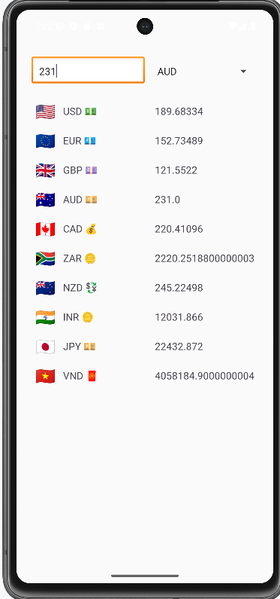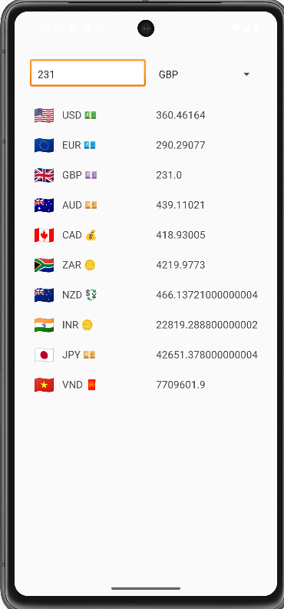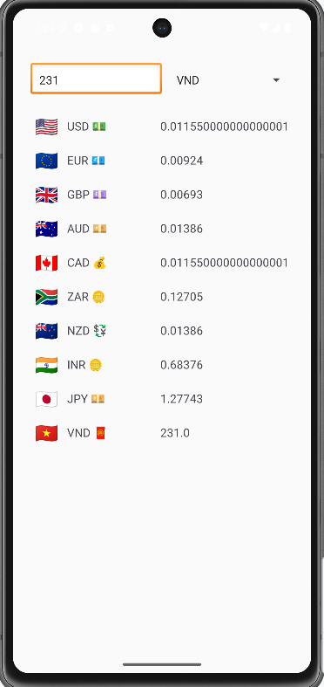

## Chuyển đổi đơn vị

### Chuẩn bị tài nguyên cần thiết

Chuẩn bị tài nguyên chuỗi values/strings.xml

<resources>  
 <string name="app_name">Đổi Đơn Vị</string>  
 <string name="textbox_hint">Nhập giá trị</string>  
  
 <string name="unit_nautical_mile">Hải lý</string>  
 <string name="unit_mile">Dặm</string>  
 <string name="unit_kilometer">Kilometer</string>  
 <string name="unit_li">Lý</string>  
 <string name="unit_meter">Met</string>  
 <string name="unit_yard">Yard</string>  
 <string name="unit_foot">Foot</string>  
 <string name="unit_inch">Inches</string>  
</resources>

Xây dựng giao diện ứng dụng activity_main.xml

*<?*xml version="1.0" encoding="utf-8"*?>*<LinearLayout  
 xmlns:android="http://schemas.android.com/apk/res/android"  
 xmlns:tools="http://schemas.android.com/tools"  
 android:id="@+id/main"  
 android:layout_width="match_parent"  
 android:layout_height="match_parent"  
 android:orientation="vertical"  
 android:background="#FAFAFA"  
 tools:context=".MainActivity">  
  
 <LinearLayout  
 android:id="@+id/inputLayout"  
 android:layout_width="match_parent"  
 android:layout_height="wrap_content"  
 android:orientation="horizontal"  
 android:gravity="center_vertical"  
 android:padding="16dp"  
 android:layout_marginTop="50dp">  
  
 <EditText  
 android:id="@+id/txtNumber"  
 android:layout_width="0dp"  
 android:layout_height="48dp"  
 android:layout_weight="1"  
 android:hint="@string/textbox_hint"  
 android:inputType="numberDecimal"  
 android:textSize="16sp"  
 android:padding="12dp"  
 android:background="@android:drawable/edit_text" />  
  
 <Spinner  
 android:id="@+id/spnUnit"  
 android:layout_width="0dp"  
 android:layout_height="48dp"  
 android:layout_weight="1"  
 android:paddingLeft="12dp"  
 android:paddingRight="12dp"  
 android:spinnerMode="dropdown" />  
 </LinearLayout>  
  
 <ScrollView  
 android:id="@+id/resultsScrollView"  
 android:layout_width="match_parent"  
 android:layout_height="match_parent">  
  
 <TableLayout  
 android:id="@+id/resultsTable"  
 android:layout_width="match_parent"  
 android:layout_height="wrap_content"  
 android:padding="8dp">  
  
 <TableRow  
 android:layout_width="match_parent"  
 android:layout_height="wrap_content"  
 android:background="#00695C">  
  
 <TextView  
 android:layout_width="match_parent"  
 android:layout_height="wrap_content"  
 android:text="Tương đương với"  
 android:textColor="#FFFFFF"  
 android:textSize="18sp"  
 android:padding="10dp"  
 android:layout_span="1"/>  
 </TableRow>  
  
 <TableRow  
 android:id="@+id/rowNauticalMile"  
 android:layout_width="match_parent"  
 android:layout_height="wrap_content"  
 android:gravity="center_vertical"  
 android:padding="10dp">  
  
 <TextView  
 android:id="@+id/lblNauticalMile"  
 android:layout_width="0dp"  
 android:layout_height="wrap_content"  
 android:layout_weight="1"  
 android:textSize="16sp"  
 android:textColor="#000000"  
 android:text="0.0"/>  
  
 <TextView  
 android:id="@+id/unitNauticalMile"  
 android:layout_width="wrap_content"  
 android:layout_height="wrap_content"  
 android:textSize="16sp"  
 android:textColor="#333333"  
 android:text="@string/unit_nautical_mile"/>  
 </TableRow>  
  
 <TableRow  
 android:id="@+id/rowMile"  
 android:layout_width="match_parent"  
 android:layout_height="wrap_content"  
 android:gravity="center_vertical"  
 android:padding="10dp">  
  
 <TextView  
 android:id="@+id/lblMile"  
 android:layout_width="0dp"  
 android:layout_height="wrap_content"  
 android:layout_weight="1"  
 android:textSize="16sp"  
 android:textColor="#000000"  
 android:text="0.0"/>  
  
 <TextView  
 android:id="@+id/unitMile"  
 android:layout_width="wrap_content"  
 android:layout_height="wrap_content"  
 android:textSize="16sp"  
 android:textColor="#333333"  
 android:text="@string/unit_mile"/>  
 </TableRow>  
  
 <TableRow  
 android:id="@+id/rowKilometer"  
 android:layout_width="match_parent"  
 android:layout_height="wrap_content"  
 android:gravity="center_vertical"  
 android:padding="10dp">  
  
 <TextView  
 android:id="@+id/lblKilometer"  
 android:layout_width="0dp"  
 android:layout_height="wrap_content"  
 android:layout_weight="1"  
 android:textSize="16sp"  
 android:textColor="#000000"  
 android:text="0.0"/>  
  
 <TextView  
 android:id="@+id/unitKilometer"  
 android:layout_width="wrap_content"  
 android:layout_height="wrap_content"  
 android:textSize="16sp"  
 android:textColor="#333333"  
 android:text="@string/unit_kilometer"/>  
 </TableRow>  
  
 <TableRow  
 android:id="@+id/rowLi"  
 android:layout_width="match_parent"  
 android:layout_height="wrap_content"  
 android:gravity="center_vertical"  
 android:padding="10dp">  
  
 <TextView  
 android:id="@+id/lblLi"  
 android:layout_width="0dp"  
 android:layout_height="wrap_content"  
 android:layout_weight="1"  
 android:textSize="16sp"  
 android:textColor="#000000"  
 android:text="0.0"/>  
  
 <TextView  
 android:id="@+id/unitLi"  
 android:layout_width="wrap_content"  
 android:layout_height="wrap_content"  
 android:textSize="16sp"  
 android:textColor="#333333"  
 android:text="@string/unit_li"/>  
 </TableRow>  
  
 <TableRow  
 android:id="@+id/rowMeter"  
 android:layout_width="match_parent"  
 android:layout_height="wrap_content"  
 android:gravity="center_vertical"  
 android:padding="10dp">  
  
 <TextView  
 android:id="@+id/lblMeter"  
 android:layout_width="0dp"  
 android:layout_height="wrap_content"  
 android:layout_weight="1"  
 android:textSize="16sp"  
 android:textColor="#000000"  
 android:text="0.0"/>  
  
 <TextView  
 android:id="@+id/unitMeter"  
 android:layout_width="wrap_content"  
 android:layout_height="wrap_content"  
 android:textSize="16sp"  
 android:textColor="#333333"  
 android:text="@string/unit_meter"/>  
 </TableRow>  
  
 <TableRow  
 android:id="@+id/rowYard"  
 android:layout_width="match_parent"  
 android:layout_height="wrap_content"  
 android:gravity="center_vertical"  
 android:padding="10dp">  
  
 <TextView  
 android:id="@+id/lblYard"  
 android:layout_width="0dp"  
 android:layout_height="wrap_content"  
 android:layout_weight="1"  
 android:textSize="16sp"  
 android:textColor="#000000"  
 android:text="0.0"/>  
  
 <TextView  
 android:id="@+id/unitYard"  
 android:layout_width="wrap_content"  
 android:layout_height="wrap_content"  
 android:textSize="16sp"  
 android:textColor="#333333"  
 android:text="@string/unit_yard"/>  
 </TableRow>  
  
 <TableRow  
 android:id="@+id/rowFoot"  
 android:layout_width="match_parent"  
 android:layout_height="wrap_content"  
 android:gravity="center_vertical"  
 android:padding="10dp">  
  
 <TextView  
 android:id="@+id/lblFoot"  
 android:layout_width="0dp"  
 android:layout_height="wrap_content"  
 android:layout_weight="1"  
 android:textSize="16sp"  
 android:textColor="#000000"  
 android:text="0.0"/>  
  
 <TextView  
 android:id="@+id/unitFoot"  
 android:layout_width="wrap_content"  
 android:layout_height="wrap_content"  
 android:textSize="16sp"  
 android:textColor="#333333"  
 android:text="@string/unit_foot"/>  
 </TableRow>  
  
 <TableRow  
 android:id="@+id/rowInch"  
 android:layout_width="match_parent"  
 android:layout_height="wrap_content"  
 android:gravity="center_vertical"  
 android:padding="10dp">  
  
 <TextView  
 android:id="@+id/lblInch"  
 android:layout_width="0dp"  
 android:layout_height="wrap_content"  
 android:layout_weight="1"  
 android:textSize="16sp"  
 android:textColor="#000000"  
 android:text="0.0"/>  
  
 <TextView  
 android:id="@+id/unitInch"  
 android:layout_width="wrap_content"  
 android:layout_height="wrap_content"  
 android:textSize="16sp"  
 android:textColor="#333333"  
 android:text="@string/unit_inch"/>  
 </TableRow>  
  
 </TableLayout>  
 </ScrollView>  
  
</LinearLayout>

Chuẩn bị ma trận tỉ lệ độ dài và, mảng mã độ dài

private String[] units = {  
 "Hải lý", "Dặm", "Km","Lý","Met","Yard","Foot","Inch"  
};  
private double[][] ratio = {  
 {1, 1.15077945, 1.852, 20.2537183, 1852, 2025.37183, 6076.11549, 72913.38583},  
 {0.86897624, 1, 1.609344, 17.6, 1609.344, 1760, 5280, 63360},  
 {0.53995680, 0.62137119, 1, 10.936133, 1000, 1093.61330, 3280.83990, 39370.07874},  
 {0.04937365, 0.05681818, 0.09144, 1, 91.44, 100, 300, 3600},  
 {0.00053996, 0.00062137, 0.001, 0.0109361, 1, 1.09361, 3.28084, 39.37008},  
 {0.00049374, 0.00056818, 0.0009144, 0.01, 0.9144, 1, 3, 36},  
 {0.00016458, 0.00018939, 0.0003048, 0.0033333, 0.3048, 0.33333, 1, 12},  
 {0.00001371, 0.00001578, 0.0000254, 0.0002778, 0.0254, 0.02778, 0.08333, 1}  
};

### Thực hiện xử lý Logic

Bước 1: Chuẩn bị các thành phần tương tác gồm Spinner, EditText và TextView

private EditText txtNumber;  
private Spinner spnUnits;  
private TextView[] lblResults;

Bước 2: Chuẩn bị hàm chuyển độ dài

private void changeLengthUnit() {  
 int rowIdx = spnUnits.getSelectedItemPosition();  
  
 if (rowIdx < 0) rowIdx = 0;  
  
 String input = txtNumber.getText().toString();  
  
 if (input.isEmpty()) {  
 input = "0";  
 }  
 if (input.equals(".")) {  
 input = "0.";  
 }  
  
 double number = 0;  
 try {  
 number = Double.*valueOf*(input);  
 } catch (NumberFormatException e) {  
 number = 0;  
 }  
  
 for (int i = 0; i < lblResults.length; i++) {  
 double temp = number * ratio[rowIdx][i];  
 lblResults[i].setText(String.*valueOf*(temp));  
 }  
}

Bước 3: Khởi tạo các biến thành viên

txtNumber = (EditText) findViewById(R.id.*txtNumber*);  
spnUnits = (Spinner) findViewById(R.id.*spnUnit*);  
  
lblResults = new TextView[]{  
 (TextView) findViewById(R.id.*lblNauticalMile*),  
 (TextView) findViewById(R.id.*lblMile*),  
 (TextView) findViewById(R.id.*lblKilometer*),  
 (TextView) findViewById(R.id.*lblLi*),  
 (TextView) findViewById(R.id.*lblMeter*),  
 (TextView) findViewById(R.id.*lblYard*),  
 (TextView) findViewById(R.id.*lblFoot*),  
 (TextView) findViewById(R.id.*lblInch*)  
};

Bước 4: Sau đó gán giá trị mã độ dài vào Spinner khi nhấn vào Spinner sẽ chuyển đổi độ dài để hiển thị

ArrayAdapter<String> adapter = new ArrayAdapter<String>(  
 this,  
 android.R.layout.*simple_spinner_item*,  
 units  
);  
adapter.setDropDownViewResource(android.R.layout.*simple_list_item_1*);  
spnUnits.setAdapter(adapter);  
  
spnUnits.setOnItemSelectedListener(new AdapterView.OnItemSelectedListener() {  
 @Override  
 public void onItemSelected(AdapterView<?> arg0, View arg1, int arg2, long arg3) {  
 changeLengthUnit();  
 }  
  
 @Override  
 public void onNothingSelected(AdapterView<?> arg0) { }  
});  
  
  
txtNumber.addTextChangedListener(new TextWatcher() {  
 @Override  
 public void onTextChanged(CharSequence arg0, int arg1, int arg2, int arg3) {  
 changeLengthUnit();  
 }  
  
 @Override  
 public void beforeTextChanged(CharSequence arg0, int arg1, int arg2, int arg3) { }  
  
 @Override  
 public void afterTextChanged(Editable arg0) { }  
});

### Kết quả sau khi thực hiện

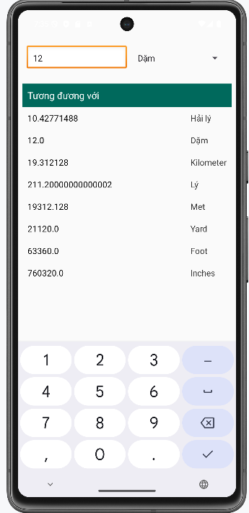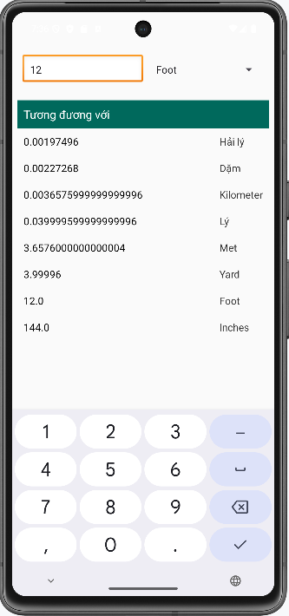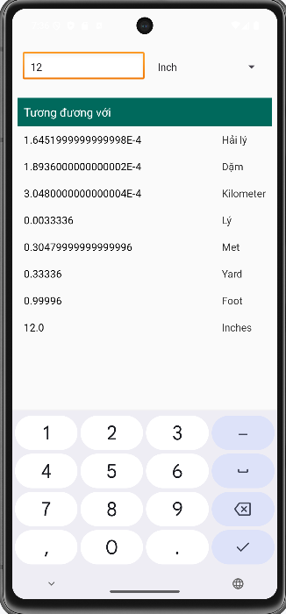

## Custom Button phần 1

### Chuẩn bị tài nguyên cần thiết

Chuẩn bị tài nguyên màu sắc values/colors.xml

*<?*xml version="1.0" encoding="utf-8"*?>*<resources>  
 <color name="colorPrimary">#3F51B5</color>  
 <color name="colorPrimaryDark">#303F9F</color>  
 <color name="colorAccent">#FF4081</color>  
 <color name="green">#00FF00</color>  
 <color name="red">#BB0000</color>  
 <color name="yellow">#FFFF00</color>  
 <color name="jd_red">#CB0000</color>  
 <color name="jd_light">#E5001F</color>  
</resources>

Xây dựng giao diện ứng dụng chưa trang trí vào drawable

btn_bg_selector.xml

*<?*xml version="1.0" encoding="utf-8"*?>*<selector xmlns:android="http://schemas.android.com/apk/res/android">  
 <item android:state_pressed="true" android:drawable="@color/red"/>  
 <item android:state_focused="true" android:drawable="@color/yellow"/>  
 <item android:drawable="@color/green"/>  
</selector>

btn_bg_selector_disabled.xml

*<?*xml version="1.0" encoding="utf-8"*?>*<selector xmlns:android="http://schemas.android.com/apk/res/android">  
 <item android:state_enabled="false" android:drawable="@color/yellow"/>  
 <item android:state_pressed="true" android:drawable="@color/red"/>  
 <item android:drawable="@color/green"/>  
</selector>

btn_drawable_selector.xml

*<?*xml version="1.0" encoding="utf-8"*?>*<selector xmlns:android="http://schemas.android.com/apk/res/android">  
 <item android:state_pressed="true" android:drawable="@drawable/sad" />  
 <item android:state_focused="true" android:drawable="@drawable/happy" />  
 <item android:drawable="@drawable/happy" />  
</selector>

btn_txt_selector

*<?*xml version="1.0" encoding="utf-8"*?>*<selector xmlns:android="http://schemas.android.com/apk/res/android">  
 <item android:state_pressed="true" android:color="@color/red"/>  
 <item android:state_focused="true" android:color="@color/yellow"/>  
 <item android:color="@color/green"/>  
</selector>

Xây dựng giao diện ứng dụng đã trang trí vào drawable

Btn_shape_round.xml

*<?*xml version="1.0" encoding="utf-8"*?>*<shape xmlns:android="http://schemas.android.com/apk/res/android"  
 android:padding="16dp"  
 android:shape="rectangle">  
 <stroke  
 android:width="1dp"  
 android:color="@android:color/black" />  
 <corners android:radius="10dp" />  
</shape>

btn_shape_gradient.xml

*<?*xml version="1.0" encoding="utf-8"*?>*<shape xmlns:android="http://schemas.android.com/apk/res/android"  
 android:shape="rectangle">  
  
 <gradient  
 android:endColor="@color/green"  
 android:gradientRadius="30dp"  
 android:type="radial"  
 android:startColor="@color/yellow" />  
  
 <corners android:radius="20dp" />  
  
 <stroke  
 android:width="4dp"  
 android:color="@android:color/black" />  
  
</shape>

btn_selector_shape.xml

*<?*xml version="1.0" encoding="utf-8"*?>*<selector xmlns:android="http://schemas.android.com/apk/res/android">  
 <item android:state_pressed="true">  
  
 <shape android:shape="oval">  
 <gradient android:angle="135" android:endColor="@color/jd_red" android:startColor="@color/green" />  
 <corners android:radius="20dp" />  
 <stroke android:width="2dp" android:color="@android:color/black" />  
 </shape>  
  
 </item>  
  
 <item>  
 <shape android:shape="rectangle">  
 <gradient android:angle="225" android:endColor="@color/green" android:startColor="@color/jd_red" />  
 <corners android:radius="20dp" />  
 <stroke android:width="4dp" android:color="@android:color/black" />  
 </shape>  
  
 </item>  
</selector>

btn_drawable_selector.xml

*<?*xml version="1.0" encoding="utf-8"*?>*<selector xmlns:android="http://schemas.android.com/apk/res/android">  
 <item android:state_pressed="true" android:drawable="@drawable/sad" />  
 <item android:state_focused="true" android:drawable="@drawable/happy" />  
 <item android:drawable="@drawable/happy" />  
</selector>

btn_txt_selector.xml

*<?*xml version="1.0" encoding="utf-8"*?>*<selector xmlns:android="http://schemas.android.com/apk/res/android">  
 <item android:state_pressed="true" android:color="@color/red"/>  
 <item android:state_focused="true" android:color="@color/yellow"/>  
 <item android:color="@color/green"/>  
</selector>

Xây dựng giao diện ở activity_main.xml

*<?*xml version="1.0" encoding="utf-8"*?>*<LinearLayout xmlns:android="http://schemas.android.com/apk/res/android"  
 android:layout_width="match_parent"  
 android:layout_height="match_parent"  
 android:gravity="center_vertical"  
 android:orientation="horizontal"  
 android:weightSum="2"  
 android:id="@+id/main">  
  
  
 <LinearLayout  
 android:layout_width="0dp"  
 android:layout_height="wrap_content"  
 android:layout_weight="1"  
 android:gravity="center"  
 android:orientation="vertical">  
  
  
 <TextView  
 android:layout_width="wrap_content"  
 android:layout_height="wrap_content"  
 android:text="Selectors"  
 android:textColor="@android:color/black"  
 android:textSize="18sp"  
 android:textStyle="bold|italic" />  
  
  
 <Button  
 android:id="@+id/btnBgSelector"  
 android:layout_width="wrap_content"  
 android:layout_height="wrap_content"  
 android:layout_margin="8dp"  
 android:background="@drawable/btn_bg_selector"  
 android:padding="8dp"  
 android:text="Colored Selector" />  
  
 <Button  
 android:id="@+id/btnBgSelectorDisabled"  
 android:layout_width="wrap_content"  
 android:layout_height="wrap_content"  
 android:layout_margin="8dp"  
 android:background="@drawable/btn_bg_selector_disabled"  
 android:enabled="false"  
 android:padding="8dp"  
 android:text="Color Selector Disabled" />  
  
 <Button  
 android:id="@+id/btnDrawableSelector"  
 android:layout_width="48dp"  
 android:layout_height="48dp"  
 android:layout_margin="8dp"  
 android:background="@drawable/btn_drawable_selector"  
 android:padding="16dp" />  
  
 <ImageButton  
 android:id="@+id/imgButton"  
 android:layout_width="wrap_content"  
 android:layout_height="wrap_content"  
 android:layout_margin="8dp"  
 android:background="@color/green"  
 android:padding="8dp"  
 android:scaleType="center"  
 android:src="@drawable/btn_drawable_selector" />  
  
 <Button  
 android:id="@+id/btnTxtSelector"  
 android:layout_width="wrap_content"  
 android:layout_height="wrap_content"  
 android:padding="8dp"  
 android:text="Text Selector"  
 android:textColor="@drawable/btn_txt_selector" />  
  
  
 </LinearLayout>  
  
  
 <LinearLayout  
 android:layout_width="0dp"  
 android:layout_height="wrap_content"  
 android:layout_weight="1"  
 android:gravity="center"  
 android:orientation="vertical">  
  
 <TextView  
 android:layout_width="wrap_content"  
 android:layout_height="wrap_content"  
 android:text="Shapes+Selectors"  
 android:textColor="@android:color/black"  
 android:textSize="18sp"  
 android:textStyle="bold|italic" />  
  
 <Button  
 android:id="@+id/btnRoundShape"  
 android:layout_width="wrap_content"  
 android:layout_height="wrap_content"  
 android:layout_margin="8dp"  
 android:background="@drawable/btn_shape_round"  
 android:padding="8dp"  
 android:text="ROUND SHAPE" />  
  
 <Button  
 android:id="@+id/btnBgShape"  
 android:layout_width="wrap_content"  
 android:layout_height="wrap_content"  
 android:background="@drawable/btn_shape_gradient"  
 android:padding="8dp"  
 android:text="SHAPE WITH GRADIENT" />  
  
  
 <Button  
 android:id="@+id/btnSelectorShape"  
 android:layout_width="wrap_content"  
 android:layout_height="wrap_content"  
 android:layout_margin="8dp"  
 android:background="@drawable/btn_selector_shape"  
 android:padding="8dp"  
 android:text="SELECTOR SHAPE" />  
  
  
 <ImageButton  
 android:layout_width="wrap_content"  
 android:layout_height="wrap_content"  
 android:layout_margin="8dp"  
 android:background="@drawable/btn_shape_gradient"  
 android:padding="8dp"  
 android:scaleType="center"  
 android:src="@drawable/btn_drawable_selector" />  
  
 <Button  
 android:layout_width="wrap_content"  
 android:layout_height="wrap_content"  
 android:layout_margin="8dp"  
 android:background="@drawable/btn_shape_capsule"  
 android:padding="8dp"  
 android:text="Text Selector"  
 android:textColor="@drawable/btn_txt_selector" />  
  
  
 </LinearLayout>  
  
  
</LinearLayout>

### Kết quả sau khi thực hiện

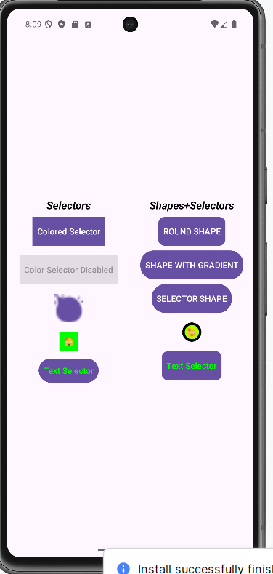

## Custom Button phần 2

### Chuẩn bị tài nguyên cần thiết

Tiếp tục với phần 1 tạo thêm 2 button vào bên dưới main activity_main

*<?*xml version="1.0" encoding="utf-8"*?>*<LinearLayout xmlns:android="http://schemas.android.com/apk/res/android"  
 xmlns:tools="http://schemas.android.com/tools"  
 android:id="@+id/main"  
 android:layout_width="match_parent"  
 android:layout_height="match_parent"  
 android:orientation="vertical"  
 android:padding="16dp"  
 tools:context=".MainActivity">  
  
 <LinearLayout  
 android:layout_width="match_parent"  
 android:layout_height="wrap_content"  
 android:gravity="center_vertical"  
 android:orientation="horizontal"  
 android:weightSum="2">  
  
 <LinearLayout  
 android:layout_width="0dp"  
 android:layout_height="wrap_content"  
 android:layout_weight="1"  
 android:gravity="center"  
 android:orientation="vertical">  
  
 <TextView  
 android:layout_width="wrap_content"  
 android:layout_height="wrap_content"  
 android:text="Selectors"  
 android:textColor="@android:color/black"  
 android:textSize="18sp"  
 android:textStyle="bold|italic" />  
  
 <Button  
 android:id="@+id/btnBgSelector"  
 android:layout_width="wrap_content"  
 android:layout_height="wrap_content"  
 android:layout_margin="8dp"  
 android:background="@drawable/btn_bg_selector"  
 android:padding="8dp"  
 android:text="Colored Selector" />  
  
 <Button  
 android:id="@+id/btnBgSelectorDisabled"  
 android:layout_width="wrap_content"  
 android:layout_height="wrap_content"  
 android:layout_margin="8dp"  
 android:background="@drawable/btn_bg_selector_disabled"  
 android:enabled="false"  
 android:padding="8dp"  
 android:text="Color Selector Disabled" />  
  
 <Button  
 android:id="@+id/btnDrawableSelector"  
 android:layout_width="48dp"  
 android:layout_height="48dp"  
 android:layout_margin="8dp"  
 android:background="@drawable/btn_drawable_selector"  
 android:padding="16dp" />  
  
 <ImageButton  
 android:id="@+id/imgButton"  
 android:layout_width="wrap_content"  
 android:layout_height="wrap_content"  
 android:layout_margin="8dp"  
 android:background="@color/green"  
 android:padding="8dp"  
 android:scaleType="center"  
 android:src="@drawable/btn_drawable_selector" />  
  
 <Button  
 android:id="@+id/btnTxtSelector"  
 android:layout_width="wrap_content"  
 android:layout_height="wrap_content"  
 android:padding="8dp"  
 android:text="Text Selector"  
 android:textColor="@drawable/btn_txt_selector" />  
  
 </LinearLayout>  
  
 <LinearLayout  
 android:layout_width="0dp"  
 android:layout_height="wrap_content"  
 android:layout_weight="1"  
 android:gravity="center"  
 android:orientation="vertical">  
  
 <TextView  
 android:layout_width="wrap_content"  
 android:layout_height="wrap_content"  
 android:text="Shapes+Selectors"  
 android:textColor="@android:color/black"  
 android:textSize="18sp"  
 android:textStyle="bold|italic" />  
  
 <Button  
 android:id="@+id/btnRoundShape"  
 android:layout_width="wrap_content"  
 android:layout_height="wrap_content"  
 android:layout_margin="8dp"  
 android:background="@drawable/btn_shape_round"  
 android:padding="8dp"  
 android:text="ROUND SHAPE" />  
  
 <Button  
 android:id="@+id/btnBgShape"  
 android:layout_width="wrap_content"  
 android:layout_height="wrap_content"  
 android:background="@drawable/btn_shape_gradient"  
 android:padding="8dp"  
 android:text="SHAPE WITH GRADIENT" />  
  
 <Button  
 android:id="@+id/btnSelectorShape"  
 android:layout_width="wrap_content"  
 android:layout_height="wrap_content"  
 android:layout_margin="8dp"  
 android:background="@drawable/btn_selector_shape"  
 android:padding="8dp"  
 android:text="SELECTOR SHAPE" />  
  
 <ImageButton  
 android:layout_width="wrap_content"  
 android:layout_height="wrap_content"  
 android:layout_margin="8dp"  
 android:background="@drawable/btn_shape_gradient"  
 android:padding="8dp"  
 android:scaleType="center"  
 android:src="@drawable/btn_drawable_selector" />  
  
 <Button  
 android:layout_width="wrap_content"  
 android:layout_height="wrap_content"  
 android:layout_margin="8dp"  
 android:background="@drawable/btn_shape_capsule"  
 android:padding="8dp"  
 android:text="Text Selector"  
 android:textColor="@drawable/btn_txt_selector" />  
  
 </LinearLayout>  
 </LinearLayout>  
  
 <Button  
 android:id="@+id/buttonShowCustomDialog"  
 android:layout_width="wrap_content"  
 android:layout_height="wrap_content"  
 android:layout_gravity="center_horizontal"  
 android:layout_marginTop="24dp"  
 android:text="Show Custom Dialog" />  
 <Button  
 android:id="@+id/buttonShowCustomToast"  
 android:layout_width="wrap_content"  
 android:layout_height="wrap_content"  
 android:layout_gravity="center_horizontal"  
 android:layout_marginTop="24dp"  
 android:text="Show Custom Toast" />  
</LinearLayout>

Sau đó tiến hành chuẩn bị custom_dialog

*<?*xml version="1.0" encoding="utf-8"*?>*<LinearLayout xmlns:android="http://schemas.android.com/apk/res/android"  
 android:layout_width="300dp" android:layout_height="wrap_content"  
 android:orientation="vertical"  
 android:padding="16dp"  
 android:background="@drawable/dialog_background_rounded"> <LinearLayout  
 android:layout_width="match_parent"  
 android:layout_height="wrap_content"  
 android:orientation="horizontal"  
 android:gravity="center_vertical"  
 android:layout_marginBottom="16dp">  
  
 <ImageView  
 android:layout_width="32dp"  
 android:layout_height="32dp"  
 android:src="@drawable/ic_home_red" android:contentDescription="Home Icon"/>  
  
 <TextView  
 android:layout_width="wrap_content"  
 android:layout_height="wrap_content"  
 android:text="Đăng nhập"  
 android:textSize="20sp"  
 android:textColor="#F44336" android:textStyle="bold"  
 android:layout_marginLeft="8dp"/>  
</LinearLayout>  
  
 <LinearLayout  
 android:layout_width="match_parent"  
 android:layout_height="wrap_content"  
 android:orientation="horizontal"  
 android:gravity="center_vertical"  
 android:layout_marginBottom="10dp">  
  
 <TextView  
 android:layout_width="wrap_content"  
 android:layout_height="wrap_content"  
 android:text="Tài khoản"  
 android:textSize="16sp"  
 android:textColor="#000000"/>  
  
 <EditText  
 android:id="@+id/edtUsername"  
 android:layout_width="0dp"  
 android:layout_height="wrap_content"  
 android:layout_weight="1"  
 android:layout_marginLeft="16dp"  
 android:backgroundTint="#FF4081" android:text="admin"  
 android:textSize="16sp"  
 android:textColor="#000000"  
 android:inputType="text"  
 android:maxLines="1"/>  
 </LinearLayout>  
  
 <LinearLayout  
 android:layout_width="match_parent"  
 android:layout_height="wrap_content"  
 android:orientation="horizontal"  
 android:gravity="center_vertical"  
 android:layout_marginBottom="24dp">  
  
 <TextView  
 android:layout_width="wrap_content"  
 android:layout_height="wrap_content"  
 android:text="Mật khẩu"  
 android:textSize="16sp"  
 android:textColor="#000000"/>  
  
 <EditText  
 android:id="@+id/edtPassword"  
 android:layout_width="0dp"  
 android:layout_height="wrap_content"  
 android:layout_weight="1"  
 android:layout_marginLeft="24dp"  
 android:backgroundTint="#FF4081" android:text="*********"  
 android:textSize="16sp"  
 android:textColor="#000000"  
 android:inputType="textPassword"  
 android:maxLines="1"/>  
 </LinearLayout>  
  
 <LinearLayout  
 android:layout_width="match_parent"  
 android:layout_height="wrap_content"  
 android:orientation="horizontal"  
 android:gravity="end"> <Button  
 android:id="@+id/btnAgree"  
 android:layout_width="wrap_content"  
 android:layout_height="wrap_content"  
 android:text="ĐỒNG Ý"  
 android:textColor="#FFFFFF"  
 android:textSize="14sp"  
 android:background="@drawable/button_custom_agree" android:paddingLeft="16dp"  
 android:paddingRight="16dp"  
 android:layout_marginRight="8dp"/>  
  
 <Button  
 android:id="@+id/btnExit"  
 android:layout_width="wrap_content"  
 android:layout_height="wrap_content"  
 android:text="THOÁT"  
 android:textColor="#000000"  
 android:textSize="14sp"  
 android:background="@drawable/button_custom_exit" android:paddingLeft="16dp"  
 android:paddingRight="16dp"/>  
 </LinearLayout>  
  
</LinearLayout>

Sau đó tiến hành chuẩn bị custom_toast

*<?*xml version="1.0" encoding="utf-8"*?>*<LinearLayout xmlns:android="http://schemas.android.com/apk/res/android"  
 android:id="@+id/toast_layout_root"  
 android:layout_width="wrap_content"  
 android:layout_height="wrap_content"  
 android:orientation="horizontal"  
 android:padding="10dp"  
 android:background="#DD333333"  
 android:gravity="center_vertical">  
  
 <ImageView  
 android:layout_width="30dp"  
 android:layout_height="30dp"  
 android:src="@android:drawable/ic_menu_upload"  
 android:contentDescription="Icon"/>  
  
 <TextView  
 android:id="@+id/txtToastMessage"  
 android:layout_width="wrap_content"  
 android:layout_height="wrap_content"  
 android:text="CUSTOM TOAST!"  
 android:textColor="@android:color/white"  
 android:textSize="16sp"  
 android:layout_marginLeft="10dp"/>  
</LinearLayout>

### **Thực hiện xử lý Logic**

Bước 1: Tiến hành thêm sự kiện vào MainActivity

buttonShowCustomDialog = findViewById(R.id.*buttonShowCustomDialog*);  
buttonShowCustomToast = findViewById(R.id.*buttonShowCustomToast*);  
buttonShowCustomDialog.setOnClickListener(new View.OnClickListener() {  
 @Override  
 public void onClick(View v) {  
 showCustomDialog();  
 }  
});  
buttonShowCustomToast.setOnClickListener(new View.OnClickListener() {  
 @Override  
 public void onClick(View v) {  
 showCustomToast();  
 }  
});  
private void showCustomDialog() {  
 final Dialog dialog = new Dialog(this);  
 dialog.setContentView(R.layout.*custom_dialog*);  
 if (dialog.getWindow() != null) {  
 dialog.getWindow().setBackgroundDrawableResource(android.R.color.*transparent*);  
 }  
  
 EditText edtUsername = dialog.findViewById(R.id.*edtUsername*);  
 EditText edtPassword = dialog.findViewById(R.id.*edtPassword*);  
 Button btnAgree = dialog.findViewById(R.id.*btnAgree*);  
 Button btnExit = dialog.findViewById(R.id.*btnExit*);  
  
 edtUsername.setText("admin");  
 edtPassword.setText("12345678");  
 btnAgree.setOnClickListener(new View.OnClickListener() {  
 @Override  
 public void onClick(View v) {  
 String username = edtUsername.getText().toString();  
 String password = edtPassword.getText().toString();  
  
 if (username.equals("admin") && password.equals("12345678")) {  
 Toast.*makeText*(MainActivity.this, "Đăng nhập thành công!", Toast.*LENGTH_SHORT*).show();  
 dialog.dismiss();  
 } else {  
 Toast.*makeText*(MainActivity.this, "Tài khoản hoặc mật khẩu không đúng.", Toast.*LENGTH_SHORT*).show();  
 }  
 }  
 });  
 btnExit.setOnClickListener(new View.OnClickListener() {  
 @Override  
 public void onClick(View v) {  
 dialog.dismiss();  
 Toast.*makeText*(MainActivity.this, "Đã thoát", Toast.*LENGTH_SHORT*).show();  
 }  
 });  
 dialog.show();  
}  
  
private void showCustomToast() {  
 LayoutInflater inflater = getLayoutInflater();  
  
 View layout = inflater.inflate(R.layout.*custom_toast*, null);  
  
 Toast toast = new Toast(getApplicationContext());  
 toast.setGravity(Gravity.*CENTER*, 0, 0);  
 toast.setDuration(Toast.*LENGTH_LONG*);  
 toast.setView(layout);  
 toast.show();  
}

### Kết quả sau khi thực hiện

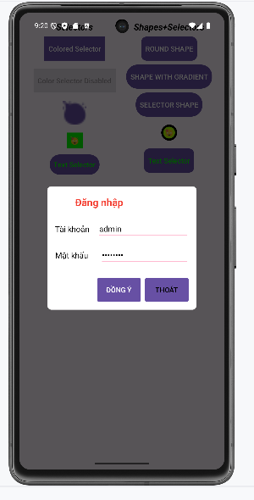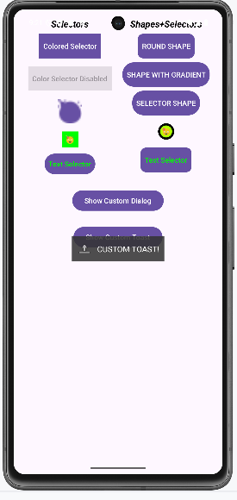

## SeekBar

### Chuẩn bị tài nguyên

Xây dựng giao diện main_activity.xml

*<?*xml version="1.0" encoding="utf-8"*?>*<LinearLayout xmlns:android="http://schemas.android.com/apk/res/android"  
 android:orientation="vertical"  
 android:layout_width="match_parent"  
 android:layout_height="match_parent"  
 android:padding="16dp">  
  
 *<!-- SeekBars RGB -->* <LinearLayout  
 android:orientation="vertical"  
 android:layout_width="match_parent"  
 android:layout_height="wrap_content">  
  
 *<!-- Red -->* <LinearLayout  
 android:orientation="horizontal"  
 android:layout_width="match_parent"  
 android:layout_height="wrap_content"  
 android:gravity="center_vertical">  
 <TextView  
 android:id="@+id/txtR"  
 android:layout_width="wrap_content"  
 android:layout_height="wrap_content"  
 android:text="R = 0"  
 android:textColor="#FF0000"  
 android:layout_marginEnd="8dp"/>  
 <SeekBar  
 android:id="@+id/seekBarR"  
 android:layout_width="0dp"  
 android:layout_weight="1"  
 android:layout_height="wrap_content"  
 android:max="255"/>  
 </LinearLayout>  
  
 *<!-- Green -->* <LinearLayout  
 android:orientation="horizontal"  
 android:layout_width="match_parent"  
 android:layout_height="wrap_content"  
 android:gravity="center_vertical">  
 <TextView  
 android:id="@+id/txtG"  
 android:layout_width="wrap_content"  
 android:layout_height="wrap_content"  
 android:text="G = 0"  
 android:textColor="#00FF00"  
 android:layout_marginEnd="8dp"/>  
 <SeekBar  
 android:id="@+id/seekBarG"  
 android:layout_width="0dp"  
 android:layout_weight="1"  
 android:layout_height="wrap_content"  
 android:max="255"/>  
 </LinearLayout>  
  
 *<!-- Blue -->* <LinearLayout  
 android:orientation="horizontal"  
 android:layout_width="match_parent"  
 android:layout_height="wrap_content"  
 android:gravity="center_vertical">  
 <TextView  
 android:id="@+id/txtB"  
 android:layout_width="wrap_content"  
 android:layout_height="wrap_content"  
 android:text="B = 0"  
 android:textColor="#0000FF"  
 android:layout_marginEnd="8dp"/>  
 <SeekBar  
 android:id="@+id/seekBarB"  
 android:layout_width="0dp"  
 android:layout_weight="1"  
 android:layout_height="wrap_content"  
 android:max="255"/>  
 </LinearLayout>  
 </LinearLayout>  
  
 <LinearLayout  
 android:orientation="horizontal"  
 android:layout_width="match_parent"  
 android:layout_height="0dp"  
 android:layout_weight="1"  
 android:layout_marginTop="16dp">  
  
 <View  
 android:id="@+id/viewRGB"  
 android:layout_width="0dp"  
 android:layout_weight="1"  
 android:layout_height="match_parent"  
 android:background="#000000"/>  
  
 <View  
 android:id="@+id/viewCMY"  
 android:layout_width="0dp"  
 android:layout_weight="1"  
 android:layout_height="match_parent"  
 android:background="#FFFFFF"/>  
 </LinearLayout>  
</LinearLayout>

### Thực hiện xử lý logic

Bước 1: Xây dựng logic xử lý bên trong MainActivity

package com.example.lab3_2_2;  
  
import android.os.Bundle;  
  
import androidx.activity.EdgeToEdge;  
import androidx.appcompat.app.AppCompatActivity;  
import androidx.core.graphics.Insets;  
import androidx.core.view.ViewCompat;  
import androidx.core.view.WindowInsetsCompat;  
  
import androidx.appcompat.app.AppCompatActivity;  
import android.os.Bundle;  
import android.graphics.Color;  
import android.widget.SeekBar;  
import android.widget.TextView;  
import android.view.View;  
  
public class MainActivity extends AppCompatActivity {  
  
 private SeekBar seekBarR, seekBarG, seekBarB;  
 private TextView txtR, txtG, txtB;  
 private View viewRGB, viewCMY;  
  
 @Override  
 protected void onCreate(Bundle savedInstanceState) {  
 super.onCreate(savedInstanceState);  
 setContentView(R.layout.*activity_main*);  
  
 seekBarR = findViewById(R.id.*seekBarR*);  
 seekBarG = findViewById(R.id.*seekBarG*);  
 seekBarB = findViewById(R.id.*seekBarB*);  
  
 txtR = findViewById(R.id.*txtR*);  
 txtG = findViewById(R.id.*txtG*);  
 txtB = findViewById(R.id.*txtB*);  
  
 viewRGB = findViewById(R.id.*viewRGB*);  
 viewCMY = findViewById(R.id.*viewCMY*);  
  
 SeekBar.OnSeekBarChangeListener listener = new SeekBar.OnSeekBarChangeListener() {  
 @Override  
 public void onProgressChanged(SeekBar seekBar, int progress, boolean fromUser) {  
 updateColor();  
 }  
  
 @Override  
 public void onStartTrackingTouch(SeekBar seekBar) { }  
  
 @Override  
 public void onStopTrackingTouch(SeekBar seekBar) { }  
 };  
  
 seekBarR.setOnSeekBarChangeListener(listener);  
 seekBarG.setOnSeekBarChangeListener(listener);  
 seekBarB.setOnSeekBarChangeListener(listener);  
  
 updateColor();  
 }  
  
 private void updateColor() {  
 int r = seekBarR.getProgress();  
 int g = seekBarG.getProgress();  
 int b = seekBarB.getProgress();  
  
 txtR.setText("R = " + r);  
 txtG.setText("G = " + g);  
 txtB.setText("B = " + b);  
  
 viewRGB.setBackgroundColor(Color.*rgb*(r, g, b));  
  
 int c = 255 - r;  
 int m = 255 - g;  
 int y = 255 - b;  
 viewCMY.setBackgroundColor(Color.*rgb*(c, m, y));  
 }  
}

### Kết quả sau khi thực hiện

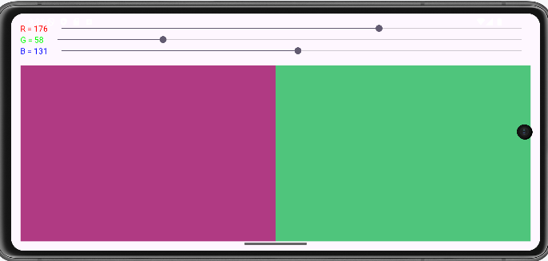

## List trong Android

### ListView

Bước 1: Tạo một ListView trong main_activity.xml

*<?*xml version="1.0" encoding="utf-8"*?>*<LinearLayout android:layout_width="match_parent"  
 android:layout_height="match_parent" android:orientation="vertical"  
 android:weightSum="10"  
 xmlns:android="http://schemas.android.com/apk/res/android">  
 <ListView  
 android:id="@+id/lvMain"  
 android:layout_weight="8"  
 android:layout_width="match_parent"  
 android:layout_height="0dp">  
 </ListView>  
 <TextView  
 android:id="@+id/txtDisplay"  
 android:layout_weight="2"  
 android:layout_width="match_parent"  
 android:layout_height="0dp"/>  
</LinearLayout>

Bước 2: Khai báo các đối tượng để hiển thị trên ListView

String[] arr = new String[]{"Android", "iOS", "Window Phone"};  
ListView lvMain;  
TextView txtDisplay;

Bước 3: Ta phải khai báo Adapter để ListView có thể render được

lvMain = findViewById(R.id.*lvMain*);  
txtDisplay = findViewById(R.id.*txtDisplay*);  
ArrayAdapter<String> adapter = new ArrayAdapter<>(this, android.R.layout.*simple_list_item_1*, arr);  
lvMain.setAdapter(adapter);

Bước 4: Thêm sự kiện cho từng phần tử của ListView

lvMain.setOnItemClickListener(new AdapterView.OnItemClickListener() {  
 @Override  
 public void onItemClick(AdapterView<?> parent, View view, int position, long id) { txtDisplay.setText(arr[position]);  
 }  
});

Bước 5: Chạy để thấy được kết quả

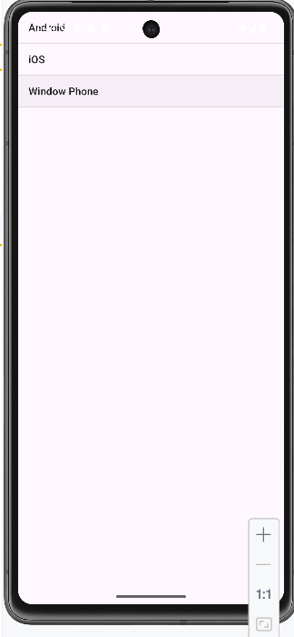

Bước 6: Tạo Model Product để hiển thị danh sách sản phẩm

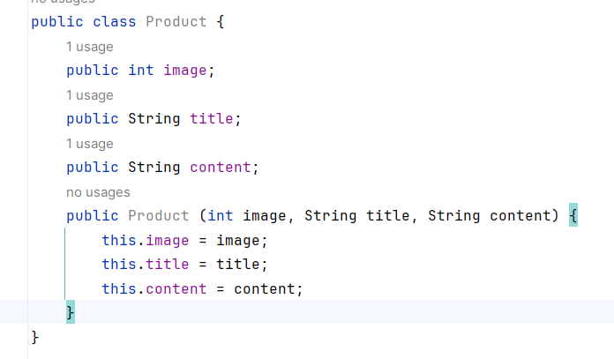

Bước 7: Triển khai giao diện cho một row.xml

<LinearLayout  
 xmlns:android="http://schemas.android.com/apk/res/android"  
 android:layout_width="match_parent"  
 android:layout_height="wrap_content"  
 android:orientation="horizontal">  
  
 <ImageView  
 android:id="@+id/imgRow"  
 android:layout_width="60dp"  
 android:layout_height="match_parent" />  
  
 <LinearLayout  
 android:layout_width="wrap_content"  
 android:layout_height="match_parent"  
 android:orientation="vertical"  
 android:layout_marginLeft="10dp"  
 android:layout_marginTop="5dp"  
 android:weightSum="3">  
  
 <TextView  
 android:id="@+id/txtTitle"  
 android:layout_width="match_parent"  
 android:layout_height="wrap_content"  
 android:layout_weight="1"  
 android:textStyle="bold"  
 android:textColor="#0942EC" />  
  
 <TextView  
 android:id="@+id/txtContent"  
 android:layout_width="match_parent"  
 android:layout_height="0dp"  
 android:layout_weight="1" />  
  
 </LinearLayout>  
</LinearLayout>

Bước 8 : Viết Adapter để render ra danh sách row

import android.view.View;  
import android.view.ViewGroup;  
import android.widget.BaseAdapter;  
import android.widget.ImageView;  
import android.widget.TextView;  
  
import com.example.lab3_3_1.Product;  
import com.example.lab3_3_1.R;  
  
import java.util.ArrayList;  
  
  
  
public class MyListViewAdapter extends BaseAdapter {  
 ArrayList<Product> list;  
  
 public MyListViewAdapter(ArrayList<Product> list) {  
 this.list = list;  
 }  
  
 @Override  
 public int getCount() {  
 return list.size();  
 }  
  
 @Override  
 public Object getItem(int position) {  
 return list.get(position);  
 }  
  
 @Override  
 public long getItemId(int position) {  
 return 0;  
 }  
  
 @Override  
 public View getView(int position, View convertView, ViewGroup parent) {  
  
 View view;  
 if (convertView == null) {  
 view = View.*inflate*(parent.getContext(), R.layout.*row*, null);  
 } else {  
 view = convertView;  
 }  
 Product product = (Product)getItem(position);  
ImageView img = view.findViewById(R.id.*imgRow*);  
 TextView txtTitle = view.findViewById(R.id.*txtTitle*);  
 TextView txtContent = view.findViewById(R.id.*txtContent*);  
  
 img.setImageResource(product.image);  
 txtTitle.setText(product.title);  
 txtContent.setText(product.content);  
  
 return view;  
 }  
}

Bước 9 Tạo dữ liệu ảo

String[] titles = new String[]{"Android", "iOS", "Window Phone"};  
String[] contents = new String[]{"Đây là hệ điều hành Android",  
 "Đây là hệ điều hành iOS",  
 "Đây là hệ điều hành Window Phone"};  
int[] imgs = new int[]{R.drawable.*android*,  
 R.drawable.*ios*,  
 R.drawable.*window_phone*};

Bước 10 Tạo danh sách để cho Adapter Binding

ArrayList<Product> list = new ArrayList<>();  
for(int i = 0; i < titles.length; i++){  
 list.add(new Product(imgs[i],titles[i],contents[i]));  
}  
MyListViewAdapter adapter = new MyListViewAdapter(list);  
lvMain.setAdapter(adapter);

Bước 11: Chạy kiểm nghiệm

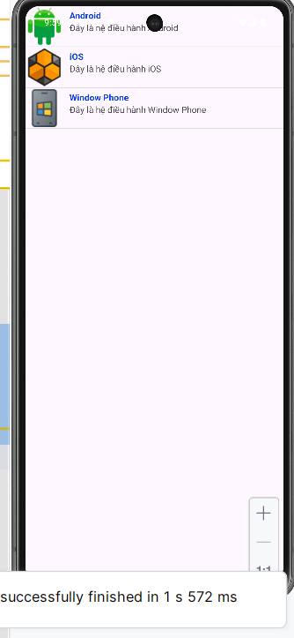

## Xây dựng chương trình hiển thị và quản lý các món ǎn

### Chuẩn bị tài nguyên cần thiết

Chuẩn bị tài nguyên hình ảnh để hiển thị

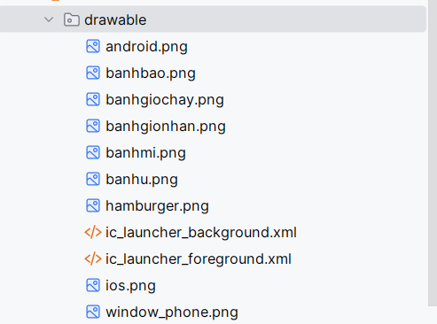

Xây dựng giao diện hiển thị danh sách món ăn

*<?*xml version="1.0" encoding="utf-8"*?>*<LinearLayout xmlns:android="http://schemas.android.com/apk/res/android"  
 android:id="@+id/main"  
 android:layout_width="match_parent"  
 android:layout_height="match_parent"  
 android:orientation="vertical"  
 android:background="#000000">  
  
 <ListView  
 android:id="@+id/lvMain"  
 android:layout_width="match_parent"  
 android:layout_height="match_parent"  
 android:divider="#444444"  
 android:dividerHeight="1dp"/>  
  
</LinearLayout>

Xây dựng giao diện món ăn

*<?*xml version="1.0" encoding="utf-8"*?>*<LinearLayout xmlns:android="http://schemas.android.com/apk/res/android"  
 android:layout_width="match_parent"  
 android:layout_height="wrap_content"  
 android:orientation="horizontal"  
 android:padding="8dp"  
 android:background="#000000"> <ImageView  
 android:id="@+id/imgFood"  
 android:layout_width="80dp"  
 android:layout_height="80dp"  
 android:scaleType="centerCrop"  
 android:src="@drawable/hamburger" /> <LinearLayout  
 android:layout_width="0dp"  
 android:layout_height="wrap_content"  
 android:layout_weight="1"  
 android:orientation="vertical"  
 android:layout_marginLeft="10dp"  
 android:layout_gravity="center_vertical">  
  
 <TextView  
 android:id="@+id/txtTitle"  
 android:layout_width="wrap_content"  
 android:layout_height="wrap_content"  
 android:text="Hamburger"  
 android:textColor="#FFFFFF"  
 android:textStyle="bold"  
 android:textSize="16sp" />  
  
 <TextView  
 android:id="@+id/txtDescription"  
 android:layout_width="wrap_content"  
 android:layout_height="wrap_content"  
 android:text="Bánh mì kẹp thịt tròn"  
 android:textColor="#CCCCCC"  
 android:textSize="14sp" />  
  
 <TextView  
 android:id="@+id/txtPrice"  
 android:layout_width="wrap_content"  
 android:layout_height="wrap_content"  
 android:text="Giá: 12.000đ"  
 android:textColor="#00FF00"  
 android:textStyle="bold"  
 android:textSize="14sp" />  
</LinearLayout>  
  
 <LinearLayout  
 android:layout_width="wrap_content"  
 android:layout_height="match_parent"  
 android:orientation="vertical"  
 android:gravity="center_vertical"  
 android:layout_marginLeft="10dp">  
  
 <ImageButton  
 android:id="@+id/btnEdit"  
 android:layout_width="35dp"  
 android:layout_height="35dp"  
 android:src="@android:drawable/ic_menu_edit" /> <ImageButton  
 android:id="@+id/btnDelete"  
 android:layout_width="35dp"  
 android:layout_height="35dp"  
 android:layout_marginTop="5dp"  
 android:src="@android:drawable/ic_delete" /> </LinearLayout>  
  
</LinearLayout>

### Thực hiện xử lý logic

Bước 1: Khởi tạo Model Product

package com.example.lab3_3_1;  
public class Product {  
 int image;  
 String title;  
 String description;  
 String price;  
  
 public Product(int image, String title, String description, String price) {  
 this.image = image;  
 this.title = title;  
 this.description = description;  
 this.price = price;  
 }  
  
 public int getImage() {  
 return image;  
 }  
  
 public String getTitle() {  
 return title;  
 }  
  
 public String getDescription() {  
 return description;  
 }  
  
 public String getPrice() {  
 return price;  
 }  
}

Bước 2: Khởi tạo MyListViewAdapter để quản lý món ăn

package com.example.lab3_3_1;  
import android.content.Context;  
import android.view.LayoutInflater;  
import android.view.View;  
import android.view.ViewGroup;  
import android.widget.BaseAdapter;  
import android.widget.ImageButton;  
import android.widget.ImageView;  
import android.widget.TextView;  
import android.widget.Toast; *// Thêm để xử lý click*import com.example.lab3_3_1.Product;  
import com.example.lab3_3_1.R;  
  
import java.util.ArrayList;  
  
public class MyListViewAdapter extends BaseAdapter {  
  
 Context context;  
 ArrayList<Product> list;  
  
 public MyListViewAdapter(Context context, ArrayList<Product> list) {  
 this.context = context;  
 this.list = list;  
 }  
  
 @Override  
 public int getCount() {  
 return list.size();  
 }  
  
 @Override  
 public Object getItem(int position) {  
 return list.get(position);  
 }  
  
 @Override  
 public long getItemId(int position) {  
 return position;  
 }  
  
 private static class ViewHolder {  
 ImageView imgFood;  
 TextView txtTitle;  
 TextView txtDescription;  
 TextView txtPrice;  
 ImageButton btnEdit;  
 ImageButton btnDelete;  
 }  
  
 @Override  
 public View getView(int position, View convertView, ViewGroup parent) {  
 ViewHolder holder;  
  
 if (convertView == null) {  
 LayoutInflater inflater = (LayoutInflater) context.getSystemService(Context.*LAYOUT_INFLATER_SERVICE*);  
  
 convertView = inflater.inflate(R.layout.*row*, null);  
  
 holder = new ViewHolder();  
 holder.imgFood = (ImageView) convertView.findViewById(R.id.*imgFood*);  
 holder.txtTitle = (TextView) convertView.findViewById(R.id.*txtTitle*);  
 holder.txtDescription = (TextView) convertView.findViewById(R.id.*txtDescription*);  
 holder.txtPrice = (TextView) convertView.findViewById(R.id.*txtPrice*);  
 holder.btnEdit = (ImageButton) convertView.findViewById(R.id.*btnEdit*);  
 holder.btnDelete = (ImageButton) convertView.findViewById(R.id.*btnDelete*);  
  
 convertView.setTag(holder);  
 } else {  
 holder = (ViewHolder) convertView.getTag();  
 }  
  
 Product product = list.get(position);  
  
 *// Gán dữ liệu lên các view* holder.imgFood.setImageResource(product.getImage());  
 holder.txtTitle.setText(product.getTitle());  
 holder.txtDescription.setText(product.getDescription());  
 holder.txtPrice.setText(product.getPrice());  
  
 holder.btnEdit.setOnClickListener(new View.OnClickListener() {  
 @Override  
 public void onClick(View v) {  
  
 }  
 });  
  
 holder.btnDelete.setOnClickListener(new View.OnClickListener() {  
 @Override  
 public void onClick(View v) {  
  
 }  
 });  
  
 return convertView;  
 }  
}

Bước 3: Tạo dữ liệu ảo

String[] titles = new String[]{  
 "Hamburger", "Bánh mì", "Bánh bao", "Bánh ú", "Bánh giò chay", "Bánh giò nhân thịt"  
};  
  
String[] descriptions = new String[]{  
 "Bánh mì kẹp thịt tròn", "Bánh mì kẹp thịt", "Bánh bao nhân thịt, trứng",  
 "Bánh ú dùng cho tết, lễ", "Bánh giò chay bằng nếp hoặc tẻ", "Bánh giò nếp, tẻ có nhân thịt"  
};  
  
String[] prices = new String[]{  
 "Giá: 12.000đ", "Giá: 10.000đ", "Giá: 12.000đ",  
 "Giá: 5.000đ", "Giá: 5.000đ", "Giá: 8.000đ"  
};  
int[] imgs = new int[]{  
 R.drawable.*hamburger*, R.drawable.*banhmi*, R.drawable.*banhbao*,  
 R.drawable.*banhu*, R.drawable.*banhgiochay*, R.drawable.*banhgionhan*};

Bước 4: Tiến hành xử lý dữ liệu và đưa vào apdater

@Override  
protected void onCreate(Bundle savedInstanceState) {  
 super.onCreate(savedInstanceState);  
 setContentView(R.layout.*activity_main*);  
 lvMain = findViewById(R.id.*lvMain*);  
 productList = new ArrayList<>();  
 for (int i = 0; i < titles.length; i++) {  
 productList.add(new Product(imgs[i], titles[i], descriptions[i], prices[i]));  
 }  
  
 adapter = new MyListViewAdapter(this, productList);  
 lvMain.setAdapter(adapter);  
  
 lvMain.setOnItemClickListener(new AdapterView.OnItemClickListener() {  
 @Override  
 public void onItemClick(AdapterView<?> parent, View view, int position, long id) {  
 Product selectedProduct = productList.get(position);  
 }  
 });  
}

### Kết quả sau khi thực hiện

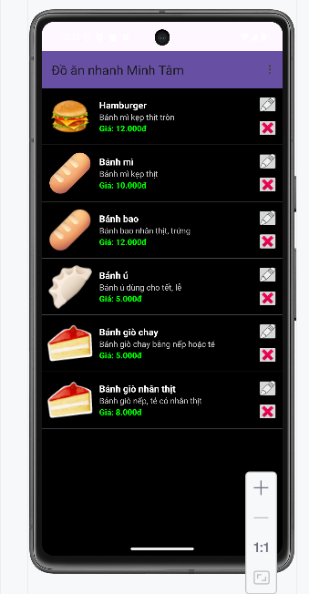

## GridView

Bước 1: Xây dựng gridview.xml

*<?*xml version="1.0" encoding="utf-8"*?>*<LinearLayout xmlns:android="http://schemas.android.com/apk/res/android"  
 android:id="@+id/main"  
 android:layout_width="match_parent"  
 android:layout_height="match_parent"  
 android:orientation="vertical"  
 android:background="#000000">  
  
 <TextView  
 android:id="@+id/header_title"  
 android:layout_width="match_parent"  
 android:layout_height="wrap_content"  
 android:text="The Rap Genius Contributors"  
 android:textColor="#FFFFFF"  
 android:textSize="20sp"  
 android:textStyle="bold"  
 android:padding="16dp"  
 android:background="#333333" /> <GridView  
 android:id="@+id/contributors_grid"  
 android:layout_width="match_parent"  
 android:layout_height="match_parent"  
 android:numColumns="3"  
 android:verticalSpacing="0dp"  
 android:horizontalSpacing="0dp"  
 android:stretchMode="columnWidth"  
 android:gravity="center"  
 android:listSelector="@android:color/transparent"/>  
</LinearLayout>

Bước 2: Xây dựng griditem.xml

*<?*xml version="1.0" encoding="utf-8"*?>*<LinearLayout xmlns:android="http://schemas.android.com/apk/res/android"  
 android:layout_width="match_parent"  
 android:layout_height="wrap_content"  
 android:orientation="vertical"  
 android:padding="8dp"  
 android:background="#000000"  
 android:gravity="center_horizontal">  
  
 <ImageView  
 android:id="@+id/contributor_image"  
 android:layout_width="50dp"  
 android:layout_height="50dp"  
 android:scaleType="centerCrop"  
 android:src="@android:drawable/ic_menu_gallery" /> <TextView  
 android:id="@+id/contributor_name"  
 android:layout_width="wrap_content"  
 android:layout_height="wrap_content"  
 android:text="Maboo"  
 android:textColor="#FFFFFF"  
 android:textSize="14sp"  
 android:textStyle="bold"  
 android:layout_marginTop="4dp" />  
  
 <TextView  
 android:id="@+id/contributor_points"  
 android:layout_width="wrap_content"  
 android:layout_height="wrap_content"  
 android:text="283,297"  
 android:textColor="#FFA500"  
 android:textSize="12sp"  
 android:layout_marginBottom="4dp" />  
  
</LinearLayout>

Bước 3: Tạo Model chứa thông tin GridItem

package com.example.lab_3_3_3;  
  
public class Contributor {  
 private int imageResId;  
 private String name;  
 private String points;  
  
 public Contributor(int imageResId, String name, String points) {  
 this.imageResId = imageResId;  
 this.name = name;  
 this.points = points;  
 }  
  
 *// Getters* public int getImageResId() {  
 return imageResId;  
 }  
  
 public String getName() {  
 return name;  
 }  
  
 public String getPoints() {  
 return points;  
 }  
}

Bước 4: Viết ContributorAdapter để hiện thị danh sách

package com.example.lab_3_3_3;  
  
import android.content.Context;  
import android.view.LayoutInflater;  
import android.view.View;  
import android.view.ViewGroup;  
import android.widget.BaseAdapter;  
import android.widget.ImageView;  
import android.widget.TextView;  
  
import java.util.ArrayList;  
  
public class ContributorAdapter extends BaseAdapter {  
 private Context context;  
 private ArrayList<Contributor> contributors;  
  
 public ContributorAdapter(Context context, ArrayList<Contributor> contributors) {  
 this.context = context;  
 this.contributors = contributors;  
 }  
  
 @Override  
 public int getCount() {  
 return contributors.size();  
 }  
  
 @Override  
 public Object getItem(int position) {  
 return contributors.get(position);  
 }  
  
 @Override  
 public long getItemId(int position) {  
 return position;  
 }  
  
 private static class ViewHolder {  
 ImageView imageView;  
 TextView nameTextView;  
 TextView pointsTextView;  
 }  
  
 @Override  
 public View getView(int position, View convertView, ViewGroup parent) {  
 ViewHolder holder;  
 if (convertView == null) {  
 LayoutInflater inflater = (LayoutInflater) context.getSystemService(Context.*LAYOUT_INFLATER_SERVICE*);  
 convertView = inflater.inflate(R.layout.*grid_item_contributor*, parent, false);  
  
 holder = new ViewHolder();  
 holder.imageView = convertView.findViewById(R.id.*contributor_image*);  
 holder.nameTextView = convertView.findViewById(R.id.*contributor_name*);  
 holder.pointsTextView = convertView.findViewById(R.id.*contributor_points*);  
 convertView.setTag(holder);  
 } else {  
 holder = (ViewHolder) convertView.getTag();  
 }  
  
 Contributor contributor = contributors.get(position);  
 holder.imageView.setImageResource(contributor.getImageResId());  
 holder.nameTextView.setText(contributor.getName());  
 holder.pointsTextView.setText(contributor.getPoints());  
  
 return convertView;  
 }  
}

Bước 5: Triển khai Adapter tại MainActivity

package com.example.lab_3_3_3;  
  
import androidx.appcompat.app.AppCompatActivity;  
import android.os.Bundle;  
import android.view.View;  
import android.widget.AdapterView;  
import android.widget.GridView;  
import android.widget.Toast;  
  
import java.util.ArrayList;  
  
public class MainActivity extends AppCompatActivity {  
  
 private GridView contributorsGrid;  
 private ContributorAdapter adapter;  
 private ArrayList<Contributor> contributorList;  
  
 @Override  
 protected void onCreate(Bundle savedInstanceState) {  
 super.onCreate(savedInstanceState);  
 setContentView(R.layout.*activity_main*);  
  
 contributorsGrid = findViewById(R.id.*contributors_grid*);  
  
 contributorList = new ArrayList<>();  
  
 contributorList.add(new Contributor(android.R.drawable.*ic_menu_gallery*, "Maboo", "283,297"));  
 contributorList.add(new Contributor(android.R.drawable.*ic_menu_camera*, "SameOldShawn", "252,433"));  
 contributorList.add(new Contributor(android.R.drawable.*ic_menu_search*, "Magnitude901", "164,935"));  
 contributorList.add(new Contributor(android.R.drawable.*ic_menu_info_details*, "Brandon", "100,466"));  
 contributorList.add(new Contributor(android.R.drawable.*ic_menu_crop*, "Clement_RGF", "93,932"));  
 contributorList.add(new Contributor(android.R.drawable.*ic_menu_compass*, "Nebja", "84,187"));  
 contributorList.add(new Contributor(android.R.drawable.*ic_menu_call*, "BBDS", "81,762"));  
 contributorList.add(new Contributor(android.R.drawable.*ic_menu_day*, "PleaseDe-ModMe", "79,243"));  
 contributorList.add(new Contributor(android.R.drawable.*ic_menu_recent_history*, "DLizzle", "76,331"));  
 contributorList.add(new Contributor(android.R.drawable.*ic_menu_rotate*, "palacelight", "75,497"));  
 contributorList.add(new Contributor(android.R.drawable.*ic_menu_revert*, "TheDarkKnight", "69,138"));  
 contributorList.add(new Contributor(android.R.drawable.*ic_menu_report_image*, "hellrel", "68,903"));  
 adapter = new ContributorAdapter(this, contributorList);  
  
 contributorsGrid.setAdapter(adapter);  
  
 contributorsGrid.setOnItemClickListener(new AdapterView.OnItemClickListener() {  
 @Override  
 public void onItemClick(AdapterView<?> parent, View view, int position, long id) {  
 Contributor selectedContributor = contributorList.get(position);  
 Toast.*makeText*(MainActivity.this, "Bạn đã chọn: " + selectedContributor.getName(), Toast.*LENGTH_SHORT*).show();  
 }  
 });  
 }  
}

Bước 6: Hiển thị kết quả

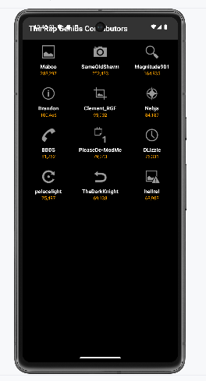

## Thực hiện chức năng thêm xóa sửa quản lý món ăn

Bước 1:Xây dựng menu_edit.xml

<menu xmlns:android="http://schemas.android.com/apk/res/android">  
 <item  
 android:id="@+id/menu_edit"  
 android:title="Sửa" />  
 <item  
 android:id="@+id/menu_delete"  
 android:title="Xóa" />  
</menu>

Bước 2: Xây dựng menu_add.xml

*<?*xml version="1.0" encoding="utf-8"*?>*<menu xmlns:android="http://schemas.android.com/apk/res/android"  
 xmlns:app="http://schemas.android.com/apk/res-auto">  
 <item  
 android:id="@+id/menu_add"  
 android:title="Thêm mới"  
 android:icon="@android:drawable/ic_menu_add" />  
  
 <item  
 android:id="@+id/menu_exit"  
 android:title="Thoát"  
 app:showAsAction="never" />  
  
</menu>

Bước 3: Thực hiện xử lý tại MainActivity

package com.example.lab3_3_1;  
  
import android.os.Bundle;  
import android.view.ContextMenu;  
import android.view.Menu;  
import android.view.MenuItem;  
import android.view.View;  
import android.widget.AdapterView;  
import android.widget.ListView;  
import android.widget.Toast;  
  
import androidx.appcompat.app.AppCompatActivity;  
import androidx.appcompat.widget.Toolbar;  
  
import java.util.ArrayList;  
  
public class MainActivity extends AppCompatActivity {  
 ListView lvMain;  
 ArrayList<Product> productList;  
 MyListViewAdapter adapter;  
 String[] titles = new String[]{  
 "Hamburger", "Bánh mì", "Bánh bao", "Bánh ú", "Bánh giò chay", "Bánh giò nhân thịt"  
 };  
 String[] descriptions = new String[]{  
 "Bánh mì kẹp thịt tròn", "Bánh mì kẹp thịt", "Bánh bao nhân thịt, trứng",  
 "Bánh ú dùng cho tết, lễ", "Bánh giò chay bằng nếp hoặc tẻ", "Bánh giò nếp, tẻ có nhân thịt"  
 };  
 String[] prices = new String[]{  
 "Giá: 12.000đ", "Giá: 10.000đ", "Giá: 12.000đ",  
 "Giá: 5.000đ", "Giá: 5.000đ", "Giá: 8.000đ"  
 };  
 int[] imgs = new int[]{  
 R.drawable.*hamburger*, R.drawable.*banhmi*, R.drawable.*banhbao*,  
 R.drawable.*banhu*, R.drawable.*banhgiochay*, R.drawable.*banhgionhan* };  
  
 @Override  
 protected void onCreate(Bundle savedInstanceState) {  
 super.onCreate(savedInstanceState);  
 setContentView(R.layout.*activity_main*);  
  
 lvMain = findViewById(R.id.*lvMain*);  
 Toolbar toolbar = findViewById(R.id.*toolbar*);  
 setSupportActionBar(toolbar);  
 productList = new ArrayList<>();  
 for (int i = 0; i < titles.length; i++) {  
 productList.add(new Product(imgs[i], titles[i], descriptions[i], prices[i]));  
 }  
  
 adapter = new MyListViewAdapter(this, productList);  
 lvMain.setAdapter(adapter);  
 registerForContextMenu(lvMain);  
 }  
  
 @Override  
 public boolean onCreateOptionsMenu(Menu menu) {  
 getMenuInflater().inflate(R.menu.*main_menu*, menu);  
 return true;  
 }  
  
 @Override  
 public boolean onOptionsItemSelected(MenuItem item) {  
 int id = item.getItemId();  
  
 if (id == R.id.*menu_add*) {  
 Product newProduct = new Product(R.drawable.*banhbao*, "Món Mới", "Mô tả cho món mới", "Giá: 20.000đ");  
 productList.add(newProduct);  
 adapter.notifyDataSetChanged();  
 Toast.*makeText*(this, "Đã thêm món mới!", Toast.*LENGTH_SHORT*).show();  
 return true;  
  
 }  
 return super.onOptionsItemSelected(item);  
 }  
  
 @Override  
 public void onCreateContextMenu(ContextMenu menu, View v, ContextMenu.ContextMenuInfo menuInfo) {  
 super.onCreateContextMenu(menu, v, menuInfo);  
 getMenuInflater().inflate(R.menu.*context_menu*, menu);  
 }  
  
 @Override  
 public boolean onContextItemSelected(MenuItem item) {  
 *// Xử lý sự kiện cho Context Menu (nhấn giữ item)* AdapterView.AdapterContextMenuInfo info = (AdapterView.AdapterContextMenuInfo) item.getMenuInfo();  
 int position = info.position; *// Lấy vị trí của item được nhấn giữ* Product selectedProduct = productList.get(position);  
  
 int id = item.getItemId();  
  
 if (id == R.id.*menu_edit*) {  
 selectedProduct.setTitle(selectedProduct.getTitle() + " (Đã sửa)");  
 adapter.notifyDataSetChanged();  
 Toast.*makeText*(this, "Đã sửa: " + selectedProduct.getTitle(), Toast.*LENGTH_SHORT*).show();  
 return true;  
  
 } else if (id == R.id.*menu_delete*) {  
 productList.remove(position);  
 adapter.notifyDataSetChanged();  
 Toast.*makeText*(this, "Đã xóa: " + selectedProduct.getTitle(), Toast.*LENGTH_SHORT*).show();  
 return true;  
 }  
  
 return super.onContextItemSelected(item);  
 }  
}

Bước 4: Hiển thị kết quả

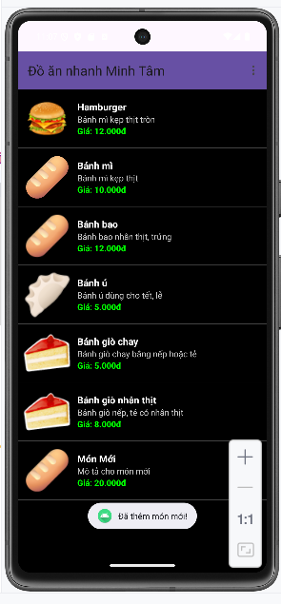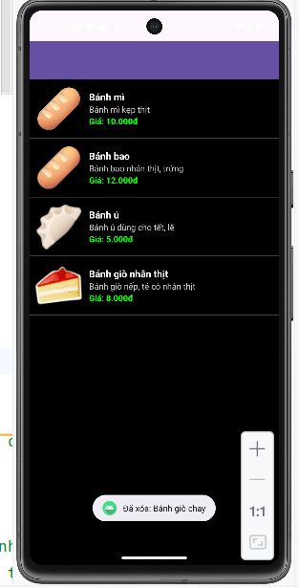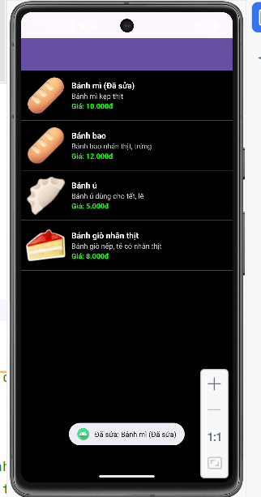

# 

## Ứng dụng truyện cười phần

### Chuẩn bị tài nguyên

Tạo Asset Folder và Tải hình ảnh và truyện bỏ vào

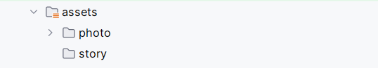

Tiến hành thêm màu sắc vào values/colors.xml

*<?*xml version="1.0" encoding="utf-8"*?>*<resources>  
 <color name="purple_200">#FFBB86FC</color>  
 <color name="purple_500">#FF6200EE</color>  
 <color name="purple_700">#FF3700B3</color>  
 <color name="teal_200">#FF03DAC5</color>  
 <color name="teal_700">#FF018786</color>  
 <color name="black">#FF000000</color>  
 <color name="white">#FFFFFFFF</color>  
 <color name="greenMid">#478942</color>  
 <color name="greenLight">#62BC5B</color>  
 <color name="greenSuperLight">#EFFFEE</color>  
</resources>

Tiến hành thêm màu sắc vào values/strings.xml

<resources>  
 <string name="app_name">TruyenCuoi</string>  
 <string name="txt_socola">Socola/string>  
 <string name="txt_story">Socola kẹo mút</string>  
</resources>

Tiến hành thêm màu sắc vào values/theme.xml

<resources xmlns:tools="http://schemas.android.com/tools">  
 *<!-- Base application theme. -->* <style name="Theme.Demo" parent="Theme.MaterialComponents.DayNight.NoActionBar">  
 *<!-- Primary brand color. -->* <item name="colorPrimary">@color/purple_500</item>  
 <item name="colorPrimaryVariant">@color/purple_700</item>  
 <item name="colorOnPrimary">@color/white</item>  
 *<!-- Secondary brand color. -->* <item name="colorSecondary">@color/teal_200</item>  
 <item name="colorSecondaryVariant">@color/teal_700</item>  
 <item name="colorOnSecondary">@color/black</item>  
 *<!-- Status bar color. -->* <item name="android:statusBarColor" tools:targetApi="l">?attr/colorPrimaryVariant</item>  
 *<!-- Customize your theme here. -->*</style>  
 </resources>

Tiến hành thiết kế giao diện m000_frg_splash.xml

*<?*xml version="1.0" encoding="utf-8"*?>*<FrameLayout xmlns:android="http://schemas.android.com/apk/res/android"  
 xmlns:tools="http://schemas.android.com/tools"  
 android:layout_width="match_parent"  
 android:layout_height="match_parent"  
 android:background="@color/greenMid">  
 <ImageView  
 android:layout_width="200dp"  
 android:layout_height="100dp"  
 android:layout_gravity="center"  
 android:src="@drawable/ic_splash"  
 tools:ignore="ContentDescription"/>  
</FrameLayout>

Tiến hành thiết kế giao diện activity_main.xml

*<?*xml version="1.0" encoding="utf-8"*?>*<LinearLayout xmlns:android="http://schemas.android.com/apk/res/android"  
 xmlns:tools="http://schemas.android.com/tools"  
 android:layout_width="match_parent"  
 android:layout_height="match_parent"  
 android:id="@+id/ln_main"  
 tools:context=".MainActivity"  
 android:orientation="horizontal">  
</LinearLayout>

### Thực hiện xử lý logic

Bước 1: Tiến hành viết M000_Frag_Splash để quản lý layout m000_frg_splash.xml

package com.example.lab4_1;  
  
import android.os.Bundle;  
import android.os.Handler;  
import android.view.LayoutInflater;  
import android.view.View;  
import android.view.ViewGroup;  
  
import androidx.fragment.app.Fragment;  
  
public class M000SplashFrg extends Fragment {  
 @Override  
 public View onCreateView(LayoutInflater inflater, ViewGroup container, Bundle savedInstanceState) {  
 initViews();  
 return inflater.inflate(R.layout.*m000_frg_splash*, container, false);  
 }  
 private void initViews() {  
 new Handler().postDelayed(this::gotoM001Screen, 2000);  
 }  
 private void gotoM001Screen() {  
 ((MainActivity) getActivity()).gotoM001Screen();  
 }  
}

Bước 2: Tiến hành xây dựng đối tượng StoryEntity

package com.example.lab4_1;  
public class StoryEntity {  
 private final String topicName;  
 private final String name;  
 private final String content;  
 public StoryEntity(String topicName, String name, String content) {  
 this.topicName = topicName;  
 this.name = name;  
 this.content = content;  
 }  
 public String getTopicName() {  
 return topicName;  
 }  
 public String getName() {  
 return name;  
 }  
 public String getContent() {  
 return content;  
 }  
}

Bước 3: Xây dựng MainActivity để quản lý activity_main.xml

package com.example.lab4_1;  
  
import android.os.Bundle;  
  
import androidx.activity.EdgeToEdge;  
import androidx.appcompat.app.AppCompatActivity;  
import androidx.core.graphics.Insets;  
import androidx.core.view.ViewCompat;  
import androidx.core.view.WindowInsetsCompat;  
import androidx.fragment.app.Fragment;  
  
public class MainActivity extends AppCompatActivity {  
 private String topicName;  
 @Override  
 protected void onCreate(Bundle savedInstanceState) {  
 super.onCreate(savedInstanceState);  
 setContentView(R.layout.*activity_main*);  
 showFrg(new M000SplashFrg());  
 }  
 private void showFrg(Fragment frg) {  
 getSupportFragmentManager().beginTransaction().replace(R.id.*ln_main*, frg,  
 null).commit();  
 }  
 public void gotoM001Screen() {  
 }  
 public void gotoM002Screen(String topicName) {  
 }  
 public void backToM001Screen() {  
 gotoM001Screen();  
 }  
}

## Ứng dụng truyện cười phần 2

### Chuẩn bị tài nguyên

Bước 1: Xây dựng giao diện layout item_topic

*<?*xml version="1.0" encoding="utf-8"*?>*<LinearLayout xmlns:android="http://schemas.android.com/apk/res/android"  
 xmlns:tools="http://schemas.android.com/tools"  
 android:layout_width="match_parent"  
 android:layout_height="wrap_content"  
 android:background="@color/white"  
 android:layout_marginBottom="10dp"  
 tools:ignore="UseCompoundDrawables">  
 <ImageView  
 android:id="@+id/iv_topic"  
 android:layout_width="180dp"  
 android:layout_height="82dp"  
 android:src="@drawable/ic_face"  
 tools:ignore="ContentDescription"/>  
 <TextView  
 android:id="@+id/tv_topic"  
 android:layout_width="match_parent"  
 android:layout_height="match_parent"  
 android:layout_marginStart="10dp"  
 android:fontFamily="sans-serif"  
 android:gravity="center_vertical"  
 android:text="@string/txt_socola"  
 android:textColor="@color/greenMid"  
 android:textSize="20sp" />  
</LinearLayout>

Bước 2: Xây dựng giao diện m001_frag_splash

*<?*xml version="1.0" encoding="utf-8"*?>*<LinearLayout xmlns:android="http://schemas.android.com/apk/res/android"  
 android:layout_width="match_parent"  
 android:layout_height="match_parent"  
 android:background="@color/greenMid"  
 android:orientation="vertical">  
 <include layout="@layout/actionbar_home" />  
 <ScrollView  
 android:layout_width="match_parent"  
 android:layout_height="match_parent">  
 <LinearLayout  
 android:id="@+id/ln_topic"  
 android:layout_width="match_parent"  
 android:layout_height="wrap_content"  
 android:orientation="vertical"  
 android:padding="10dp" />  
 </ScrollView>  
</LinearLayout>

Bước 3: Xây dựng Action_bar home

*<?*xml version="1.0" encoding="utf-8"*?>*<LinearLayout  
 xmlns:android="http://schemas.android.com/apk/res/android"  
 xmlns:app="http://schemas.android.com/apk/res-auto"  
 android:layout_width="match_parent"  
 android:layout_height="56dp"  
 android:background="@color/greenLight"  
 android:orientation="horizontal">  
 <ImageView  
 android:id="@+id/iv_back"  
 android:layout_width="56dp"  
 android:layout_height="56dp"  
 android:layout_marginStart="10dp"  
 android:padding="10dp"  
 android:src="@drawable/ic_back"  
 android:visibility="gone"  
 app:tint="@color/white"  
 android:layout_marginLeft="10dp" />  
 <TextView  
 android:id="@+id/tv_name"  
 android:layout_width="match_parent"  
 android:layout_height="match_parent"  
 android:layout_marginStart="10dp"  
 android:gravity="center_vertical"  
 android:text="Truyện cười "  
 android:textColor="@color/white"  
 android:textSize="24sp"  
 android:layout_marginLeft="10dp" />  
</LinearLayout>

### Thực hiện xử lý logic

Bước 1: Xây dựng M001TopicFrg để quản lý m001_frag_splash

package com.example.lab4_1;  
import android.content.Context;  
import android.graphics.BitmapFactory;  
import android.os.Bundle;  
import android.view.LayoutInflater;  
import android.view.View;  
import android.view.ViewGroup;  
import android.widget.ImageView;  
import android.widget.LinearLayout;  
import android.widget.TextView;  
import androidx.fragment.app.Fragment;  
  
public class M001TopicFrg extends Fragment implements View.OnClickListener {  
 private Context mContext;  
 @Override  
 public View onCreateView(LayoutInflater inflater, ViewGroup container,  
 Bundle savedInstanceState) {  
 View rootView = inflater.inflate(R.layout.*m001_frg_topic*, container, false);  
 initViews(rootView);  
 return rootView;  
 }  
 @Override  
 public void onAttach(Context context) {  
 super.onAttach(context);  
 mContext = context;  
 }  
 private void initViews(View v) {  
 LinearLayout lnMain = v.findViewById(R.id.*ln_topic*);  
 lnMain.removeAllViews();  
 try {  
 String[] listItem = mContext.getAssets().list("photo");  
 for (String fileName : listItem) {  
 String name = fileName.substring(0, fileName.indexOf("."));  
 View vTopic = LayoutInflater.*from*(mContext).inflate(R.layout.*item_topic*, null);  
 ImageView ivTopic = vTopic.findViewById(R.id.*iv_topic*);  
 TextView tvTopic = vTopic.findViewById(R.id.*tv_topic*);  
 ivTopic.setImageBitmap(BitmapFactory  
 .*decodeStream*(mContext.getAssets().open("photo/" + fileName)));  
 tvTopic.setText(name);  
 lnMain.addView(vTopic);  
 LinearLayout.LayoutParams params = (LinearLayout.LayoutParams)  
 vTopic.getLayoutParams();  
 params.bottomMargin = 40;  
 vTopic.setLayoutParams(params);  
 vTopic.setTag(name);  
 vTopic.setOnClickListener(this);  
 }  
 } catch (Exception e) {  
 e.printStackTrace();  
 }  
 }  
 @Override  
 public void onClick(View v) {  
 ((MainActivity) getActivity()).gotoM002Screen((String)v.getTag());  
 }  
}

Bước 2: Xây dựng logic xử lý MainActivity

package com.example.lab4_1;  
import android.os.Bundle;  
import androidx.activity.EdgeToEdge;  
import androidx.appcompat.app.AppCompatActivity;  
import androidx.core.graphics.Insets;  
import androidx.core.view.ViewCompat;  
import androidx.core.view.WindowInsetsCompat;  
import androidx.fragment.app.Fragment;  
  
public class MainActivity extends AppCompatActivity {  
 private String topicName;  
 @Override  
 protected void onCreate(Bundle savedInstanceState) {  
 super.onCreate(savedInstanceState);  
 setContentView(R.layout.*activity_main*);  
 showFrg(new M000SplashFrg());  
 }  
 private void showFrg(Fragment frg) {  
 getSupportFragmentManager().beginTransaction().replace(R.id.*ln_main*, frg,  
 null).commit();  
 }  
 public void gotoM001Screen() {  
 getSupportFragmentManager().beginTransaction().replace(R.id.*ln_main*, new  
 M001TopicFrg(), null).commit();  
 }  
 public void gotoM002Screen(String topicName) {  
 }  
 public void backToM001Screen() {  
 gotoM001Screen();  
 }  
}

## Ứng dụng truyện cười phần 3

### Chuẩn bị tài nguyên

Bước 1: Xây dựng giao diện item_story.xml

*<?*xml version="1.0" encoding="utf-8"*?>*<LinearLayout xmlns:android="http://schemas.android.com/apk/res/android"  
 xmlns:tools="http://schemas.android.com/tools"  
 android:layout_width="match_parent"  
 android:layout_height="match_parent"  
 android:background="@color/greenMid"  
 android:orientation="vertical">  
 <include layout="@layout/actionbar_home" />  
 <androidx.recyclerview.widget.RecyclerView  
 android:id="@+id/rv_story"  
 android:layout_width="match_parent"  
 android:layout_height="match_parent"  
 tools:listitem="@layout/item_story" />  
</LinearLayout>

Bước 2: Xây dựng item_detail_story.xml

*<?*xml version="1.0" encoding="utf-8"*?>*<LinearLayout xmlns:android="http://schemas.android.com/apk/res/android"  
 android:layout_width="match_parent"  
 android:layout_height="match_parent"  
 android:orientation="vertical"  
 android:padding="10dp">  
 <TextView  
 android:id="@+id/tv_name"  
 android:layout_width="match_parent"  
 android:layout_height="wrap_content"  
 android:layout_marginTop="20dp"  
 android:gravity="center"  
 android:padding="10dp"  
 android:text="Vừa ǎn vừa nói"  
 android:textColor="@color/greenMid"  
 android:textSize="24sp"  
 android:textStyle="bold" />  
 <ScrollView  
 android:layout_width="match_parent"  
 android:layout_height="match_parent">  
 <LinearLayout  
 android:layout_width="match_parent"  
 android:layout_height="wrap_content"  
 android:orientation="vertical">  
 <TextView  
 android:id="@+id/tv_content"  
 android:layout_width="match_parent"  
 android:layout_height="wrap_content"  
 android:fontFamily="sans-serif-light"  
 android:gravity="center_vertical"  
 android:lineSpacingExtra="5dp"  
 android:padding="10dp"  
 android:text="Nội dung truyện"  
 android:textColor="@color/black"  
 android:textSize="18sp" />  
 </LinearLayout>  
 </ScrollView>  
</LinearLayout>

Bước 3: Xây dựng m003_frg_detail_story.xml

*<?*xml version="1.0" encoding="utf-8"*?>*<LinearLayout xmlns:android="http://schemas.android.com/apk/res/android"  
 android:layout_width="match_parent"  
 android:layout_height="match_parent"  
 android:background="@color/white"  
 android:orientation="vertical">  
 <include layout="@layout/actionbar_home" />  
 <androidx.viewpager.widget.ViewPager  
 android:id="@+id/vp_story"  
 android:layout_width="match_parent"  
 android:layout_height="match_parent"/>  
</LinearLayout>

### Thực hiện xử lý logic

Bước 1: Xử lý logic khởi tạo StoryAdapter

package com.example.lab4_1;  
import android.content.Context;  
import android.view.LayoutInflater;  
import android.view.View;  
import android.view.ViewGroup;  
import android.widget.TextView;  
import androidx.recyclerview.widget.RecyclerView;  
import java.util.ArrayList;  
import java.util.List;  
public class StoryAdapter extends RecyclerView.Adapter<StoryAdapter.StoryHolder> {  
 private final ArrayList<StoryEntity> listStory;  
 private final Context mContext;  
 public StoryAdapter(ArrayList<StoryEntity> listStory, Context mContext) {  
 this.listStory = listStory;  
 this.mContext = mContext;  
 }  
 @Override  
 public StoryHolder onCreateViewHolder(ViewGroup parent, int viewType) {  
 View view = LayoutInflater.*from*(mContext).inflate(R.layout.*item_story*, parent, false);  
 return new StoryHolder(view);  
 }  
 @Override  
 public void onBindViewHolder(StoryAdapter.StoryHolder holder, int position) {  
 StoryEntity item = listStory.get(position);  
 holder.tvName.setTag(item);  
 holder.tvName.setText(item.getName());  
 }  
 @Override  
 public int getItemCount() {  
 return listStory.size();  
 }  
 public class StoryHolder extends RecyclerView.ViewHolder {  
 TextView tvName;  
 public StoryHolder(View itemView) {  
 super(itemView);  
 tvName = itemView.findViewById(R.id.*tv_story*);  
 itemView.setOnClickListener(v -> {  
 ((MainActivity)mContext).gotoM003Screen(listStory, (StoryEntity)tvName.getTag());  
 });  
 }  
 }  
}

Bước 2: Xây dựng DetailStoryAdapter

package com.example.lab4_1;  
import android.content.Context;  
import android.view.LayoutInflater;  
import android.view.View;  
import android.view.ViewGroup;  
import android.widget.TextView;  
import androidx.annotation.NonNull;  
import androidx.viewpager.widget.PagerAdapter;  
import java.util.List;  
public class DetailStoryAdapter extends PagerAdapter {  
 private final List<StoryEntity> listStory;  
 private final Context mContext;  
 public DetailStoryAdapter(List<StoryEntity> listStory, Context mContext) {  
 this.listStory = listStory;  
 this.mContext = mContext;  
 }  
 @Override  
 public Object instantiateItem(ViewGroup container, int position) {  
 View view = LayoutInflater.*from*(mContext).inflate(R.layout.*item_detail_story*, container,  
 false);  
 StoryEntity item = listStory.get(position);  
 TextView tvName = view.findViewById(R.id.*tv_name*);  
 TextView tvContent = view.findViewById(R.id.*tv_content*);  
 tvName.setTag(item);  
 tvName.setText(item.getName());  
 tvContent.setText(item.getContent());  
 container.addView(view);  
 return view;  
 }  
 @Override  
 public int getCount() {  
 return listStory.size();  
 }  
 @Override  
 public boolean isViewFromObject(View view, Object object) {  
 return view.equals(object);  
 }  
 @Override  
 public void destroyItem(ViewGroup container, int position, Object object) {  
 container.removeView((View) object);  
 }  
}

Bước 3: Xây dựng M002StoryFrg để quản lý truyện

package com.example.lab4_1;  
import android.content.Context;  
import android.os.Bundle;  
import android.view.LayoutInflater;  
import android.view.View;  
import android.view.ViewGroup;  
import android.widget.Adapter;  
import android.widget.TextView;  
import android.widget.Toast;  
import androidx.fragment.app.Fragment;  
import androidx.recyclerview.widget.LinearLayoutManager;  
import androidx.recyclerview.widget.RecyclerView;  
import java.io.BufferedReader;  
import java.io.IOException;  
import java.io.InputStream;  
import java.io.InputStreamReader;  
import java.util.ArrayList;  
import java.util.List;  
public class M002StoryFrg extends Fragment {  
 private Context mContext;  
 private ArrayList<StoryEntity> listStory;  
 private String topicName;  
 private StoryEntity currentStory;  
 @Override  
 public View onCreateView(LayoutInflater inflater, ViewGroup container, Bundle savedInstanceState) {  
 View rootView = inflater.inflate(R.layout.*m002_frag_story*, container, false);  
 initViews(rootView);  
 return rootView;  
 }  
 @Override  
 public void onAttach(Context context) {  
 super.onAttach(context);  
 mContext = context;  
 }  
 private void initViews(View v) {  
 v.findViewById(R.id.*iv_back*).setVisibility(View.*VISIBLE*);  
 v.findViewById(R.id.*iv_back*).setOnClickListener(v1 -> backToM001Screen());  
 ((TextView) v.findViewById(R.id.*tv_name*)).setText(topicName);  
 RecyclerView rv = v.findViewById(R.id.*rv_story*);  
 ArrayList<StoryEntity> listStory = readStory();  
 StoryAdapter adapter = new StoryAdapter(listStory,mContext);  
 rv.setAdapter(adapter);  
 rv.setLayoutManager(new LinearLayoutManager(mContext));  
 }  
 private ArrayList<StoryEntity> readStory() {  
 ArrayList<StoryEntity> listStory = new ArrayList<>();  
 BufferedReader reader = null;  
 try {  
 reader = new BufferedReader(  
 newInputStreamReader(mContext.getAssets().open("story/"+topicName+".txt"),"UTF-8"));  
 String mLine = "";  
 do {  
 String title = reader.readLine();  
 if (title == null) break;  
 String content = "";  
 do {  
 mLine = reader.readLine();  
 content += mLine + "\n";  
 } while (!mLine.contains("','0');"));  
 content = content.replace("','0');","");  
 StoryEntity storyEntity = new StoryEntity(topicName, title, content);  
 listStory.add(storyEntity);  
 } while (mLine != null);  
 } catch (IOException e) {  
 }  
 return listStory;  
 }  
 public void setTopicName(String topicName){  
 this.topicName = topicName;  
 }  
 private void backToM001Screen() {  
 ((MainActivity) getActivity()).backToM001Screen();  
 }  
}

Bước 4: Xây dựng M003StoryFrg để quản lý

package com.example.lab4_1;  
import android.content.Context;  
import android.os.Bundle;  
import android.view.LayoutInflater;  
import android.view.View;  
import android.view.ViewGroup;  
import android.widget.TextView;  
import androidx.fragment.app.Fragment;  
import androidx.viewpager.widget.ViewPager;  
import java.util.ArrayList;  
public class M003DetailStoryFrg extends Fragment {  
 private Context mContext;  
 private ArrayList<StoryEntity> listStory;  
 private String topicName;  
 private StoryEntity currentStory;  
 @Override  
 public View onCreateView(LayoutInflater inflater, ViewGroup container, Bundle  
 savedInstanceState) {  
 View rootView = inflater.inflate(R.layout.*m003_frg_detail_story*, container, false);  
 initViews(rootView);  
 return rootView;  
 }  
 @Override  
 public void onAttach(Context context) {  
 super.onAttach(context);  
 mContext = context;  
 }  
 private void initViews(View v) {  
 v.findViewById(R.id.*iv_back*).setVisibility(View.*VISIBLE*);  
 v.findViewById(R.id.*iv_back*).setOnClickListener(v1 -> backToM002Screen());  
 ((TextView) v.findViewById(R.id.*tv_name*)).setText(topicName);  
 ViewPager vp = v.findViewById(R.id.*vp_story*);  
 DetailStoryAdapter adapter = new DetailStoryAdapter(listStory, mContext);  
 vp.setAdapter(adapter);  
 vp.setCurrentItem(listStory.indexOf(currentStory), true);  
 }  
 private void backToM002Screen() {  
 ((MainActivity) getActivity()).gotoM002Screen(topicName);  
 }  
 public void setData(String topicName, ArrayList<StoryEntity> listStory, StoryEntity  
 currentStory) {  
 this.currentStory = currentStory;  
 this.topicName = topicName;  
 this.listStory = listStory;  
 }  
}

Bước 5: Xây dựng activity_main quản lý bởi MainActivity

package com.example.lab4_1;  
import android.content.Context;  
import android.os.Bundle;  
import android.view.LayoutInflater;  
import android.view.View;  
import android.view.ViewGroup;  
import android.widget.TextView;  
import androidx.annotation.NonNull;  
import androidx.annotation.Nullable;  
import androidx.fragment.app.Fragment;  
import androidx.recyclerview.widget.LinearLayoutManager;  
import androidx.recyclerview.widget.RecyclerView;  
  
import java.io.BufferedReader;  
import java.io.IOException;  
import java.io.InputStreamReader;  
import java.util.ArrayList;  
  
public class M002StoryFrg extends Fragment {  
 private Context mContext;  
 private ArrayList<StoryEntity> listStory;  
 private String topicName;  
  
 @Nullable  
 @Override  
 public View onCreateView(@NonNull LayoutInflater inflater, @Nullable ViewGroup container, @Nullable Bundle savedInstanceState) {  
 View rootView = inflater.inflate(R.layout.*m002_frag_story*, container, false);  
 initViews(rootView);  
 return rootView;  
 }  
  
 @Override  
 public void onAttach(@NonNull Context context) {  
 super.onAttach(context);  
 mContext = context;  
 }  
  
 private void initViews(View v) {  
 v.findViewById(R.id.*iv_back*).setVisibility(View.*VISIBLE*);  
 v.findViewById(R.id.*iv_back*).setOnClickListener(v1 -> backToM001Screen());  
  
 ((TextView) v.findViewById(R.id.*tv_name*)).setText(topicName);  
  
 RecyclerView rv = v.findViewById(R.id.*rv_story*);  
  
 *// Sửa: Gán vào biến toàn cục thay vì tạo biến cục bộ mới* listStory = readStory();  
  
 StoryAdapter adapter = new StoryAdapter(listStory, mContext);  
 rv.setAdapter(adapter);  
 rv.setLayoutManager(new LinearLayoutManager(mContext));  
 }  
  
 private ArrayList<StoryEntity> readStory() {  
 ArrayList<StoryEntity> resultList = new ArrayList<>();  
 BufferedReader reader = null;  
 try {  
 *// SỬA LỖI: Bỏ "BufferedReader" ở đầu dòng này* reader = new BufferedReader(  
 new InputStreamReader(mContext.getAssets().open("story/" + topicName + ".txt"), "UTF-8")  
 );  
  
 String mLine;  
 while ((mLine = reader.readLine()) != null) {  
 String title = mLine; *// Dòng đầu tiên là tiêu đề  
  
 // Dùng StringBuilder để nối chuỗi nhanh hơn* StringBuilder contentBuilder = new StringBuilder();  
  
 *// Đọc nội dung cho đến khi gặp chuỗi kết thúc* while ((mLine = reader.readLine()) != null) {  
 if (mLine.contains("','0');")) {  
 *// Nếu gặp dòng kết thúc thì ngắt vòng lặp* break;  
 }  
 contentBuilder.append(mLine).append("\n");  
 }  
  
 String content = contentBuilder.toString();  
  
 *// Tạo đối tượng và thêm vào list* StoryEntity storyEntity = new StoryEntity(topicName, title, content);  
 resultList.add(storyEntity);  
 }  
 } catch (IOException e) {  
 e.printStackTrace();  
 } finally {  
 *// BẮT BUỘC: Đóng reader để giải phóng bộ nhớ* if (reader != null) {  
 try {  
 reader.close();  
 } catch (IOException e) {  
 e.printStackTrace();  
 }  
 }  
 }  
 return resultList;  
 }  
  
 public void setTopicName(String topicName) {  
 this.topicName = topicName;  
 }  
  
 private void backToM001Screen() {  
 if (getActivity() instanceof MainActivity) {  
 ((MainActivity) getActivity()).backToM001Screen();  
 }  
 }  
}

### Kết quả sau khi thực hiện

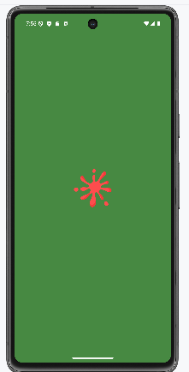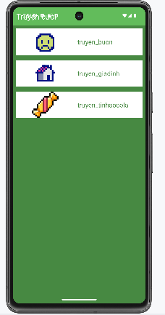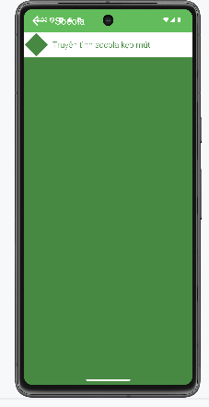

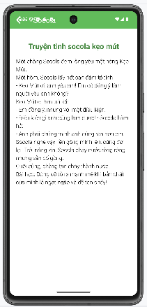

## Ứng dụng 12 cung hoàng đạo

### Chuẩn bị tài nguyên cần thiết

Tải các tài nguyên cần thiết, tạo thư mục asset

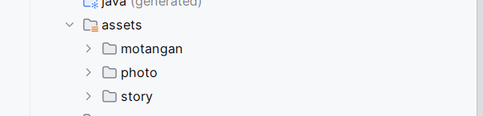

Tiến hành sửa res/values/theme.xml

<resources xmlns:tools="http://schemas.android.com/tools">  
 *<!-- Base application theme. -->* <style name="Theme.Demo" parent="Theme.MaterialComponents.DayNight.NoActionBar">  
 *<!-- Primary brand color. -->* <item name="colorPrimary">@color/purple_500</item>  
 <item name="colorPrimaryVariant">@color/purple_700</item>  
 <item name="colorOnPrimary">@color/white</item>  
 *<!-- Secondary brand color. -->* <item name="colorSecondary">@color/teal_200</item>  
 <item name="colorSecondaryVariant">@color/teal_700</item>  
 <item name="colorOnSecondary">@color/black</item>  
 *<!-- Status bar color. -->* <item name="android:statusBarColor" tools:targetApi="l">?attr/colorPrimaryVariant</item>  
 *<!-- Customize your theme here. -->*</style>  
 </resources>

Tiến hành thêm màu sắc vào values/colors.xml

*<?*xml version="1.0" encoding="utf-8"*?>*<resources>  
 <color name="purple_200">#FFBB86FC</color>  
 <color name="purple_500">#FF6200EE</color>  
 <color name="purple_700">#FF3700B3</color>  
 <color name="teal_200">#FF03DAC5</color>  
 <color name="teal_700">#FF018786</color>  
 <color name="black">#FF000000</color>  
 <color name="white">#FFFFFFFF</color>  
 <color name="greenMid">#478942</color>  
 <color name="greenLight">#62BC5B</color>  
 <color name="greenSuperLight">#EFFFEE</color>  
</resources>

Xây dựng giao diện m000_frg_splash.xml

*<?*xml version="1.0" encoding="utf-8"*?>*<FrameLayout xmlns:android="http://schemas.android.com/apk/res/android"  
 xmlns:tools="http://schemas.android.com/tools"  
 android:layout_width="match_parent"  
 android:layout_height="match_parent"  
 android:background="@color/greenMid">  
 <ImageView  
 android:layout_width="200dp"  
 android:layout_height="100dp"  
 android:layout_gravity="center"  
 android:src="@drawable/ic_splash"  
 tools:ignore="ContentDescription"/>  
</FrameLayout>

Thiết kế giao diện background vuông tròn xanh res/drawable/bg_rounded_blue

*<?*xml version="1.0" encoding="utf-8"*?>*<shape xmlns:android="http://schemas.android.com/apk/res/android"  
 android:shape="rectangle">  
  
 <solid android:color="#283593" />  
  
 <corners android:radius="20dp" />  
  
</shape>

Thiết kế giao diện m001_act_menu.xml

*<?*xml version="1.0" encoding="utf-8"*?>*<androidx.constraintlayout.widget.ConstraintLayout xmlns:android="http://schemas.android.com/apk/res/android"  
 xmlns:app="http://schemas.android.com/apk/res-auto"  
 android:id="@+id/main_layout"  
 android:layout_width="match_parent"  
 android:layout_height="match_parent"  
 android:background="#1A237E">  
  
 <TextView  
 android:id="@+id/tv_title"  
 android:layout_width="wrap_content"  
 android:layout_height="wrap_content"  
 android:text="APP 12 CUNG HOÀNG ĐẠO"  
 android:textColor="#FFD700"  
 android:textSize="24sp"  
 android:textStyle="bold"  
 android:layout_marginTop="30dp"  
 app:layout_constraintTop_toTopOf="parent"  
 app:layout_constraintStart_toStartOf="parent"  
 app:layout_constraintEnd_toEndOf="parent"/>  
  
 <View  
 android:id="@+id/view_center"  
 android:layout_width="1dp"  
 android:layout_height="1dp"  
 app:layout_constraintBottom_toBottomOf="parent"  
 app:layout_constraintEnd_toEndOf="parent"  
 app:layout_constraintStart_toStartOf="parent"  
 app:layout_constraintTop_toTopOf="parent"  
 app:layout_constraintVertical_bias="0.4" />  
 <LinearLayout  
 android:id="@+id/info_panel"  
 android:layout_width="match_parent"  
 android:layout_height="wrap_content"  
 android:orientation="vertical"  
 android:background="#283593"  
 android:padding="20dp"  
 android:layout_margin="16dp"  
 app:layout_constraintBottom_toBottomOf="parent"  
 app:layout_constraintStart_toStartOf="parent"  
 app:layout_constraintEnd_toEndOf="parent">  
 <LinearLayout  
 android:layout_width="match_parent"  
 android:layout_height="wrap_content"  
 android:orientation="horizontal"  
 android:gravity="center_vertical"  
 android:layout_marginBottom="10dp">  
  
 <ImageView  
 android:id="@+id/iv_icon_selected"  
 android:layout_width="60dp"  
 android:layout_height="60dp"  
 android:src="@drawable/ic_face"  
 android:contentDescription="Icon Selected"/>  
  
 <TextView  
 android:id="@+id/tv_name_selected"  
 android:layout_width="wrap_content"  
 android:layout_height="wrap_content"  
 android:text="Tên Cung"  
 android:textColor="#FFFFFF"  
 android:textSize="20sp"  
 android:textStyle="bold"  
 android:layout_marginStart="15dp"/>  
 </LinearLayout>  
  
 <TextView  
 android:id="@+id/tv_desc_short"  
 android:layout_width="match_parent"  
 android:layout_height="wrap_content"  
 android:text="Nội dung mô tả sẽ hiện ở đây..."  
 android:textColor="#E0E0E0"  
 android:textSize="14sp"  
 android:maxLines="3"  
 android:ellipsize="end"  
 android:layout_marginBottom="15dp"/>  
  
 <Button  
 android:id="@+id/btn_see_more"  
 android:layout_width="wrap_content"  
 android:layout_height="wrap_content"  
 android:text="XEM THÊM"  
 android:backgroundTint="#FFD700"  
 android:textColor="#3E2723"  
 android:textStyle="bold"  
 android:layout_gravity="center_horizontal"/>  
 </LinearLayout>  
  
</androidx.constraintlayout.widget.ConstraintLayout>

Thiết kế giao diện m002_act_detail.xml

*<?*xml version="1.0" encoding="utf-8"*?>*<RelativeLayout xmlns:android="http://schemas.android.com/apk/res/android"  
 android:layout_width="match_parent"  
 android:layout_height="match_parent"  
 android:background="#1A237E"  
 android:padding="16dp">  
  
 <Button  
 android:id="@+id/btn_back"  
 android:layout_width="wrap_content"  
 android:layout_height="wrap_content"  
 android:text="QUAY LẠI"  
 android:backgroundTint="#5C6BC0"  
 android:layout_alignParentEnd="true" />  
  
 <ImageView  
 android:id="@+id/iv_detail_icon"  
 android:layout_width="120dp"  
 android:layout_height="120dp"  
 android:layout_below="@id/btn_back"  
 android:layout_marginTop="20dp"  
 android:src="@drawable/ic_face" />  
  
 <TextView  
 android:id="@+id/tv_detail_name"  
 android:layout_width="wrap_content"  
 android:layout_height="wrap_content"  
 android:layout_toEndOf="@id/iv_detail_icon"  
 android:layout_alignTop="@id/iv_detail_icon"  
 android:layout_marginStart="20dp"  
 android:layout_marginTop="30dp"  
 android:text="Bạch Dương"  
 android:textColor="#FFD700"  
 android:textSize="24sp"  
 android:textStyle="bold" />  
  
 <ScrollView  
 android:layout_width="match_parent"  
 android:layout_height="match_parent"  
 android:layout_below="@id/iv_detail_icon"  
 android:layout_marginTop="20dp"  
 android:background="@drawable/bg_rounded_blue"  
 android:padding="16dp">  
  
 <TextView  
 android:id="@+id/tv_detail_content"  
 android:layout_width="match_parent"  
 android:layout_height="wrap_content"  
 android:text="Nội dung rất dài..."  
 android:textColor="@color/white"  
 android:textSize="16sp"  
 android:lineSpacingExtra="6dp"/>  
 </ScrollView>  
  
</RelativeLayout>

Xây dựng giao diện main_activity.xml

*<?*xml version="1.0" encoding="utf-8"*?>*<LinearLayout xmlns:android="http://schemas.android.com/apk/res/android"  
 android:id="@+id/ln_main"  
 android:layout_width="match_parent"  
 android:layout_height="match_parent"  
 android:orientation="vertical"  
 android:background="@color/white">  
  
</LinearLayout>

### Thực hiện xử lý logic

Bước 1: Xây dựng M000SplashFrg quản lý m000_frg_splash

package com.example.lab4_1;  
  
import android.os.Bundle;  
import android.os.Handler;  
import android.view.LayoutInflater;  
import android.view.View;  
import android.view.ViewGroup;  
  
import androidx.fragment.app.Fragment;  
  
public class M000SplashFrg extends Fragment {  
 @Override  
 public View onCreateView(LayoutInflater inflater, ViewGroup container, Bundle savedInstanceState) {  
 initViews();  
 return inflater.inflate(R.layout.*m000_frg_splash*, container, false);  
 }  
 private void initViews() {  
 new Handler().postDelayed(this::gotoM001Screen, 2000);  
 }  
 private void gotoM001Screen() {  
 ((MainActivity) getActivity()).gotoM001Screen();  
 }  
}

Bước 2: Xây dựng M001MenuFrg để quản lý M001_act_menu

package com.example.lab4_1;  
import android.content.Context;  
import android.graphics.drawable.Drawable;  
import android.os.Bundle;  
import android.view.LayoutInflater;  
import android.view.View;  
import android.view.ViewGroup;  
import android.widget.Button;  
import android.widget.ImageView;  
import android.widget.TextView;  
import android.widget.Toast;  
import androidx.annotation.NonNull;  
import androidx.annotation.Nullable;  
import androidx.constraintlayout.widget.ConstraintLayout;  
import androidx.fragment.app.Fragment;  
import java.io.BufferedReader;  
import java.io.IOException;  
import java.io.InputStream;  
import java.io.InputStreamReader;  
  
public class M001MenuFrg extends Fragment {  
  
 private Context mContext;  
 private ConstraintLayout mainLayout;  
 private ImageView ivSelected;  
 private TextView tvNameSelected, tvDescShort;  
 private Button btnSeeMore;  
  
 private String currentTitle = "";  
 private String currentImageFileName = "";  
  
 @Override  
 public void onAttach(@NonNull Context context) {  
 super.onAttach(context);  
 mContext = context;  
 }  
  
 @Nullable  
 @Override  
 public View onCreateView(@NonNull LayoutInflater inflater, @Nullable ViewGroup container, @Nullable Bundle savedInstanceState) {  
 View view = inflater.inflate(R.layout.*m001_act_menu*, container, false);  
 initViews(view);  
 renderPhotosFromAssets();  
 return view;  
 }  
  
 private void initViews(View v) {  
 mainLayout = v.findViewById(R.id.*main_layout*);  
 ivSelected = v.findViewById(R.id.*iv_icon_selected*);  
 tvNameSelected = v.findViewById(R.id.*tv_name_selected*);  
 tvDescShort = v.findViewById(R.id.*tv_desc_short*);  
 btnSeeMore = v.findViewById(R.id.*btn_see_more*);  
  
 btnSeeMore.setOnClickListener(v1 -> {  
 if (currentTitle.isEmpty()) {  
 Toast.*makeText*(mContext, "Vui lòng chọn một cung hoàng đạo!", Toast.*LENGTH_SHORT*).show();  
 return;  
 }  
 ((MainActivity) getActivity()).gotoM002Screen(currentTitle, null, currentImageFileName);  
 });  
 }  
  
 private void renderPhotosFromAssets() {  
 try {  
 String[] files = mContext.getAssets().list("photo");  
 if (files == null || files.length == 0) return;  
  
 int numberOfPhotos = files.length;  
 float angleStep = 360f / numberOfPhotos;  
 int radiusInPx = dpToPx(170);  
 int iconSizeInPx = dpToPx(80);  
  
 for (int i = 0; i < numberOfPhotos; i++) {  
 String fileName = files[i];  
  
 ImageView imageView = new ImageView(mContext);  
 imageView.setId(View.*generateViewId*());  
  
 try (InputStream ims = mContext.getAssets().open("photo/" + fileName)) {  
 Drawable d = Drawable.*createFromStream*(ims, null);  
 imageView.setImageDrawable(d);  
 }  
  
 ConstraintLayout.LayoutParams params = new ConstraintLayout.LayoutParams(iconSizeInPx, iconSizeInPx);  
 params.circleConstraint = R.id.*view_center*;  
 params.circleRadius = radiusInPx;  
 params.circleAngle = angleStep * i;  
 imageView.setLayoutParams(params);  
  
 imageView.setOnClickListener(v -> loadInfoFromMoTaNgan(fileName));  
  
 mainLayout.addView(imageView);  
  
 if (i == 0) loadInfoFromMoTaNgan(fileName);  
 }  
 } catch (IOException e) {  
 e.printStackTrace();  
 }  
 }  
  
 private void loadInfoFromMoTaNgan(String imageFileName) {  
 try (InputStream ims = mContext.getAssets().open("photo/" + imageFileName)) {  
 Drawable d = Drawable.*createFromStream*(ims, null);  
 ivSelected.setImageDrawable(d);  
 currentImageFileName = imageFileName;  
 } catch (IOException e) {  
 e.printStackTrace();  
 }  
  
 String baseName = imageFileName;  
 if (baseName.contains(".")) {  
 baseName = baseName.substring(0, baseName.lastIndexOf('.'));  
 }  
  
 String textFileName = "motangan/" + baseName + ".txt";  
  
 try {  
 InputStream is = mContext.getAssets().open(textFileName);  
 BufferedReader reader = new BufferedReader(new InputStreamReader(is, "UTF-8"));  
 String title = reader.readLine();  
 StringBuilder contentBuilder = new StringBuilder();  
 String line;  
 while ((line = reader.readLine()) != null) {  
 contentBuilder.append(line).append("\n");  
 }  
 tvNameSelected.setText(title);  
 tvDescShort.setText(contentBuilder.toString());  
 currentTitle = title;  
 reader.close();  
 } catch (IOException e) {  
 tvNameSelected.setText(baseName);  
 tvDescShort.setText("Chưa có mô tả.");  
 currentTitle = baseName;  
 }  
 }  
  
 private int dpToPx(int dp) {  
 float density = getResources().getDisplayMetrics().density;  
 return Math.*round*(dp * density);  
 }  
}

Bước 3: Xây dựng M002DetailFrg để quản lý m002_act_detail

package com.example.lab4_1;  
import android.content.Context;  
import android.graphics.drawable.Drawable;  
import android.os.Bundle;  
import android.view.LayoutInflater;  
import android.view.View;  
import android.view.ViewGroup;  
import android.widget.Button;  
import android.widget.ImageView;  
import android.widget.TextView;  
import androidx.annotation.NonNull;  
import androidx.annotation.Nullable;  
import androidx.fragment.app.Fragment;  
import java.io.BufferedReader;  
import java.io.IOException;  
import java.io.InputStream;  
import java.io.InputStreamReader;  
  
public class M002DetailFrg extends Fragment {  
  
 private Context mContext;  
 private String name;  
 private String imageFileName;  
  
 @Override  
 public void onAttach(@NonNull Context context) {  
 super.onAttach(context);  
 mContext = context;  
 }  
  
 @Nullable  
 @Override  
 public View onCreateView(@NonNull LayoutInflater inflater, @Nullable ViewGroup container, @Nullable Bundle savedInstanceState) {  
 View view = inflater.inflate(R.layout.*m002_act_detail*, container, false);  
 initViews(view);  
 return view;  
 }  
  
 public void setData(String name, String content, String imageFileName) {  
 this.name = name;  
 this.imageFileName = imageFileName;  
 }  
  
 private void initViews(View v) {  
 ImageView ivDetail = v.findViewById(R.id.*iv_detail_icon*);  
 TextView tvName = v.findViewById(R.id.*tv_detail_name*);  
 TextView tvContent = v.findViewById(R.id.*tv_detail_content*);  
 Button btnBack = v.findViewById(R.id.*btn_back*);  
  
 tvName.setText(name);  
  
 if (imageFileName != null) {  
 try (InputStream ims = mContext.getAssets().open("photo/" + imageFileName)) {  
 Drawable d = Drawable.*createFromStream*(ims, null);  
 ivDetail.setImageDrawable(d);  
 } catch (IOException e) {  
 e.printStackTrace();  
 }  
 loadStoryContent(imageFileName, tvContent);  
 }  
  
 btnBack.setOnClickListener(v1 -> {  
 ((MainActivity) getActivity()).backToMenu();  
 });  
 }  
  
 private void loadStoryContent(String imageFileName, TextView tvContent) {  
 String baseName = imageFileName;  
 if (baseName.contains(".")) {  
 baseName = baseName.substring(0, baseName.lastIndexOf('.'));  
 }  
 String storyPath = "story/" + baseName + ".txt";  
  
 try {  
 InputStream is = mContext.getAssets().open(storyPath);  
 BufferedReader reader = new BufferedReader(new InputStreamReader(is, "UTF-8"));  
 reader.readLine();  
 StringBuilder contentBuilder = new StringBuilder();  
 String line;  
 while ((line = reader.readLine()) != null) {  
 contentBuilder.append(line).append("\n");  
 }  
 tvContent.setText(contentBuilder.toString());  
 reader.close();  
 } catch (IOException e) {  
 tvContent.setText("Không tìm thấy nội dung chi tiết.");  
 }  
 }  
}

Bước 4: Viết code xử lý ở MainActivity

package com.example.lab4_1;  
import android.os.Bundle;  
import androidx.appcompat.app.AppCompatActivity;  
import androidx.fragment.app.Fragment;  
  
public class MainActivity extends AppCompatActivity {  
  
 @Override  
 protected void onCreate(Bundle savedInstanceState) {  
 super.onCreate(savedInstanceState);  
 setContentView(R.layout.*activity_main*);  
 showFrg(new M000SplashFrg());  
 }  
  
 private void showFrg(Fragment frg) {  
 getSupportFragmentManager().beginTransaction()  
 .replace(R.id.*ln_main*, frg, null)  
 .addToBackStack(null)  
 .commit();  
 }  
  
 public void gotoM001Screen() {  
 getSupportFragmentManager().popBackStack(null, androidx.fragment.app.FragmentManager.*POP_BACK_STACK_INCLUSIVE*);  
 showFrg(new M001MenuFrg());  
 }  
  
 public void gotoM002Screen(String name, String content, String imageFile) {  
 M002DetailFrg frg = new M002DetailFrg();  
 frg.setData(name, content, imageFile);  
 showFrg(frg);  
 }  
 public void backToMenu() {  
 getSupportFragmentManager().popBackStack();  
 }  
}

### Kết quả thực hiện

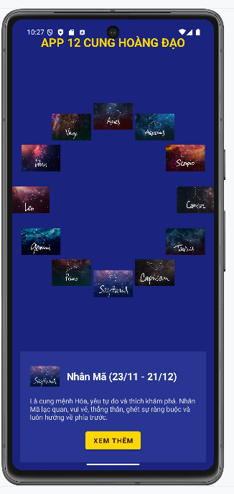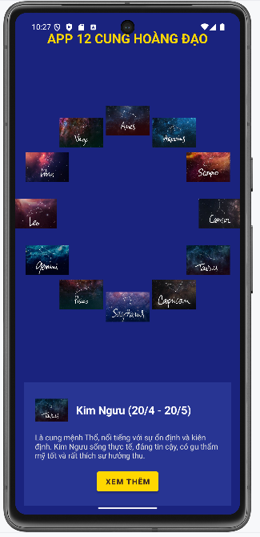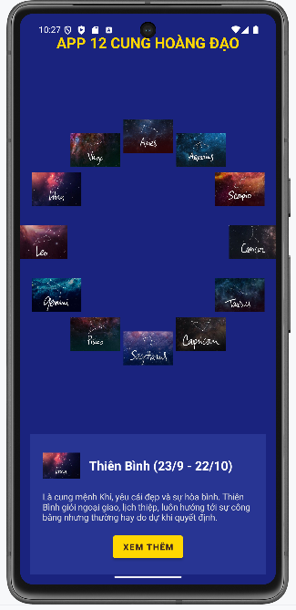

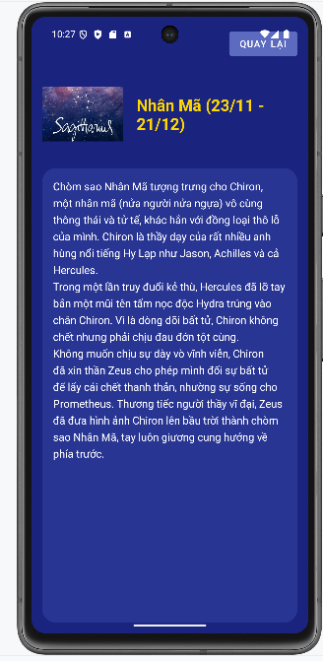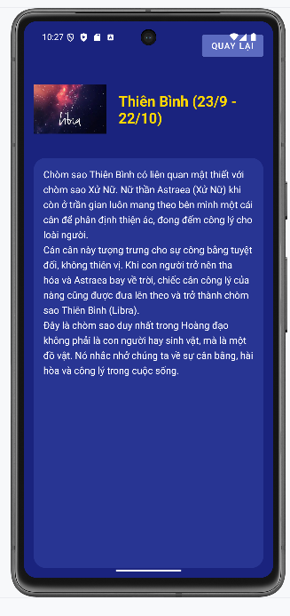

# 

## Ứng dụng đăng nhập và đăng ký

### Chuẩn bị tài nguyên cần thiết

Lưu file ảnh vào drawable/bg_rect

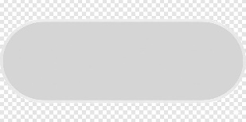

Thiết kế giao diện background bằng cách sử dụng Drawable bg_radius.xml

*<?*xml version="1.0" encoding="utf-8"*?>*<layer-list xmlns:android="http://schemas.android.com/apk/res/android">  
 <item android:drawable="@drawable/bg_rect" />  
 <item android:bottom="3dp">  
 <shape>  
 <corners android:radius="20dp"/>  
 <solid android:color="#ffffff" />  
 </shape>  
 </item>  
</layer-list>

Thiết kế giao diện background bằng cách sử dụng Drawable bg_login.xml

*<?*xml version="1.0" encoding="utf-8"*?>*<layer-list xmlns:android="http://schemas.android.com/apk/res/android">  
 <item android:drawable="@drawable/bg_rect" />  
 <item android:bottom="3dp">  
 <shape>  
 <corners android:radius="20dp"/>  
 <solid android:color="#ffffff" />  
 </shape>  
 </item>  
</layer-list>

Thiết kế giao diện background bằng cách sử dụng Drawable bg_top.xml

*<?*xml version="1.0" encoding="utf-8"*?>*<shape xmlns:android="http://schemas.android.com/apk/res/android">  
 <corners android:bottomLeftRadius="100dp" />  
 <gradient  
 android:angle="145"  
 android:endColor="@color/orange"  
 android:startColor="@color/orangeMid"/>  
</shape>

Tải hình ảnh icon định dạng 24x24 từ trên mạng



Thêm màu sắc vào values/colors.xml

*<?*xml version="1.0" encoding="utf-8"*?>*<resources>  
 <color name="purple_200">#FFBB86FC</color>  
 <color name="purple_500">#FF6200EE</color>  
 <color name="purple_700">#F4511E</color>  
 <color name="teal_200">#FF03DAC5</color>  
 <color name="teal_700">#FF018786</color>  
 <color name="black">#FF000000</color>  
 <color name="white">#FFFFFFFF</color>  
 <color name="orange">#FB8C00</color>  
 <color name="gray">#EAE5E3</color>  
 <color name="orangeMid">#F4511E</color>  
</resources>

Thêm nội dung vào values/strings.xml

<resources>  
 <string name="app_name">Login</string>  
 <string name="txt_login">Login</string>  
 <string name="hint_email">Email</string>  
 <string name="hint_password">Password</string>  
 <string name="txt_forgot_pass">Forgot password?</string>  
 <string name="txt_no_account">Don\'t have an account ?</string>  
 <string name="txt_register">Register</string>  
</resources>

Tiến hành tạo file layout res/layout/m000_frg_login.xml có nội dung

*<?*xml version="1.0" encoding="utf-8"*?>*<LinearLayout xmlns:android="http://schemas.android.com/apk/res/android"  
 android:layout_width="match_parent"  
 android:layout_height="match_parent"  
 android:background="@color/gray"  
 android:orientation="vertical">  
 <FrameLayout  
 android:layout_width="match_parent"  
 android:layout_height="wrap_content">  
 <View  
 android:layout_width="match_parent"  
 android:layout_height="300dp"  
 android:background="@drawable/bg_top"/>  
 <TextView  
 android:layout_width="wrap_content"  
 android:layout_height="wrap_content"  
 android:layout_gravity="end"  
 android:layout_marginTop="220dp"  
 android:layout_marginEnd="30dp"  
 android:layout_marginRight="30dp"  
 android:text="@string/txt_login"  
 android:textColor="@color/white"  
 android:textSize="20sp" />  
 </FrameLayout>  
 <EditText  
 android:autofillHints="Email"  
 android:inputType="textEmailAddress"  
 android:id="@+id/edt_email"  
 android:layout_width="match_parent"  
 android:layout_height="50dp"  
 android:layout_marginHorizontal="30dp"  
 android:layout_marginTop="50dp"  
 android:layout_marginBottom="3dp"  
 android:background="@drawable/bg_radius"  
 android:drawableLeft="@drawable/ic_email"  
 android:drawablePadding="10dp"  
 android:hint="@string/hint_email"  
 android:padding="10dp"  
 android:textSize="18sp" />  
 <EditText  
 android:autofillHints="Password"  
 android:inputType="textPassword"  
 android:id="@+id/edt_pass"  
 android:layout_width="match_parent"  
 android:layout_height="50dp"  
 android:layout_marginHorizontal="30dp"  
 android:layout_marginTop="20dp"  
 android:layout_marginBottom="3dp"  
 android:background="@drawable/bg_radius"  
 android:drawableLeft="@drawable/ic_key"  
 android:drawablePadding="10dp"  
 android:hint="@string/hint_password"  
 android:padding="10dp"  
 android:textSize="18sp" />  
 <TextView  
 android:layout_width="wrap_content"  
 android:layout_height="wrap_content"  
 android:layout_gravity="end"  
 android:layout_marginTop="10dp"  
 android:layout_marginRight="30dp"  
 android:text="@string/txt_forgot_pass"  
 android:textColor="@color/black"  
 android:textSize="18sp" />  
 <TextView  
 android:id="@+id/tv_login"  
 android:layout_width="match_parent"  
 android:layout_height="50dp"  
 android:layout_gravity="end"  
 android:layout_marginHorizontal="30dp"  
 android:layout_marginTop="40dp"  
 android:background="@drawable/bg_login"  
 android:gravity="center"  
 android:padding="10dp"  
 android:text="@string/txt_login"  
 android:textColor="@color/white"  
 android:textSize="18sp" />  
 <TableRow  
 android:layout_width="match_parent"  
 android:layout_height="wrap_content"  
 android:layout_marginTop="30dp"  
 android:gravity="center">  
 <TextView  
 android:layout_width="wrap_content"  
 android:layout_height="wrap_content"  
 android:layout_gravity="end"  
 android:text="@string/txt_no_account"  
 android:textColor="@color/black"  
 android:textSize="14sp" />  
 <TextView  
 android:id="@+id/tv_register"  
 android:layout_marginLeft="5dp"  
 android:layout_width="wrap_content"  
 android:layout_height="wrap_content"  
 android:layout_gravity="end"  
 android:text="@string/txt_register"  
 android:textColor="@color/orange"  
 android:textSize="14sp"  
 android:textStyle="bold" />  
 </TableRow>  
</LinearLayout>

Tiến hành tạo file layout res/layout/m001_frg_register.xml có nội dung

*<?*xml version="1.0" encoding="utf-8"*?>*<LinearLayout xmlns:android="http://schemas.android.com/apk/res/android"  
 xmlns:app="http://schemas.android.com/apk/res-auto"  
 xmlns:tools="http://schemas.android.com/tools"  
 android:layout_width="match_parent"  
 android:layout_height="match_parent"  
 android:background="@color/gray"  
 android:orientation="vertical">  
 <FrameLayout  
 android:layout_width="match_parent"  
 android:layout_height="wrap_content">  
  
 <View  
 android:layout_width="match_parent"  
 android:layout_height="300dp"  
 android:background="@drawable/bg_top"/>  
 <ImageView  
 android:id="@+id/iv_back"  
 android:layout_width="56dp"  
 android:layout_height="56dp"  
 android:padding="10dp"  
 android:src="@drawable/ic_back"  
 app:tint="@color/white"  
 tools:ignore="ContentDescription"/>  
 <TextView  
 android:layout_width="wrap_content"  
 android:layout_height="wrap_content"  
 android:layout_gravity="end"  
 android:layout_marginTop="220dp"  
 android:layout_marginRight="30dp"  
 android:text="@string/txt_register"  
 android:textColor="@color/white"  
 android:textSize="20sp" />  
 </FrameLayout>  
 <EditText  
 android:id="@+id/edt_email"  
 android:layout_width="match_parent"  
 android:layout_height="50dp"  
 android:layout_marginHorizontal="30dp"  
 android:layout_marginTop="50dp"  
 android:layout_marginBottom="3dp"  
 android:autofillHints="Email"  
 android:background="@drawable/bg_radius"  
 android:drawableLeft="@drawable/ic_email"  
 android:drawablePadding="10dp"  
 android:hint="@string/hint_email"  
 android:inputType="textEmailAddress"  
 android:padding="10dp"  
 android:textSize="18sp" />  
 <EditText  
 android:id="@+id/edt_pass"  
 android:layout_width="match_parent"  
 android:layout_height="50dp"  
 android:layout_marginHorizontal="30dp"  
 android:layout_marginTop="10dp"  
 android:layout_marginBottom="3dp"  
 android:autofillHints="Password"  
 android:background="@drawable/bg_radius"  
 android:drawableLeft="@drawable/ic_key"  
 android:drawablePadding="10dp"  
 android:hint="@string/hint_password"  
 android:inputType="textPassword"  
 android:padding="10dp"  
 android:textSize="18sp" />  
 <EditText  
 android:id="@+id/edt_re_pass"  
 android:layout_width="match_parent"  
 android:layout_height="50dp"  
 android:layout_marginHorizontal="30dp"  
 android:layout_marginTop="10dp"  
 android:layout_marginBottom="3dp"  
 android:autofillHints="Password"  
 android:background="@drawable/bg_radius"  
 android:drawableLeft="@drawable/ic_key"  
 android:drawablePadding="10dp"  
 android:hint="@string/hint_password"  
 android:inputType="textPassword"  
 android:padding="10dp"  
 android:textSize="18sp" />  
 <TextView  
 android:id="@+id/tv_register"  
 android:layout_width="match_parent"  
 android:layout_height="50dp"  
 android:layout_gravity="end"  
 android:layout_marginHorizontal="30dp"  
 android:layout_marginTop="20dp"  
 android:background="@drawable/bg_login"  
 android:gravity="center"  
 android:padding="10dp"  
 android:text="@string/txt_register"  
 android:textColor="@color/white"  
 android:textSize="18sp" />  
</LinearLayout>

Tiến hành tạo file layout res/layout/activity_main.xml có nội dung

*<?*xml version="1.0" encoding="utf-8"*?>*<LinearLayout xmlns:android="http://schemas.android.com/apk/res/android"  
 android:id="@+id/ln_main"  
 android:layout_width="match_parent"  
 android:layout_height="match_parent"  
 android:orientation="vertical">  
</LinearLayout>

### Thực hiện xử lý logic

Bước 1:Tiến hành xử lý M000LoginFragment để hiển thị giao diện m000_frg_login

package com.example.lab5;  
import android.content.Context;  
import android.content.SharedPreferences;  
import android.os.Bundle;  
import android.view.LayoutInflater;  
import android.view.View;  
import android.view.ViewGroup;  
import android.view.animation.AnimationUtils;  
import android.widget.EditText;  
import android.widget.Toast;  
import androidx.fragment.app.Fragment;  
 public class M000LoginFragment extends Fragment implements View.OnClickListener {  
 private EditText edtEmail, edtPass;  
 private Context mContext;  
  
 @Override  
 public View onCreateView(LayoutInflater inflater, ViewGroup container, Bundle savedInstanceState) {  
 View rootView = inflater.inflate(R.layout.*m000_frg_login*, container, false);  
 initView(rootView);  
 return rootView;  
 }  
  
 @Override  
 public void onAttach(Context context) {  
 super.onAttach(context);  
 mContext = context;  
 }  
  
 private void initView(View v) {  
 edtEmail = v.findViewById(R.id.*edt_email*);  
 edtPass = v.findViewById(R.id.*edt_pass*);  
 v.findViewById(R.id.*tv_login*).setOnClickListener(this);  
 v.findViewById(R.id.*tv_register*).setOnClickListener(this);  
 }  
  
 @Override  
 public void onClick(View v) {  
 v.startAnimation(AnimationUtils.*loadAnimation*(mContext,  
 androidx.appcompat.R.anim.*abc_fade_in*));  
 if (v.getId() == R.id.*tv_login*) {  
 login(edtEmail.getText().toString(), edtPass.getText().toString());  
 } else if (v.getId() == R.id.*tv_register*) {  
 gotoRegisterScreen();  
 }  
 }  
  
 private void gotoRegisterScreen() {  
 ((MainActivity) mContext).gotoRegisterScreen();  
 }  
  
 private void login(String mail, String pass) {  
 if (mail.isEmpty() || pass.isEmpty()) {  
 Toast.*makeText*(mContext, "Empty value", Toast.*LENGTH_SHORT*).show();  
 return;  
 }  
 SharedPreferences pref = mContext.getSharedPreferences(MainActivity.*SAVE_PREF*,  
 Context.*MODE_PRIVATE*);  
 String savedPass = pref.getString(mail, null);  
 if (savedPass == null) {  
 Toast.*makeText*(mContext, "Email is not existed!", Toast.*LENGTH_SHORT*).show();  
 return;  
 }  
 if (!pass.equals(savedPass)) {  
 Toast.*makeText*(mContext, "Password is not correct!", Toast.*LENGTH_SHORT*).show();  
 return;  
 }  
 Toast.*makeText*(mContext, "Login accountsuccessfully!", Toast.*LENGTH_SHORT*).show();  
 }  
 }

Bước 2:Tiến hành xử lý M001RegisterFragment để hiển thị giao diện m001_frg_register

package com.example.lab5;  
import android.content.Context;  
import android.content.SharedPreferences;  
import android.os.Bundle;  
import android.view.LayoutInflater;  
import android.view.View;  
import android.view.ViewGroup;  
import android.view.animation.AnimationUtils;  
import android.widget.EditText;  
import android.widget.Toast;  
import androidx.fragment.app.Fragment;  
public class M001RegisterFragment extends Fragment implements View.OnClickListener {  
 private EditText edtEmail, edtPass, edtRepass;  
 private Context mContext;  
 @Override  
 public View onCreateView(LayoutInflater inflater, ViewGroup container, Bundle savedInstanceState) {  
 View rootView = inflater.inflate(R.layout.*m001_frg_register*, container, false);  
 initView(rootView);  
 return rootView;  
 }  
 @Override  
 public void onAttach(Context context) {  
 super.onAttach(context);  
 mContext = context;  
 }  
 private void initView(View v) {  
 edtEmail = v.findViewById(R.id.*edt_email*);  
 edtPass = v.findViewById(R.id.*edt_pass*);  
 edtRepass = v.findViewById(R.id.*edt_re_pass*);  
 v.findViewById(R.id.*tv_register*).setOnClickListener(this);  
 v.findViewById(R.id.*iv_back*).setOnClickListener(this);  
 }  
 @Override  
 public void onClick(View v) {  
 v.startAnimation(AnimationUtils.*loadAnimation*(mContext,  
 androidx.appcompat.R.anim.*abc_fade_in*));  
 if (v.getId() == R.id.*iv_back*) {  
 gotoLoginScreen();  
 } else if (v.getId() == R.id.*tv_register*) {  
 register(edtEmail.getText().toString(), edtPass.getText().toString(), edtRepass.getText().toString());  
 }  
 }  
 private void gotoLoginScreen() {  
 ((MainActivity) mContext).gotoLoginScreen();  
 }  
 private void register(String mail, String pass, String repass) {  
 if (mail.isEmpty() || pass.isEmpty() || repass.isEmpty()) {  
 Toast.*makeText*(mContext,"Empty value", Toast.*LENGTH_SHORT*).show();  
 return;  
 }  
 if (!pass.equals(repass)) {  
 Toast.*makeText*(mContext,"Password is not match", Toast.*LENGTH_SHORT*).show();  
 }  
 SharedPreferences pref = mContext.getSharedPreferences(MainActivity.*SAVE_PREF*,  
 Context.*MODE_PRIVATE*);  
 String savedPass = pref.getString(mail, null);  
 if (savedPass != null) {  
 Toast.*makeText*(mContext,"Email is existed!", Toast.*LENGTH_SHORT*).show();  
 return;  
 }  
 pref.edit().putString(mail, pass).apply();  
 Toast.*makeText*(mContext,"Register account successfully!", Toast.*LENGTH_SHORT*).show();  
 gotoLoginScreen();  
 }  
}

Bước 3: Xử lý logic ActivityMain để điều khiển các Fragment

package com.example.lab5;  
  
import android.os.Bundle;  
  
import androidx.activity.EdgeToEdge;  
import androidx.appcompat.app.AppCompatActivity;  
import androidx.core.graphics.Insets;  
import androidx.core.view.ViewCompat;  
import androidx.core.view.WindowInsetsCompat;  
  
public class MainActivity extends AppCompatActivity {  
 public static final String *SAVE_PREF* = "save_pref";  
 @Override  
 protected void onCreate(Bundle savedInstanceState) {  
 super.onCreate(savedInstanceState);  
 setContentView(R.layout.*activity_main*);  
 gotoLoginScreen();  
 }  
 public void gotoRegisterScreen() {  
 getSupportFragmentManager().beginTransaction().replace(R.id.*ln_main*, new  
 M001RegisterFragment()).commit();  
 }  
 public void gotoLoginScreen() {  
 getSupportFragmentManager().beginTransaction().replace(R.id.*ln_main*, new  
 M000LoginFragment()).commit();  
 }  
}

### Kết quả sau khi thực hiện

